Name: Date:

Cornstarch Experiment
GradSWE and UW Science Explorers
Materials needed:

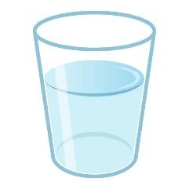
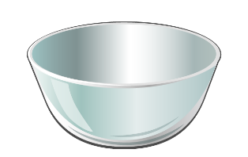
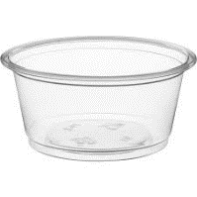
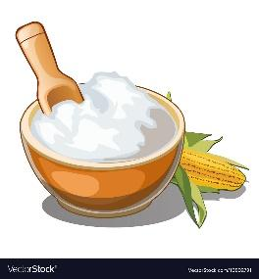
Water

Cornstarch
Bowl
Spoon
Cup

Science terms:
- Solid:
- Liquid:
- Viscosity:
- Non-Newtonian Fluid:
Directions:
- Add 2 measuring cups of cornstarch to a bowl.
- Measure out 1 measuring cup of water and slowly add the water to the bowl.
- Mix well with your hands or with a spoon.
- Add more or less of each ingredient until you reach the consistency of honey.
- Make your observations!
Questions:
- Tap the surface of the mixture with a spoon. Does it splash?

- Roll some of the mixture into a ball. What happens when you stop rolling?

- Stir the mixture slowly with your finger. Now stir the mixture quickly. Do you feel a difference?

- Is cornstarch oobleck a liquid, solid, or non-Newtonian fluid?

