Objectives:
- Chemical reactions can cause changes in color and release gases
- Chemicals in food can be classified as an acid, base or neutral
- Acids and bases react to form water (plus something else), becoming neutral

Materials:
- pH indicator (we’ll be using the fish tank “low range” tester as it is more sensitive)
- Small cups for testing
- Funnels
- Graduated cylinders
- Spoons
- Vinegar
- Lemon Juice
- Baking soda
- Baking powder
- Egg white (pasteurized)
- Milk
- Water
- Balloons
- Clear water/soda/juice bottles
- pipette
- Butcher paper

Background video:
This video will describe a chemical reaction and introduce the idea that chemical reactions are involved in baking.
https://www.youtube.com/watch?v=37pir0ej_SE

Preparation:
To ease clean up, place butcher paper on the desks. Remind students that they are not allowed to eat ANYTHING that is part of their chemistry laboratory, even if it’s food.

Part I: Acid vs Base Testing

- Discuss an acid and bases: have the students read the general description of acids and bases on their worksheet. Also discuss the idea of a neutral substance.
- Based on the properties on their worksheet, ask the students to predict which of the “chemicals” we’ll be testing are acidic, basic, or neutral.
- Introduce the idea of an indicator: since we can’t safely taste or touch the “chemicals” that we are looking at today, we’ll actually observe a chemical reaction as a test. The indicator will react with an acid to create a yellow color and react with a base to create a blue color. A neutral color will be green. Refer to the indicator result card.
- Place 20-50 mL (1-2 Tbsp) of each solution to test in a clear plastic cup: water, vinegar, egg white, lemon juice, milk, clear dish soap.
- Add 2-4 drops of indicator to each solution. It may be necessary to agitate the cup slightly (especially for the egg white).
- Help students interpret the colors to indicate whether each chemical is acidic, basic or neutral. Students can record these on their worksheets. Encourage students to compare their results to their predictions.

Part II: Neutralization tests
- Ask students what happens when acids and bases are brought into contact with each other? Will a chemical reaction occur? Will the resulting product be acidic, basic or neutral?
- Take a clear plastic cup and add 20-50 mL of egg white.
- Add about 5 drops of indicator and agitate. The solution should now be blue (you may want to put the cup over a white piece of paper to make this more clear).
- Use a pipette to add lemon juice to the solution.
- When you have added enough lemon juice to neutralize the base, the solution will turn green. Ask the students: is this new solution still a base? What is it now?
- Now, repeat this test more systematically
  - Have the students review the reaction chart on their worksheet and label each substance as either acid, base, or neutral
  - On the butcher paper, prepare a chart to label the test samples according to the chart on the worksheet
  - Fill three of the cups, as labelled, with egg white or lemon juice (again 20-50 mL or 1-2 tbsp of each)
  - Add 3-5 drops of indicator to each. Confirm that they turned the color you would expect
  - Begin adding the appropriate acid/base/water according to the labels; start by adding a small amount of each and see if there is evidence of a reaction and add more if you see no evidence initially; try to avoid adding so much of one solution to change the pH significantly by dilution
You should see clear evidence of a chemical reaction in vinegar-egg yolk and lemon juice-baking soda. Note that the lemon juice and baking soda should change color, indicating neutralization but will also release a gas, further evidence of a chemical reaction.
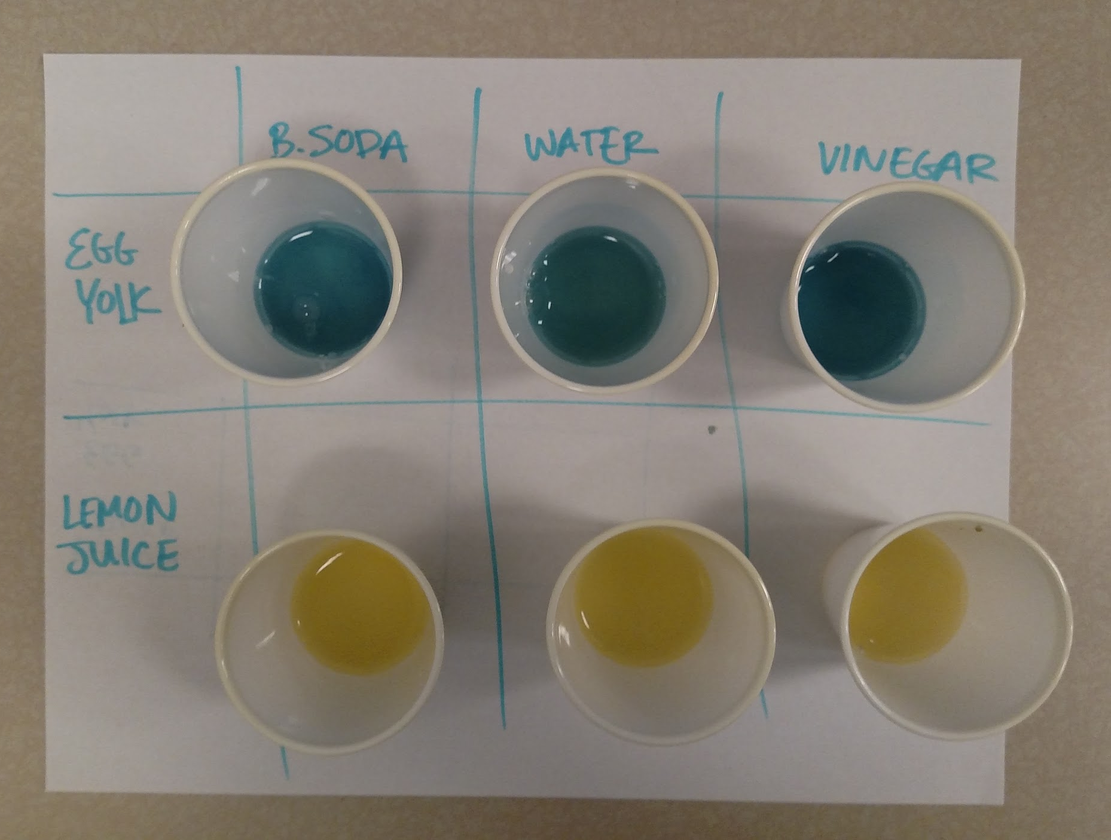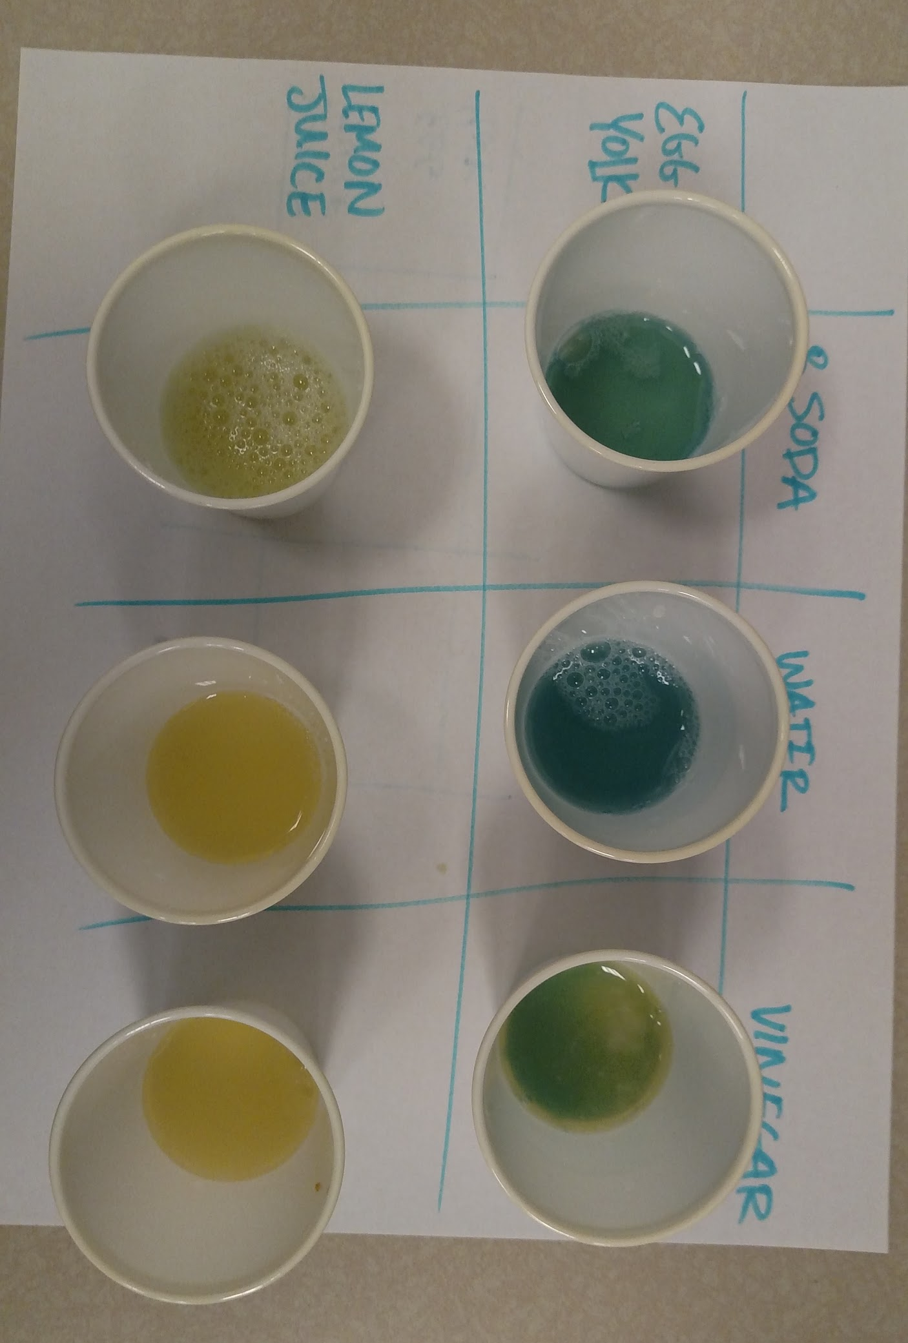
- Help students fill out the reaction worksheet.
- Ask students if they can make a general statement about acid-acid, base-base, or acid-base reactions? What about reactions with water?

Part III: Acid/Base reactions can also release a gas
- Recap with students the fact that a chemical reaction can release a gas (such as the carbon dioxide in cake).
- Ask students how they might be able to detect the formation of a gas? Discuss that since we can’t see a gas, we will have to trap it in a balloon.
- Measure out 100 mL (6-7 tbsp) of vinegar into a clear plastic bottle
- Prepare the balloon by giving it a few good stretches in all directions
- Add about 10 mL of baking soda (1 tbsp) to the balloon
- Without transferring the baking soda to the bottle, affix the open end of the balloon to the bottle.
- Lift the closed end of the balloon and shake the baking soda into the bottle.
- Ask students for their observations.

Part IV: Baking soda vs baking powder (optional)
- Ask students if they know the difference between baking powder and baking soda. Tell them that we can find a clue about their difference by watching different reactions.
- Next to your bottle with baking soda and vinegar, place three more bottles with these labels:
Baking Soda + Water
Baking Powder + Vinegar
Baking Powder + Water
- As before, add 100 mL of the proper liquid to each bottle and 10 mL of the proper powder to each balloon.
- First, flip the Baking Powder + Vinegar balloon and observe the results. It should react pretty much the same way as the Baking Soda + Vinegar.
- Next, flip the Baking Soda + Water. There should be little or no reaction here.
- Ask students what will happen when we flip the Baking Powder + Water balloon.
- Finally, flip the Baking Powder + Water balloon and observe. This should produce a similar reaction to Baking Soda + Vinegar. This is because Baking Powder is a mixture of Baking Soda and powdered acids. When these powdered acids become wet, they form an acidic solution and react with the Baking Soda in the powder. One of the acids in Baking Powder reacts immediately with the Baking Soda but the other will only react with the application of heat.

Optional Extension:
Using one balloon and one bottle with vinegar and Baking Soda, how big can you make the balloon? Try experimenting with different ratios. This will hint at the idea of a limiting reagent.

Wrap Up Video: about the difference between baking powder and baking soda https://www.youtube.com/watch?v=xBw77n7Dsj0

