Angular Momentum
I had a pretty hard time planning this lesson. I couldn’t find resources with the right level of detail and vocabulary with the right level of engagement. I tried my best.

Activity 1: Develop intuition for momentum.
Go through slides in this folder.

Activity 2: Make a spinning top.

Materials
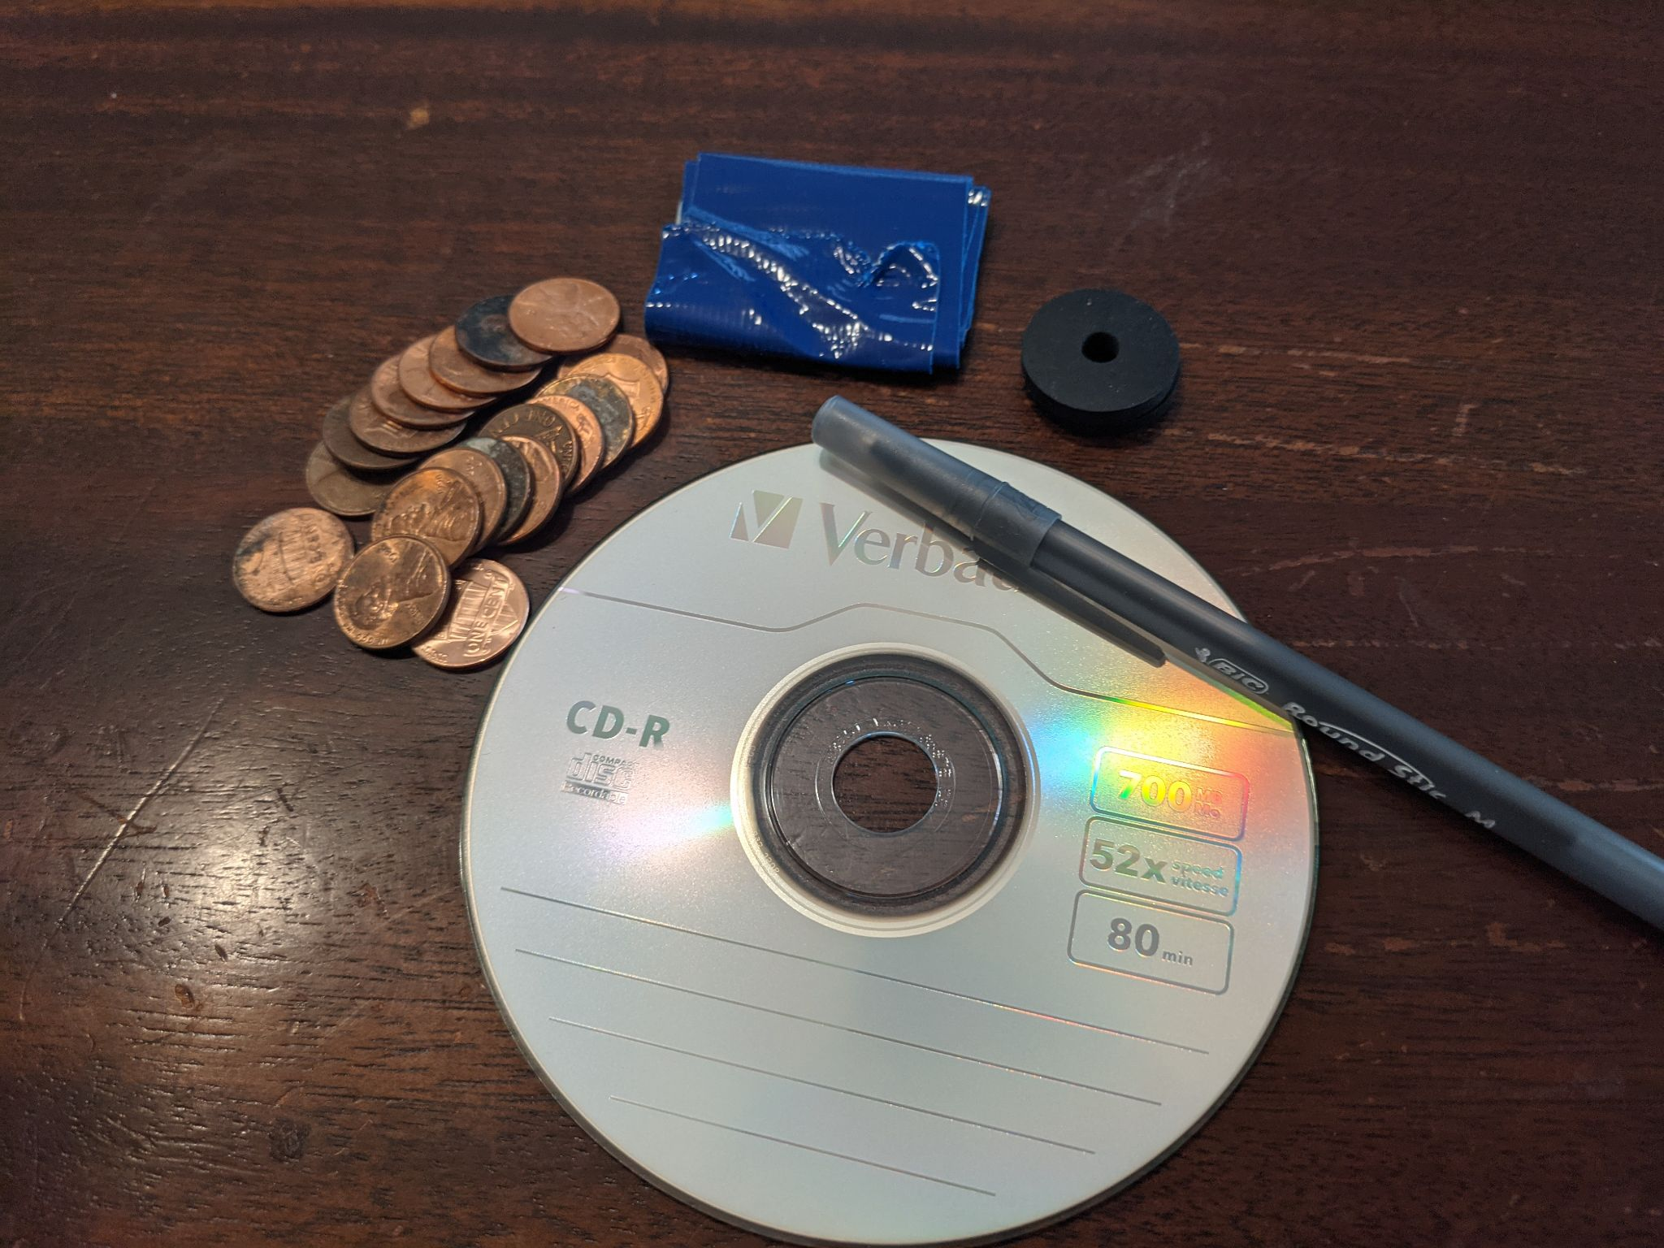
- CD
- Pen
- Rubber washer with quarter inch inner diameter. Make sure it fits around pen.
- 20 pennies
- Some tape (duct tape, masking tape, and scotch tape should work just fine).

Before angular momentum
- Try to make the pen stand as long as possible. It won’t stay up very long

Now add angular momentum

- Now let’s try to make the pen stand upright by adding angular momentum. We are going to turn the pen into a top. Slide rubber washer from the pointy end of the pen.
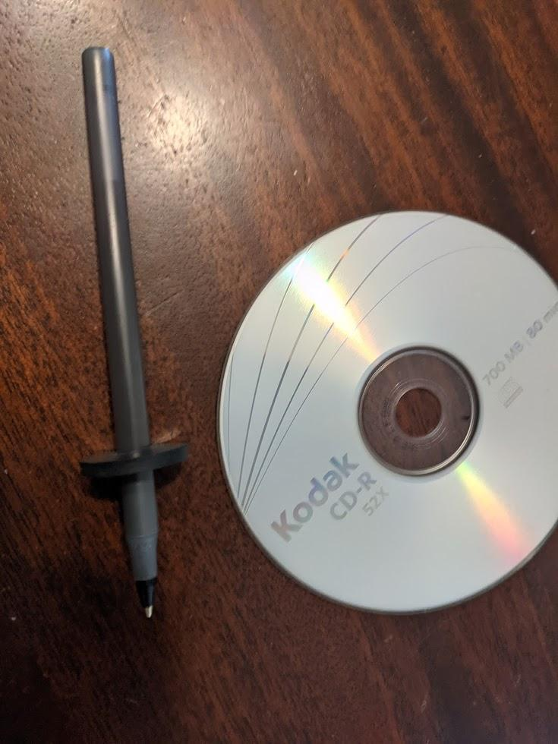
- Slide CD onto the other side. Tape rubber washer to the CD. Center the CD and rubber washer as best as you can.
I find that the whole system is more stable when the CD lies low along the pen.
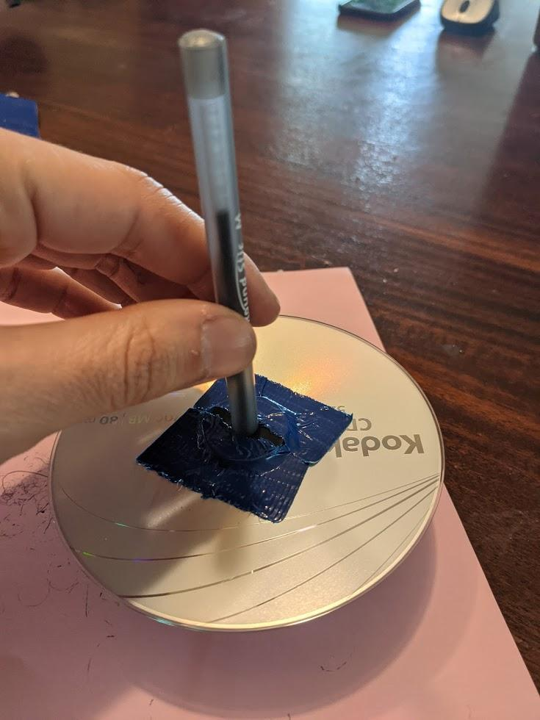
- Slide the other rubber washer underneath the CD. Make sure that the rubber washer is centered on the CD and tape it.
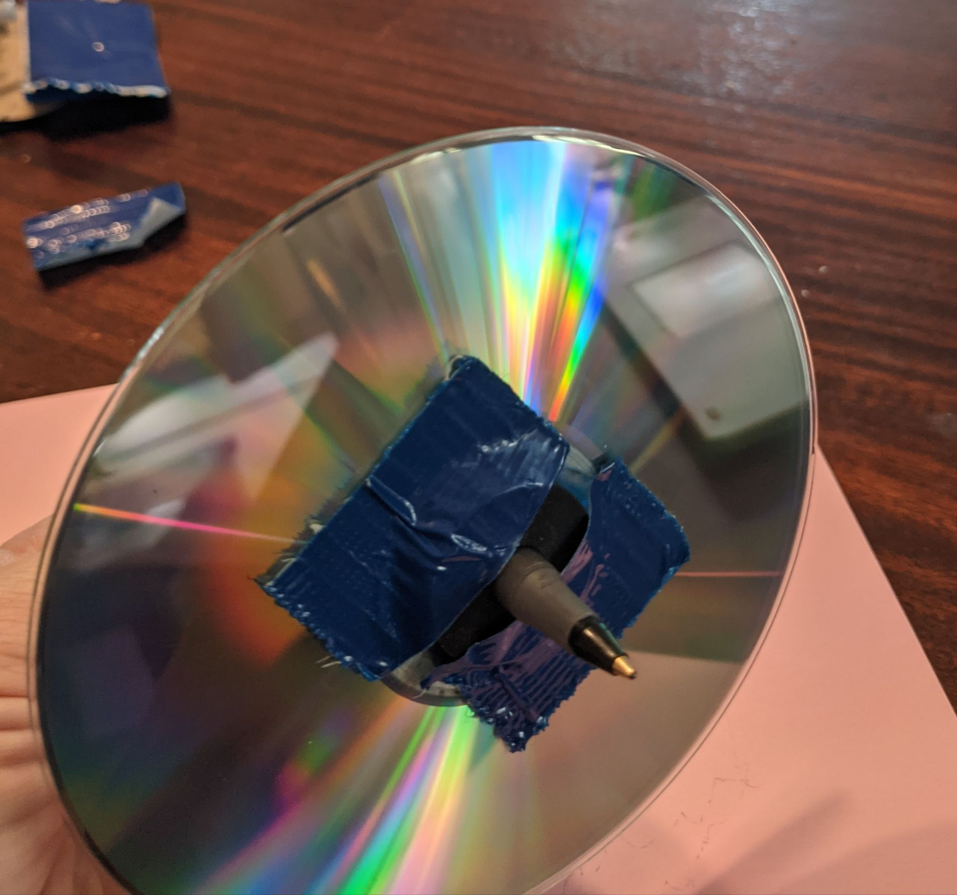
- Make the pen perpendicular to the table. Make sure the CD is level to the table. Adjust if necessary. The more your top spins upright, the more stable it is, and the longer it will spin.
- Spin the pen and try to make it stand as long as possible. It should stand much longer. I find that spinning the pen with your palms is pretty robust.
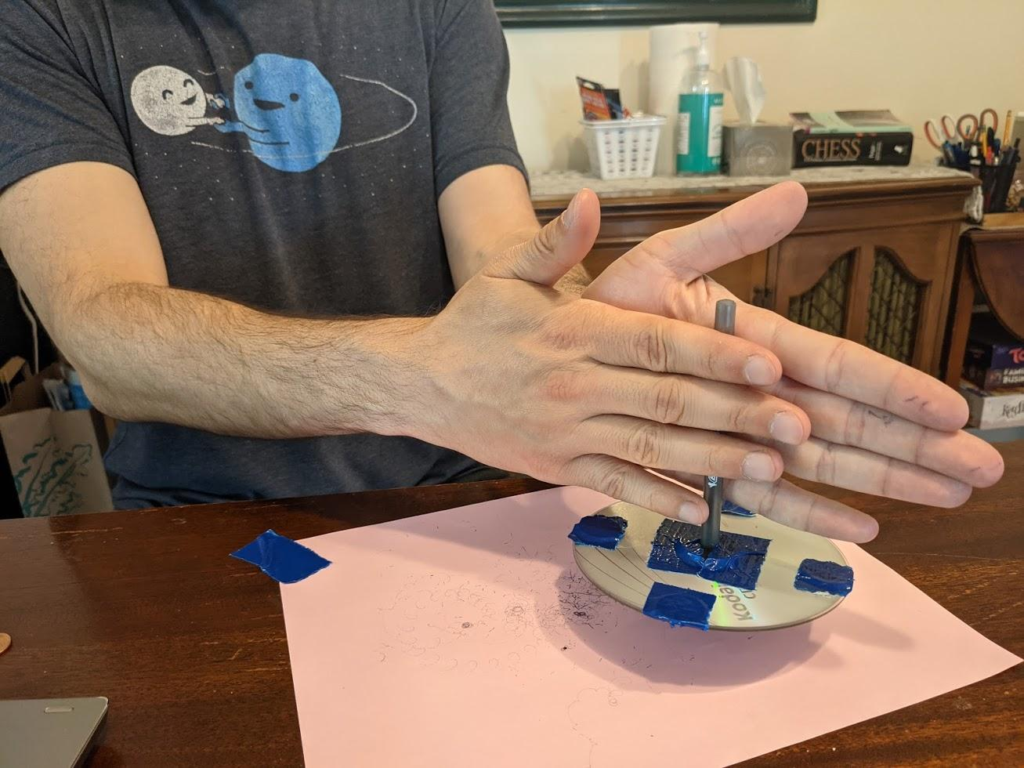
- Add 4 pennies close to the inside of the CD. Then spin it. It should stand for much longer because of the increased angular momentum.
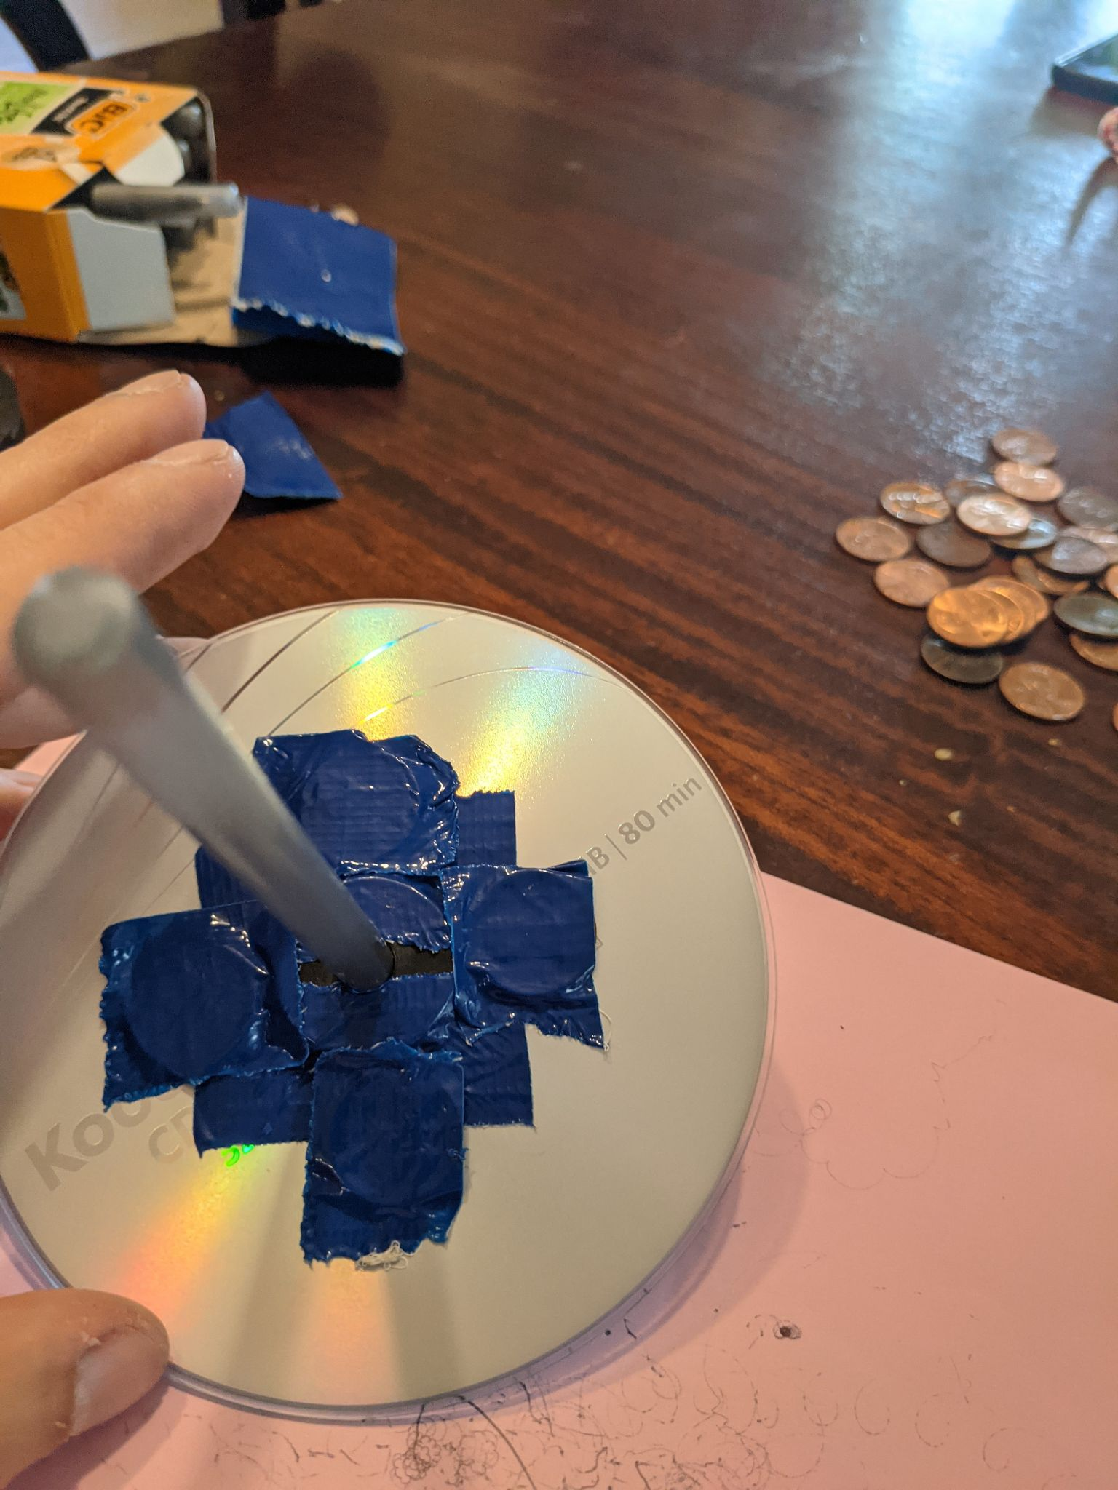
- Move the pennies towards the outside of the CD. Try to keep the weight as evenly distributed as you can.
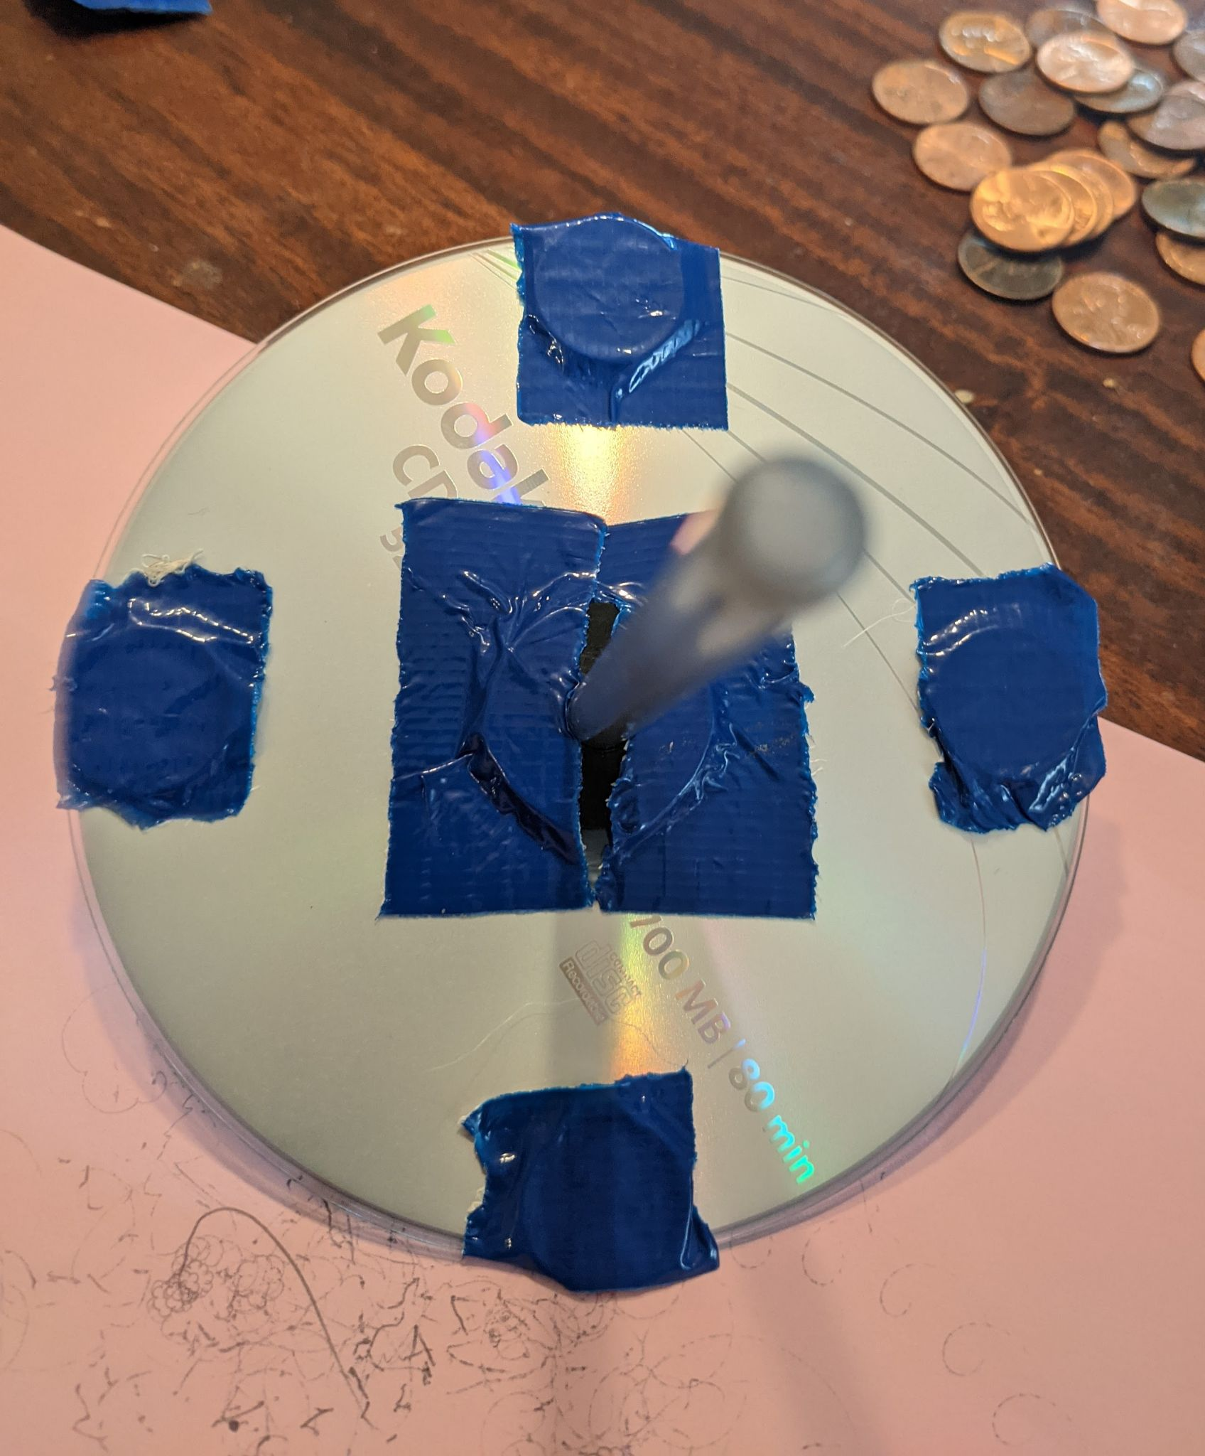
- Add 4 more pennies on the outer edge and make it spin again. The added weight should give it even more angular momentum. I was able to get it to spin for over 2 minutes.
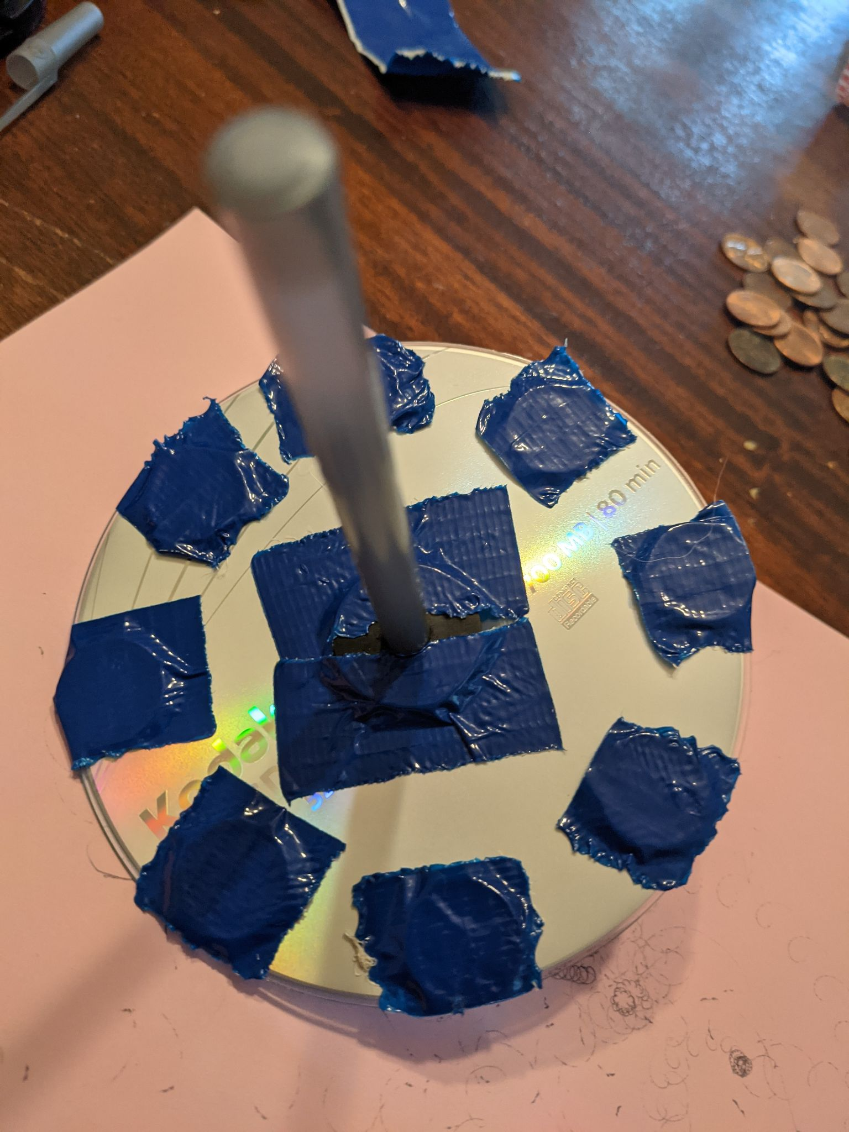
- What else can you do to make the top last longer?
- Why does the top stop spinning?

Talk about conservation of angular momentum.
Spinning dumbbell demo: https://www.youtube.com/watch?v=GTk6GjQNd04
Spinning ice skater: https://www.youtube.com/watch?v=MjYk5TRpOlE
More conservation of angular momentum: https://www.youtube.com/watch?v=BcjOxVJyu8w&t=13s
Gyroscopic rotation: https://www.youtube.com/watch?v=4qvAGjJKMwM

