Brain Activity Worksheet

As you learn about the type of activities that the different parts of your brain help you do, label the brain below!

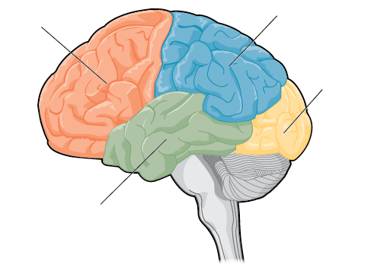

- The FRONTAL lobe is the part of our brain that supports our ability to plan, predict, remember things in the short term, understand rules, and translate our thoughts into actions. Which part of the brain do you think is the frontal lobe?
  - Try to solve the Raven’s Progressive Matrices puzzles. What do you need to figure out in order to complete the puzzle? What pieces of information do you use to figure it out?

  - Play the card matching game. What do you have to remember to win? Do you think you’ll remember it after dinner? Tomorrow? Next week?

- The TEMPORAL lobe is the part of our brain that is closest to our temples. If you have ever seen someone pressing on the sides of their head in frustration, their skull is protecting their temporal lobes! This part of the brain supports our abilities to remember things over long periods of time, and recognize those things when we see them again. Which part of the brain do you think is the temporal lobe?
  - Think back to what you did for Halloween last year. Write a quick story and draw a picture about it below!

  - Check out some of the pictures that are printed out. Do you recognize these characters? Where have you seen them before?

- The OCCIPITAL lobe is the part of our brain that is at the back of our heads. It gets its funny name from two Latin words: ob, meaning behind, and caput, meaning the head. This part of the brain is what first processes the images that your eyes see, and does a little “photoshopping”. Which part of the brain do you think is the occipital lobe?
  - Try to find your “blind spot”. Usually, the occipital lobe “fills in” the information so that we do not see the blind spot. But, if we look at something in just the right way, we can “trick” the occipital lobe into filling in the “wrong” information!

  - Complete the Stroop task. Write and color an example of a “hard” Stroop word that would trick a person into saying the wrong color!

- The PARIETAL lobe is the part of our brain that is between the frontal and occipital lobes. It does a lot of different things, including helping you read the words on this page, see motion, and feel touch. Which part of the brain do you think is the parietal lobe?
  - Partner up with one of your groupmates and try to find your two-touch threshold on your fingertip, and then your forearm. Where is it easier to feel two points that are close together?

  - Take a look at the perceptual illusions. Even though they don’t actually move on the paper, the patterns of shapes and bright/dark colors trick your parietal cortex into thinking they do move! Why do you think it seems like it moves more when you aren’t looking directly at it?

Surgical Report
Now that we know what parts of the brain do what, we are ready to perform surgery!

- Under what lobe of the brain was the tumor found? Can you draw a brain (like the one on the first page) and label where the tumor is?

- What abilities do you think this tumor would affect, given what you have learned today?

