Did you know that this flower…
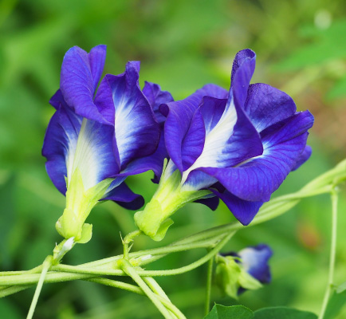
Can be used to make tea?

The flower above is a butterfly pea flower. Today, we’ll experiment with butterfly pea flower tea. The butterfly pea plant is native to Southeast Asia, and butterfly pea flower tea is a popular drink in Thailand. For centuries, butterfly pea flower tea has been used as a coloring dye. Butterfly pea flowers also have a special chemical called anthocyanin. The anthocyanin causes butterfly pea flower tea to change color when the pH of the tea changes. This means that when an acid or a base is added to the tea, the tea changes colors!

What color do you think the tea will change to if we add...

an acid:

a base:
By reading the lemonade packet, I think that lemonade is…

- an acid b) a base

Based on the results of the experiment, I think that baking soda is…

- an acid b) a base

Using a pH strip, I can tell that lemonade is…

- an acid b) a base

with pH level:

Using a pH strip, I can tell that baking soda is…

- an acid b) a base

with pH level:

