Cow Eye
Fill in the parts!

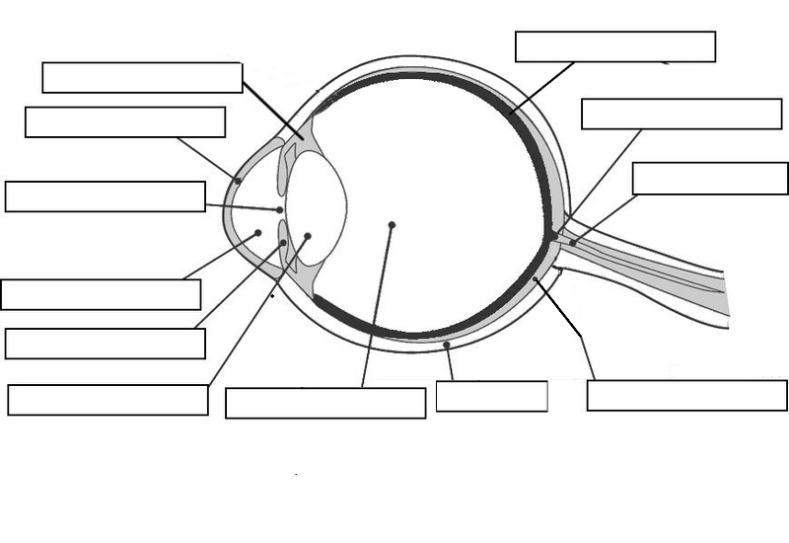Parts:

Aqueous humor - A clear liquid that helps give the cornea its shape.
Choroid coat - Tissue below the retina that supplies nutrients.
Cornea - Clear, protective coating in front of the eye.
Ciliary body - Tissue surrounding the lens. Can change the shape of the lens for focusing.
Iris - Muscle in front of the lens. Can change how much light enters the eye.
Lens - A clear structure that can change shape, allowing us to focus on objects we see.
Optic disc - Where the optic nerve attaches to the eye. Also our blind spot.
Optic nerve - Nerve bundle which carries images from the eye to the brain.
Pupil - The hole at the center of the iris. This is why light passes through into our eye.
Retina - A thin layer at the back of the eye. This is where light images are received.
Sclera - Thick, outer covering of the eyeball.
Vitreous humor - Thick, clear jelly that gives the eyeball its shape.

