Charging up balloon (mathisfun.com)

Attraction to wall. Repel each other. (dkfindout.com)
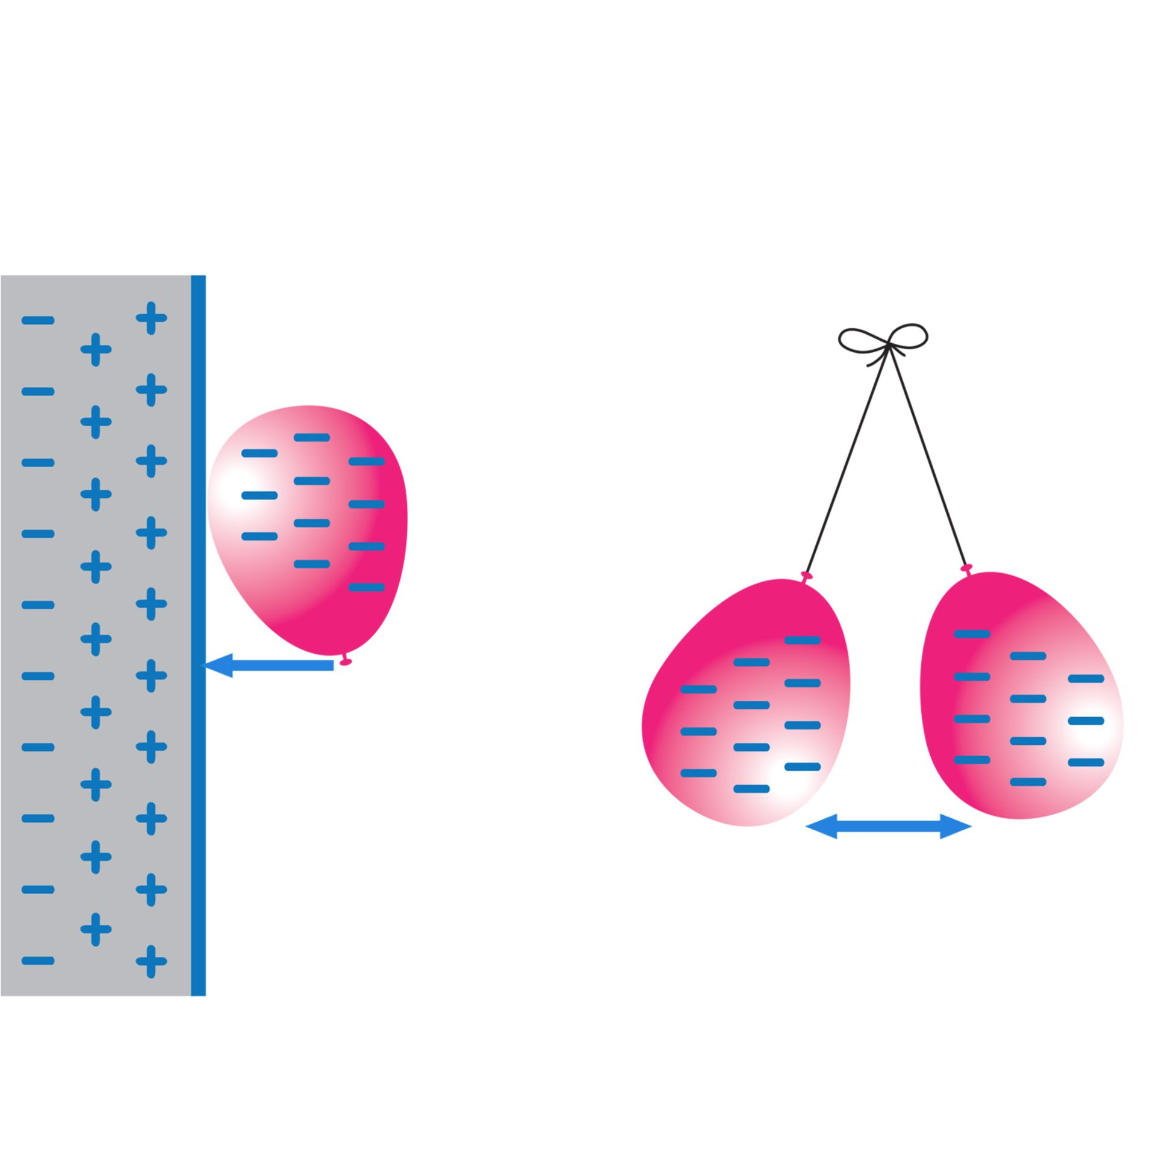

Attraction to ball (sciphile.org)
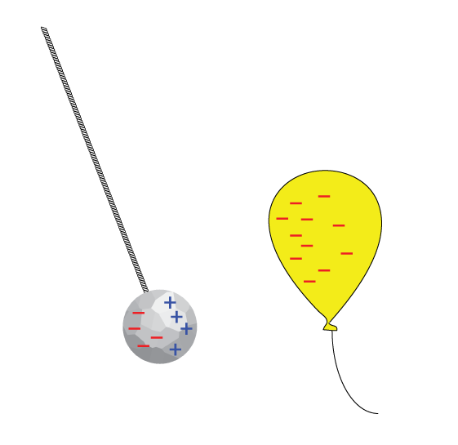

Lemon Battery (wikipedia)
