Today’s activities are centered on electric energy. The main idea here is to get across the idea that there are little charges which can be positive of negative, and separating the different kinds of charges gives them energy. That energy can then be transformed into light, sound, wind, motion etc.
Supplies:
- Balloons (2 per group)
- Soda can (1 per group)
- Confetti (1 little handful per group)
- Puffed rice (1 little handful per group)
- AA battery (1 per group)
- LED (1 per group)
- Other electrical components (not enough for everyone, will have to pass from group to group)
- One potato (or 3 slices) per group
- 3 paper bowls per group
- 3 zinc-coated nails per group
- 3 pennies per group
- 4 wires w/ alligator clips per group
Activity 1: Balloons and static (“sticky” or “non-moving”) electricity
Steps:
- Have each student blow up a balloon and tie the end off.
- Each person should rub the balloon many times on top of their head or a wool sweater (about 20 times).
- Hold the balloon against a sweater (wool or nylon) or the wall and watch it stick.
- Use the charged balloon to pick up various items: (scraps of paper, puffed rice, etc…)
- Use the balloon to make the kids’ hair stand on end
- Use the charged balloon to roll an empty aluminum can across the table.
- Try putting both balloons together and letting go (they should repel each other).
Discuss:
- Why does the rubbing the balloon on your hair or on a sweater “charge it up”
  - Its pulling negative charge (electrons) off of the sweater/your head. Charge is sticking to the balloon.
- What do the charges on the balloon do to the scraps of paper/metal can?
  - Like charges (- and -) repel and opposite charges (- and +) attract.
- What does the balloon stick to the best once it’s charged?
- Discuss the fact that when you separate charges, like by stealing electrons from your hair or sweater, you give the charges Electric Potential Energy.

Activity 2: Battery power
Steps:
- Have each student connect a wire (using the alligator clip) to each leg of the LED bulb.
- Have the student connect the long lead of the LED to the + side of the battery. Connect the short lead to the – side of the battery.
- Use conductive tape to facilitate the connection of parts.
- Observe the illuminated LED.
- Try connecting other devices (filament bulb, krypton bulb, buzzer).

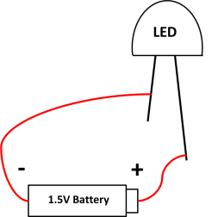
Discuss:
- How is the battery like the balloon?
  - It separates charges, giving them energy.
- How is it different?
  - The charges can move.
- What is the battery providing to make the LED light up?
  - A flow of energized electrons or “electric current” which flow through the metal wires and give their energy to the LED (or other component).
- Which direction does current flow in the circuit?
  - From positive through the LED and back to negative.
- What could we use instead of a battery?
  - Anything that separates charge and allows the charges to flow.
- Do you think we could use a potato?

Activity 3: Potato circuits
Steps:
- Cut the potato into 3 pieces
- Insert a copper penny and a zinc nail into each potato piece. Make sure the penny and the nail don’t touch each other! You may want to use scissors to make slits for the pennies.
- Using the wire, connect the potatoes together “in series” (use the diagram below as a guide).
- Connect the “penny side” (cathode) of the resulting “potato battery” to the long leg of the LED.
- Connect the “nail side” (anode) of the resulting “potato battery” to the short leg of the LED.
- Observe the illuminated LED. (Will probably need to dim the lights for this)
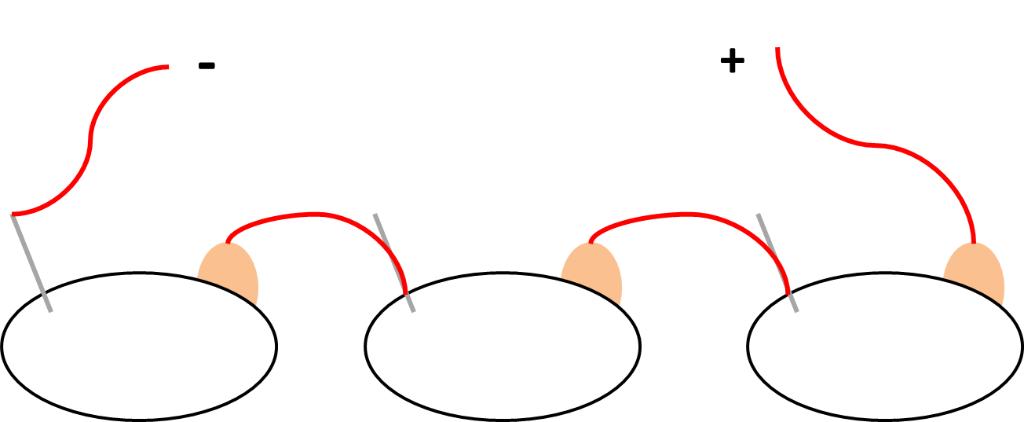
- Use a digital multi-meter to read off the voltage of the series-connected potato battery.

Discuss:
- How is the potato circuit like the balloon?
  - The zinc steals the electrons from the copper (through the liquid in the potato) and gives them energy.
- How is the potato like the battery?
  - It provides current for the circuit. It has a positive and a negative side. It provides chemical energy.
- Is the LED brighter when using the potato or when using the battery? Why?
  - It is brighter when we use the battery because the battery is providing more current to the circuit. This can be confirmed with the digital multi-meter.
- How could we improve the circuit?
  - Adding more potatoes in series increases the voltage. Adding them in parallel (connect nail to nail and penny to penny) increases the current.
Activity 4: A big potato circuit (larger groups and whole group, if there’s time)
Steps:
- Have everyone come together with their potato circuits.
- Connect multiple 3-cell potato circuits in parallel with the LED.
- Connect all 3-cell potato circuits in series and observe the resulting voltage with the digital multi-meter.
Activity 5: Whole group demo with Van deGraff (if time)
Steps:
- Have the kids all sit down together.
- Briefly explain how the VdG generator works
- Demo either with paper streamers, or with one of us with long straight hair for effect
- Let each student take a turn getting charged up.

