Fossils

Objectives
- Students will learn what fossils are, how they are formed, and what we can learn from them.
- Students will learn how to make their own “fossils” with Plaster of Paris.
- Students will learn what can be deduced from fossils.

Quarantine kits:
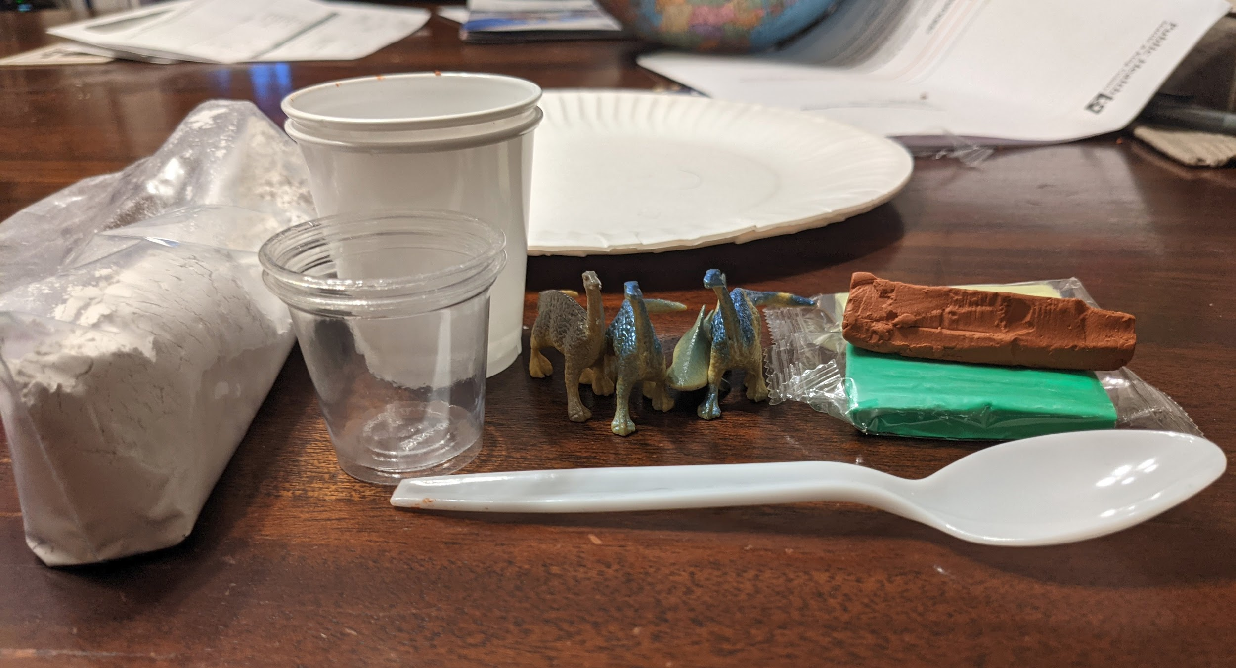
Handful of modeling clay
Plastic utensil (like a spoon or knife)
1.25oz/37mL plastic solo cup
3oz/88mL plastic (bathroom) cup
Handful of dinosaur toys and sea creature toys.
Paper plates as a surface to work on
Bag of plaster of paris (I gave everyone ½ cup).
Worksheets.
Students need to get cold tap water on their own.

Activity 1: Watch Video (~5 min)
How do dinosaur fossils form? | Natural History Museum

Activity 2: Make a fossil (~20 min +/- 10 min)
I mostly just followed this video: How To Make A Dino Fossil

- Form a lump of molding clay into a flat disk.
- Make an impression with your dinosaur or sea creature. We’re basically making a negative mold.
- Build a clay wall around this impression. This is to contain the Plaster of Paris while it sets.
I did this by rolling some clay on the table until I got a very thick noodle (maybe ¼” diameter?), and then I flattened that noodle with my hand. Then I wrapped this flattened sheet around the impression.
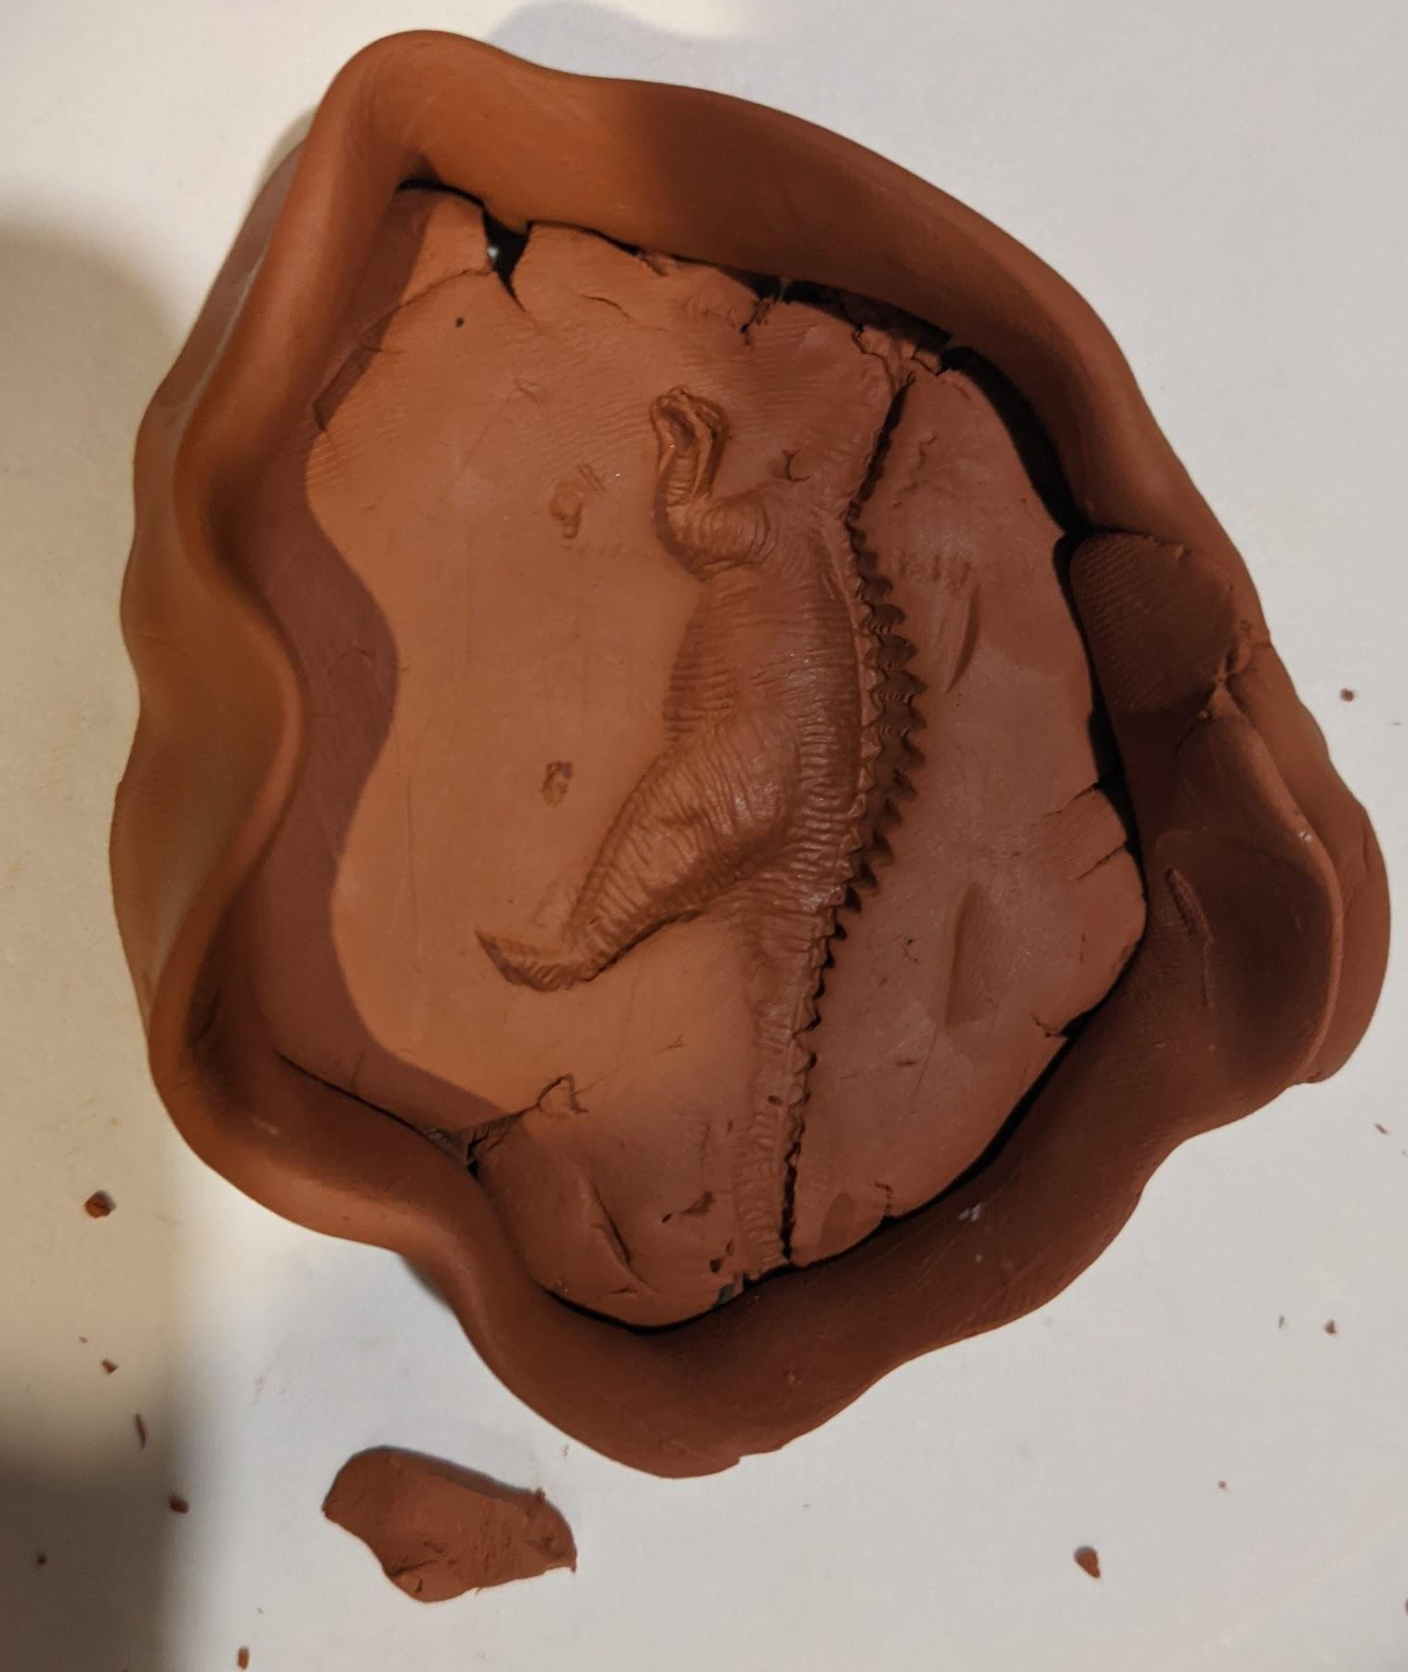
- Place negative mold onto paper plate to mitigate Plaster of Paris accidents.
- Mix Plaster of Paris with cold water with a 2:1 ratio. This is what I did:
  - Fill a 1.25 oz cup with Plaster of Paris.
  - Pour Plaster of Paris into a 3oz bathroom cup.
  - Pour cold water into a 1.25 oz cup until it is half way full.
  - Pour cold water into Plaster of Paris.
  - Mix it until it has a putty like consistency.
- Pour of Paris into clay impression.
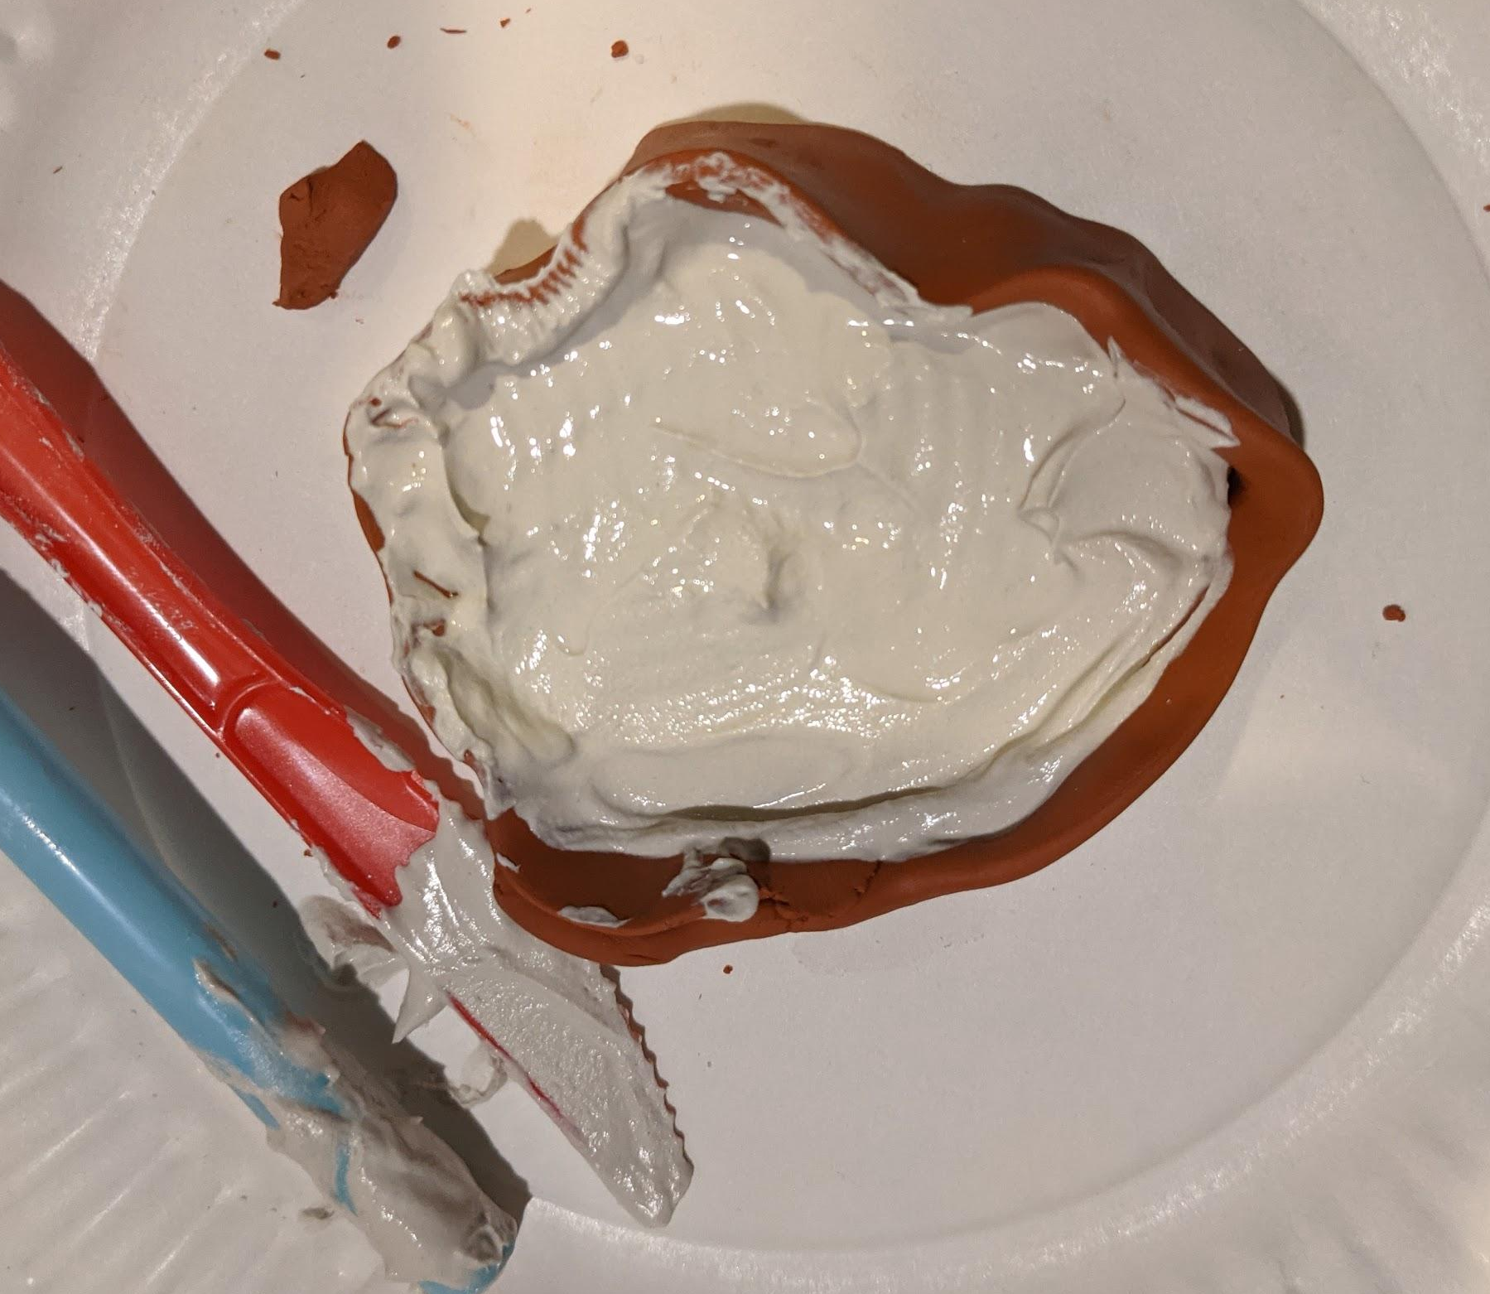
- Plaster of Paris will take more than 30 minutes to set. Hopefully, it will set by the end of class, but it likely won’t. Plaster of Paris might be mostly solid but very brittle.
- After 30 or so minutes, remove molds from the clay.
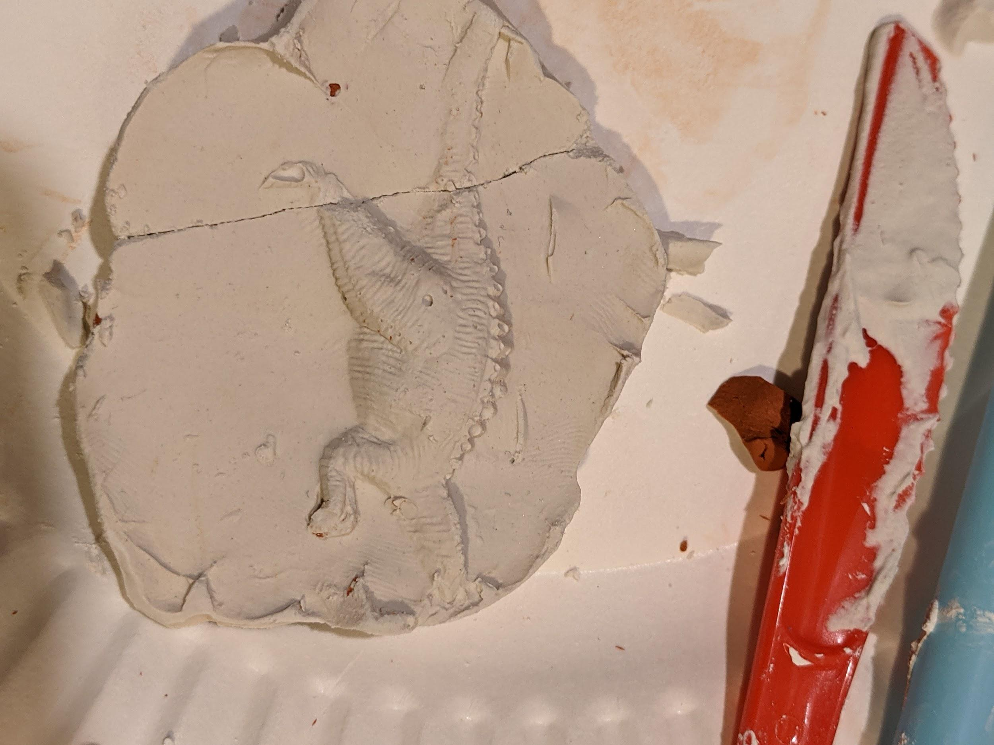
- Discuss with students about what can be learned from fossils. What characteristics about the original animal can you deduce from the fossil? What can’t you deduce from the fossil?

Activity 3: Discussion of fossils
Tutors will discuss the questions in the worksheet “week_3-_fossils_worksheet.docx”.
Some of those questions can’t be answered without the fossils. So just move on to the next activity and come back to this worksheet when your fossil is dry. But do make sure to go through the Fossil Facts, since those are important for solving the word search.
In addition to the worksheet questions, tutors can ask:
- What are the requirements for an animal to turn into a fossil?
- Why does it take so long for real fossils to form?
- Where can fossils be found?

Activity 4: Word Search.
Students can work through fossils-worksheet-free-printable-word-search-games__1_.pdf

Activity 3b: back to the fossil discussion
You may have skipped through most of the questions because the Plaster of Paris hasn’t set yet. Hopefully it will be set by the end of the lesson. Students can try to answer the questions from the picture of our fossil or from the attached picture of an already set plaster mold.

Optional Activity: Make more “fossils”
Students have plenty of Plaster of Paris. Go nuts :)

