Exploring Graphite Circuits
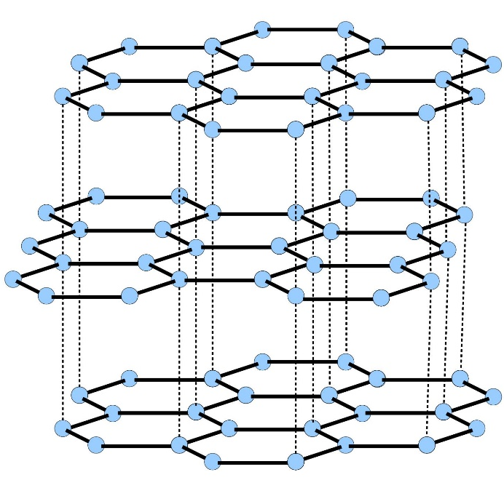
Overview:
We will learn the basics of circuits and explore how graphite can conduct electricity.
Essential Question:
What makes a working circuit, and how can we make one out of graphite lead that lights up an LED bulb?
Vocabulary:
Colloquial description of vocab. We’ll use an analogy to vehicles driving on a highway, to give a way to understand the relevant circuit concepts.
- Charge – an electron or proton, which are the components of atoms; the movement of these particles makes up electricity
- Circuit – a path, filled with things like wires and lightbulbs, for charges to move through
- Current – the amount of electricity flowing, and how fast the electricity is moving
  - Imagine standing by the side of a highway, and counting how many cars pass by you in one minute. The numbers of cars passing by is similar to the current, the number of charges moving
- Voltage – the “engine” pushing the charges through a circuit; different types of batteries have different voltages
  - Imagine the engine it takes to move a semi truck down the highway, compared to a small car’s engine, compared to a horse pulling a carriage. The power each of these produces to pull the cart is analogous to the voltage provided by a battery.
- Resistance – how hard it is to move the charges through the circuit
  - Think of running through mud or water, or running up a hill, compared to running on flat ground. If you try to run just as hard in water versus on land, you will move much slower! Similarly, charges in circuits with high resistance can’t move as easily.
Background:
What we call “pencil lead” is actually a substance called graphite, which consists of many stacked sheets of carbon atoms. (We will have a model of graphene layers.) When the graphite is many sheets thick, it conducts electricity just like a metal. However, when there is only one layer of graphite, its properties change dramatically! Most crystals have all the atoms bonded to each other, but graphite is a unique type of crystal where the atoms in different layers aren’t bonded together, they just sit next to each other. This allows the sheets of graphite to be separated quite easily. This is what makes it work so well as a pencil.
Very thin pieces of graphite are useful for building incredibly small devices. At UW, we use graphite as a conductor to study microscopic material properties.
In this lesson, we will be exploring circuits using graphite. The lightbulb in our circuit will get brighter as more current flows through the circuit, and will get dimmer as the resistance increases, and current decreases. Resistance can be measured with a multimeter, and the unit of resistance is the ohm.

Research Connection:
The discovery of graphene in 2004 has opened up an entirely new, exciting frontier of materials research. Scientists today study 2D materials, including graphene, exploring new quantum states of matter. Additionally, researchers can take these 2D materials and stack them onto each other, combining and possibly even changing their properties. The field of 2D materials offers many exciting possibilities for future technologies.

NGSS Standards:
Standard Number | Standard text
MS-PS1-1 | Develop models to describe the atomic composition of simple molecules and extended structures.

Materials:
- Light-emitting diode (LED)
- 9 volt batteries
- Alligator clip wires
- Graphite pencil
- Eraser
- Multimeter
- Resistors
- Ball and stick graphite models

Procedure:
NOTE: THE VOLUNTEER SHOULD ALWAYS BE THE ONE HANDLING THE BATTERY-CONNECTED CIRCUIT! IT IS VERY POSSIBLE TO SHORT THE CIRCUIT, WHICH CAN CREATE LOTS OF HEAT, POTENTIALLY EVEN SMOKE AND FIRE! IF THERE IS STRANGE ODOR, HEAT, ETC, IMMEDIATELY DISCONNECT THE BATTERY!
First, remind the students what they talked about last week about crystals. Tell them graphite is unique, and discuss how the graphite easily separates into layers, which is why they can work in pencils. Explain how they act conductive like a metal, while the paper does not, so we can draw our own circuits right on the paper. Show the slides with our uses for graphite.
Next, give an introduction to circuits, walking through the vocabulary above. Briefly walk through how we will make a light bulb light up.
Split the kids up into 4-5 groups, and have the volunteers lead discussion and interaction within these smaller groups.
- First, test the battery and explain how to properly connect the battery to the LED
  - Ask the kids if they have any idea how to properly connect the battery to the bulb. Explore touching the wires to the same lead on the battery, the same side on the LED, and different orientations of the LED.
  - Discuss with them the idea of a closed circuit, and how electricity flows.
  - Ask them if electricity can flow through any material, what type of material will work best, etc. Talk about conductors versus insulators.
  - The circuit should be set up as shown below. Attach the battery correctly to the leads, and the light should turn on.
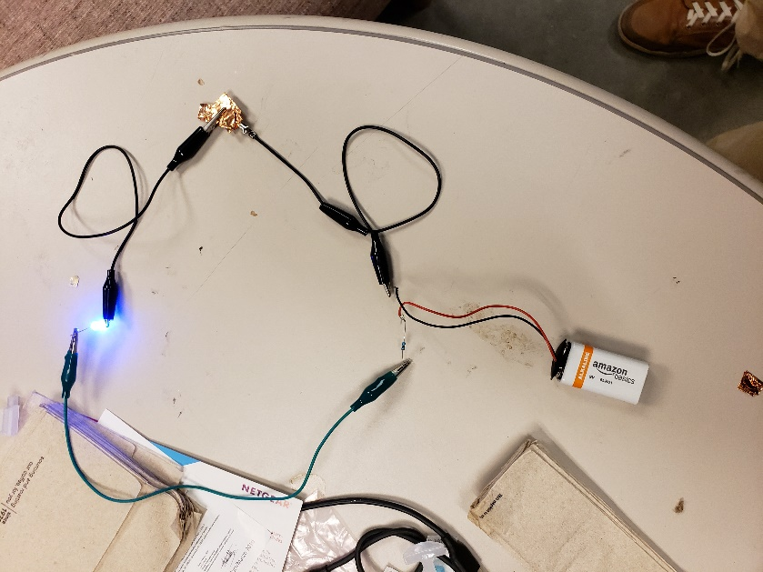
- Draw the first circuit!
  - Get out the first sheet of paper, and demonstrate how the circuits are to be drawn with the pencils.
  - Unclip the wires that have the copper attached with them. We will use these to attach to the graphite sheets.
  - Try attaching the wires just to the paper, not to the graphite. Ask them to predict what will happen.
  - Test the circuit with the clips and the battery, and show that the bulb lights up!
  - Try the circuit with one battery connected versus two, and observe the difference in brightness of the light bulbs.
  - Explain that this still creates a closed circuit, and electricity can flow through the combination of batteries.
  - Pass around the different sheets, and have the students draw the other patterns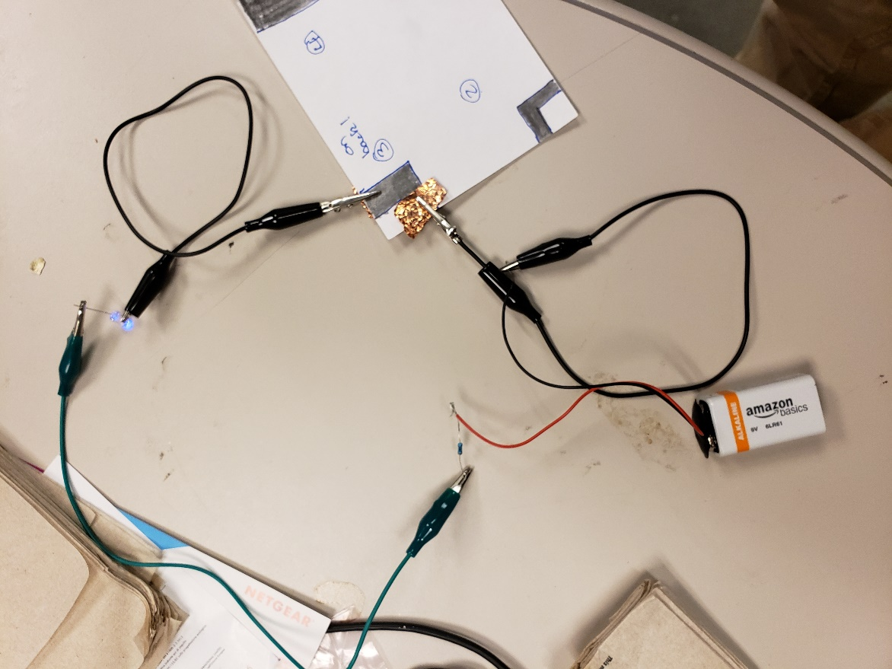
- Test different types of circuit drawings
  - Try a thinner pattern, thicker pattern, and one drawn on both sides of the paper
  - Test the resistance on each of the patterns! This may be a more useful test than just observing the brightness.
  - Try connecting two LEDs in series, and two in parallel. Predict what will happen. How does the brightness differ in each configuration, compared to your predictions?
- Free drawing
  - Let the students design and test their own circuits. Try and help them understand why their circuits are or are not working.

Discussion

How does the length of the graphite circuit affect the brightness of the LED? What about the size of the lines?
- Can we connect the bulb to just one side of the battery? Can we connect the battery to just one side of the bulb?
- Does the orientation of the LED affect whether it will light up in the circuit?
- What happens if we erase part of the circuit? Can electricity still flow?
- When we connect multiple LEDs in series, what happens to the brightness?
- When we connect multiple LEDs in parallel, what happens to the brightness?

References:
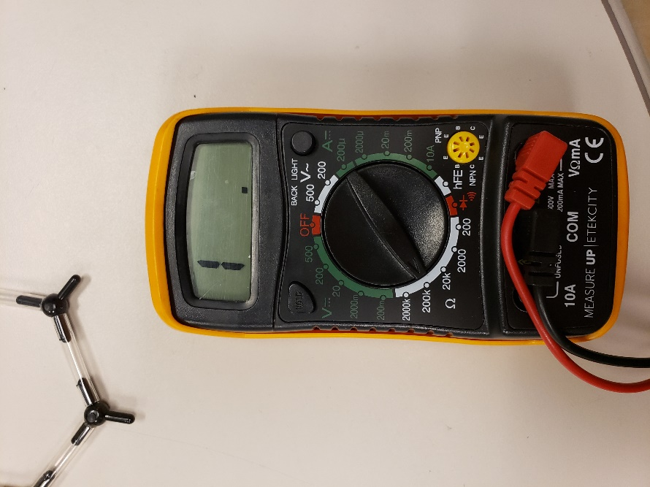
To use the ammeter, have it turned to the 200k knob, as known above. Disconnect the battery from the circuit, and touch the ammeter leads to the metal connecting to the graphite to measure the resistance.

Sources:
https://lpmmc.cnrs.fr/spip.php?article407&amp;lang=en

