Part 1 Instructor notes:
Left and right sides are the ‘patient’s’ left and right (as if someone is facing you and you are looking at their heart).

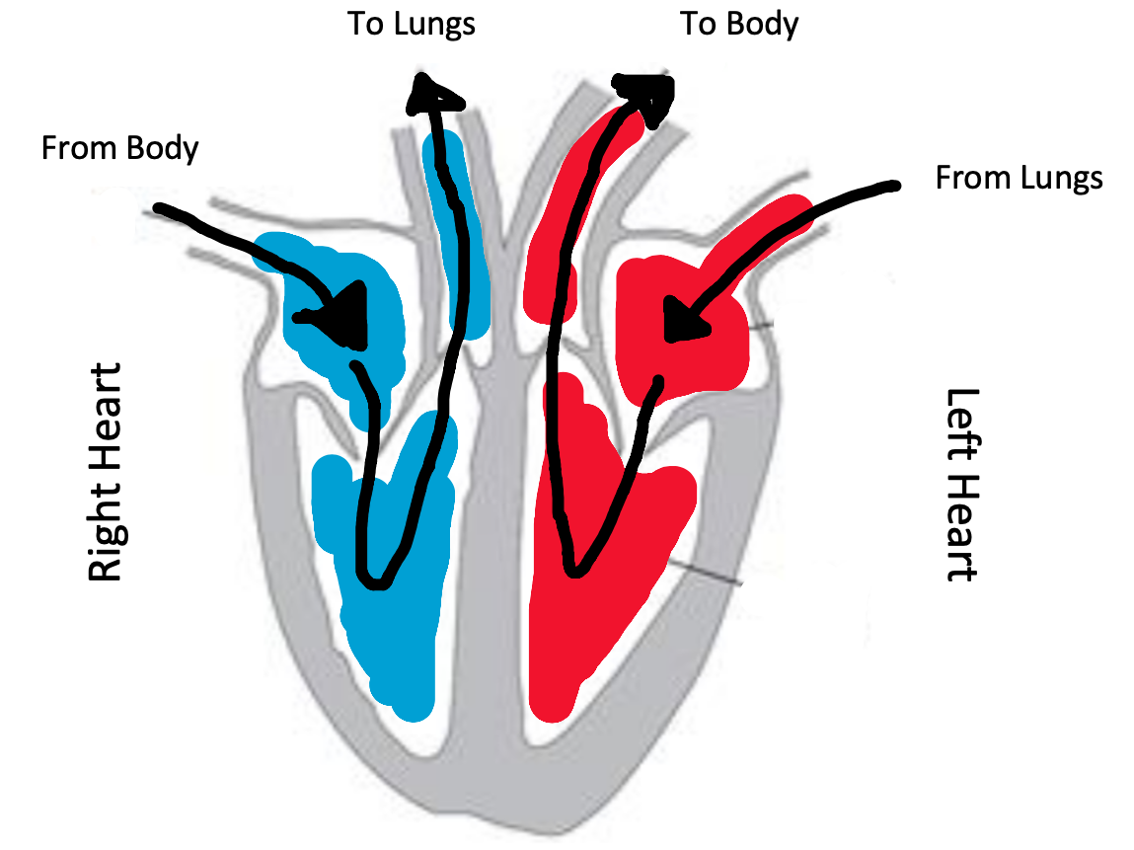

Additional Questions:
Why does our heart have two sides?
Answer: To keep oxygenated and deoxygenated blood separate.

What keeps blood flowing in the right direction? (why doesn’t blood flow backwards?)
Answer: The valves close and keep blood from flowing backwards through them.

Part 2: Heart Rate Instructor notes:
Possible ways to decrease heart rate:
Deep, slow breaths
Lying down.

Possible ways to increase the heart rate:
Jumping jacks
Pushups
Running in place

How many noises do you hear per heartbeat?
Answer: Two

Where do you think sound is coming from? (What part of the heart is making noise?)
Answer: The valves snapping closed
(More detail if they are interested: atrioventricular valves make the first noise. Pulmonary and aortic valves make the second noise)

Additional Questions:
Why does our heart rate change after exercise?
Answer: Our muscles need more oxygen so our heart has to pump faster to supply this oxygen

If activities don’t work, ask them why they think this happened?
Some possibilities are that 30 seconds wasn’t long enough to change their heart rate. They may have already been at rest so they couldn’t decrease their heart rate further
oxygen

Part 3: Model heart: Instructor notes. There is no worksheet for this part.

Go get a model heart and make sure it is set up properly so it won’t spill/squirt water.

Explain to the students that the three jars represent the body, atrium and ventricle (on one side of the heart). You will press on the balloon to pump water through.

Questions:
- What do you think the balloons on the ends of the straws represent?
Heart valves.
- Which direction do you think water will flow through the heart? Why?
It should flow into the free ends of the straws and out the ones that are covered in balloons. The balloons prevent water from flowing backwards.
- Have the students label the three jars with the provided labels.

To test the direction of fluid flow, place food coloring into the ‘Atrium’
To operate the model heart, press down on the balloon on the ventricle. Water should squirt into the ‘Body’. Release the balloon and water should be sucked in from the atrium

Question:
Why is it important for blood to flow in one direction through the heart?
Otherwise oxygenated blood might go back to the lungs and deoxygenated blood might go back to the body.

Tips and troubleshooting.
The instructor may want to hold the ventricle balloon in place so it doesn’t slide off the jar.

If air is flowing back from the body to the ventricle, try pinching the valve (leading to the body) closed as you release the ventricle. This should force water to flow in from the atrium.

Model heart construction:
We made the hearts ahead of time because they are a bit difficult to construct and we didn’t have time to make them during the lesson.
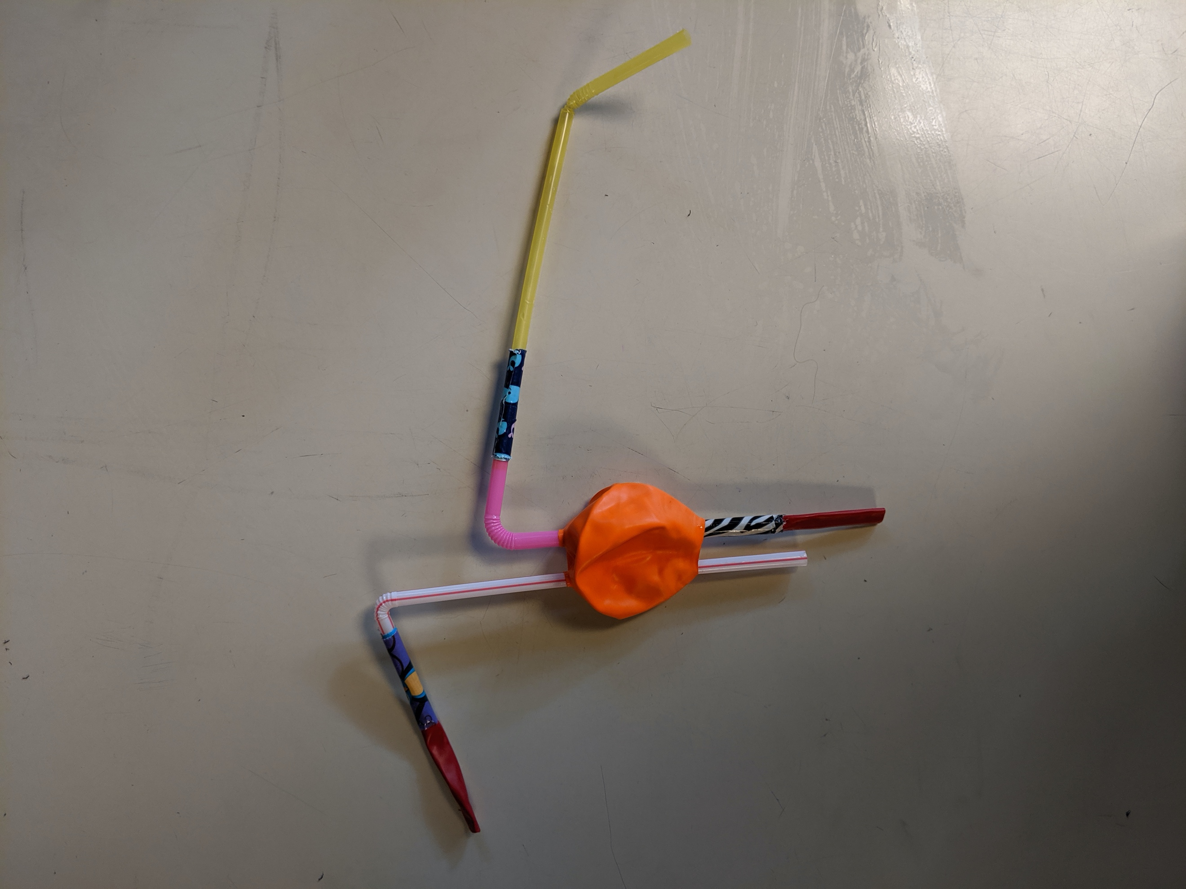
Set up of the straws and balloons
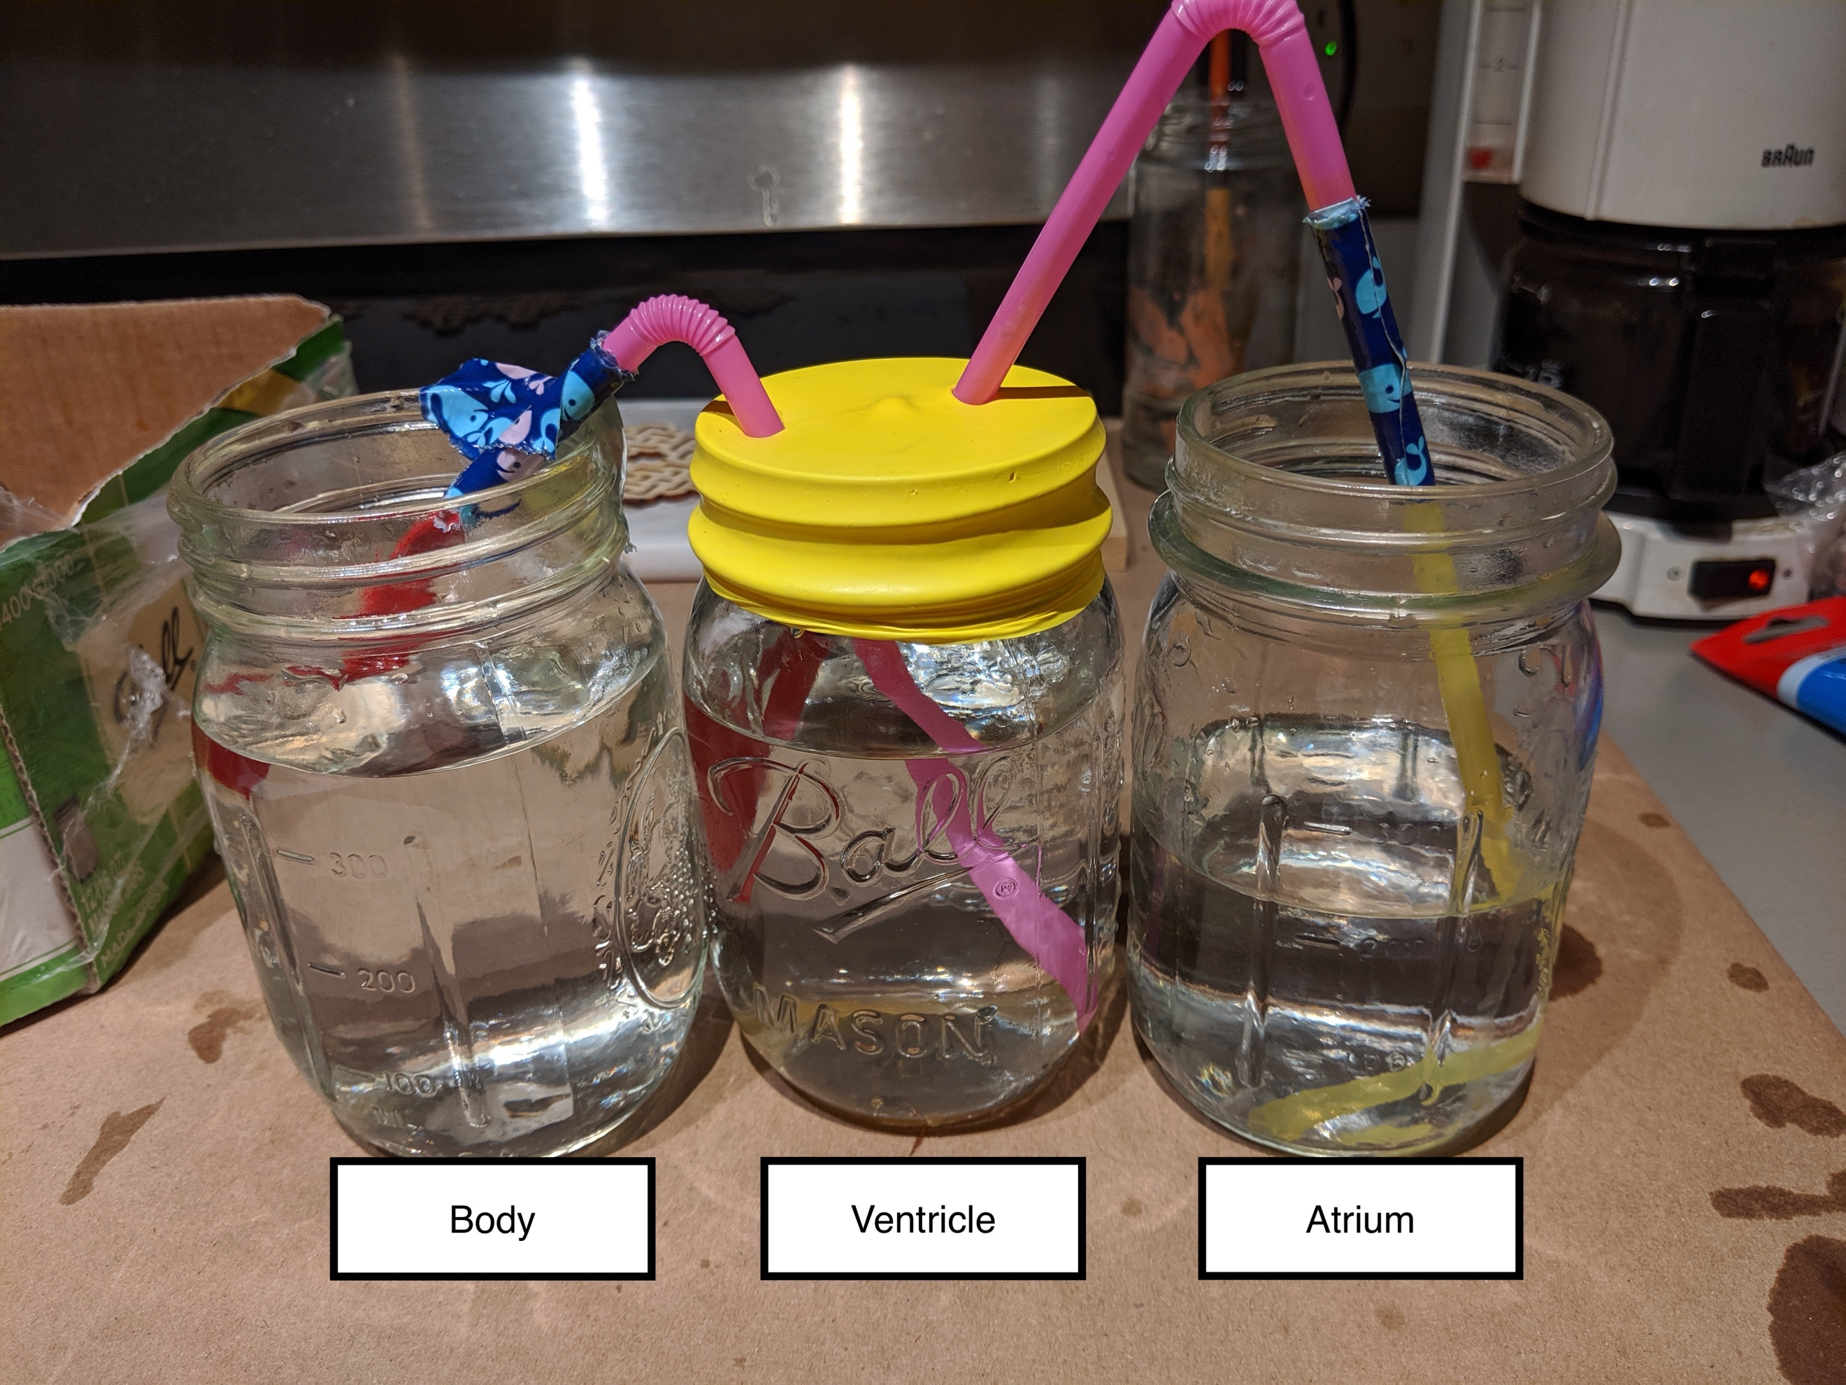

Materials:
3 Mason Jars
3 straws
1 thin balloon (the kind for balloon animals)
1 round balloon (the typical type of balloon)
Scissors
Tape
Labels for the three chambers
Food coloring

- Cut the neck off the round balloon leaving the round part
- Cut two tiny holes in the top of the balloon (roughly the size of a pinhead)
- Cut off a ~2 inch piece of the thin balloon. Put it over the end of one of the straws and secure with tape.
- Repeat this with a second straw.
- Insert one of the straws through the tiny hole in balloon
- Fill one jar (the ventricle) with water, stretch the round balloon over the top of the jar so that the end of the straw with the thin balloon is in the jar (pull the round balloon as tight as possible)
- Insert the second straw through the other small hole. The end with the thin balloon should be sticking out.
- Attach the balloon end of the second straw to the edge of a ‘Body’ jar (so that any water that comes out of this straw will be caught)
- Attach a third straw to the free end of the first straw. Seal with tape.
- Place the loose end of the third straw into the ‘Atrium’ jar. Fill this jar with water. Add food coloring to the ‘Atrium’ to help illustrate the direction of fluid flow.

This model heart is based off two different model heart ideas that I found online:
https://www.youtube.com/watch?v=pPjS52Ee9Jc
https://www.steampoweredfamily.com/activities/heart-model-heart-stem/

Labels for the jars:

Atrium | Atrium | Atrium | Atrium
Ventricle | Ventricle | Ventricle | Ventricle
Body | Body | Body | Body

