The Heart

Part 1. The circulatory system
Watch a video about the circulatory system:
https://www.youtube.com/watch?v=CWFyxn0qDEU
Fill in the heart diagram:
- Draw an arrow to show where blood enters the heart from the body. Label this ‘from body’.
- Draw the path that blood takes through the heart.
- Draw an arrow showing where blood exits the heart on the way to the lungs. Label this ‘to lungs’.
- Draw an arrow showing where blood enters the heart after returning from the lungs. label this ‘from lungs’.
- Draw the path that blood takes through the heart.
- Draw an arrow showing where the blood exits the heart on its way to the body. Label this ‘to body’.
- Color in the oxygenated blood (blood that is full of oxygen from the lungs) in red.
- Color in areas that have deoxygenated blood (blood after your body has used up the oxygen) in blue.

Diagram adapted from: https://www.almondburycs.org.uk/attachments/download.asp?file=613&type=pdf
Part 2. Heart Rate

- Find your pulse. Place two fingers on your neck to the side of your trachea.
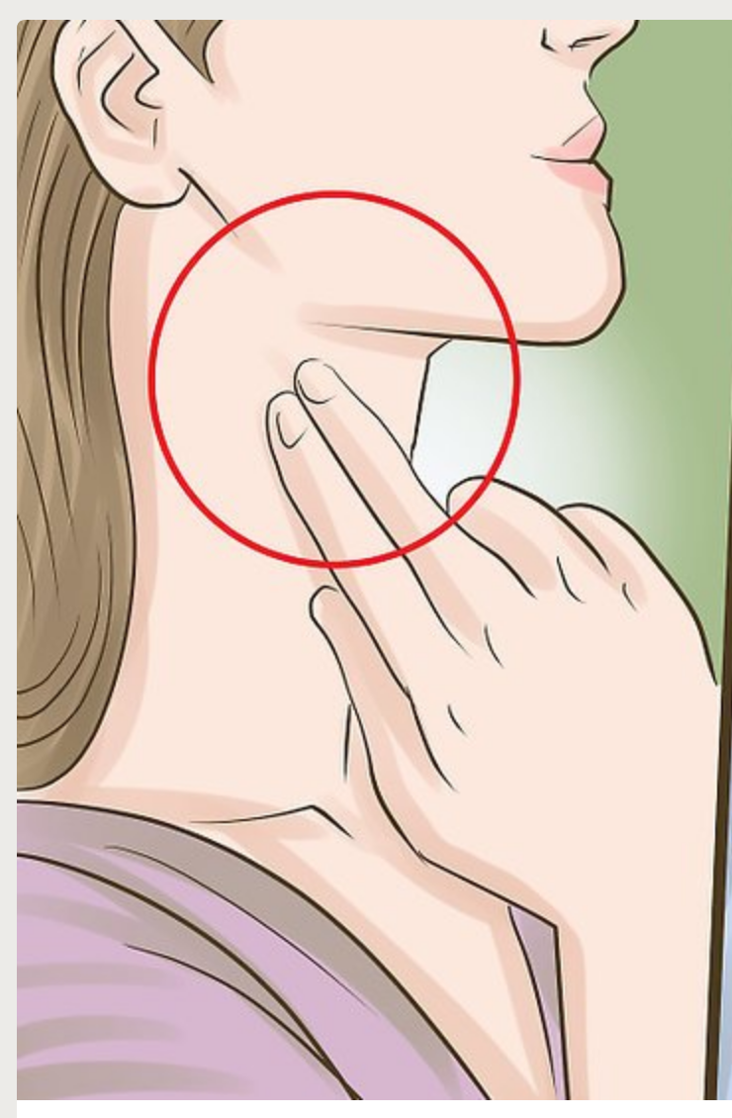
Image from https://www.wikihow.com/Check-Your-Pulse

- Count how many times your heart beats in 15 seconds. Then multiply by 4 to find your heart rate (beats per minute). Record your answer in the ‘baseline’ row of the table below.

- What is one way you could decrease your heart rate? What is one way you could increase your heart rate?

- Do an activity that decreases your heart rate for 30 seconds. Then count how many times your heart beats in the next 15 seconds. Multiply by 4 and record your heart rate.

- Do an activity that increases your heart rate for 30 seconds. Then count how many times your heart beats during the next 15 seconds. Multiply by 4 and record your heart rate.

Activity | Beats in 15 seconds | Heart rate (beats per minute)
Baseline

- Use the stethoscope to listen to your heart. Place the ear pieces in your ears and put the bell on the left side of your chest. (Clean the earpieces and bell between students)

- How many noises do you hear for each heartbeat?

- What part of your heart do you think is making the noise?

