What makes up a robot?

Robots are made of four basic parts:

THE POWER SOURCE: A robot needs a supply of electricity to run. This is usually a battery.

THE CONTROL SYSTEM: A robot uses a computer to decide what to do. A human must program the computer to make the robot do what the human wants. A human must program a robot’s computer with very specific instructions.

THE INPUTS: Robotic inputs are called sensors. Sensors detect information about the area around the robot and sends that information back to the computer, so it can better decide what to do. Robots can have more than one sensor and there are many different kinds of sensors.

THE OUTPUTS: After the computer decides what to do, it will activate its outputs. Outputs may include running a motor to turn wheels, closing a claw, or making a noise.

Looking at the two robots below, identify at least one example of a control system, power source, input and output. What part of a human serves as a control system, power source, input and output?

.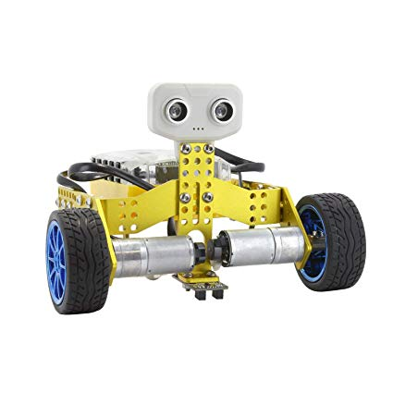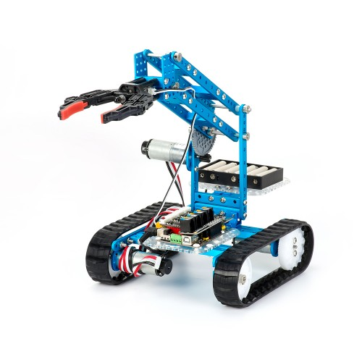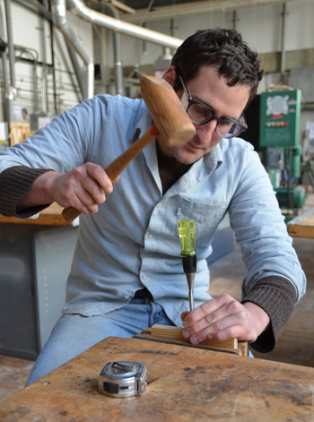

Humans vs Robots
Robots are better at some jobs than humans. For example, robots are better at repetitive tasks because they don’t get bored or tired. They are also better at working in places humans don’t want to go or can’t go at all. However, humans are better than robots at other jobs, like creative decision making.

Figure out which jobs are better for humans are better at and which robots are better at

Task | Should a human or robot do this? Why?
Making millions of cookies.
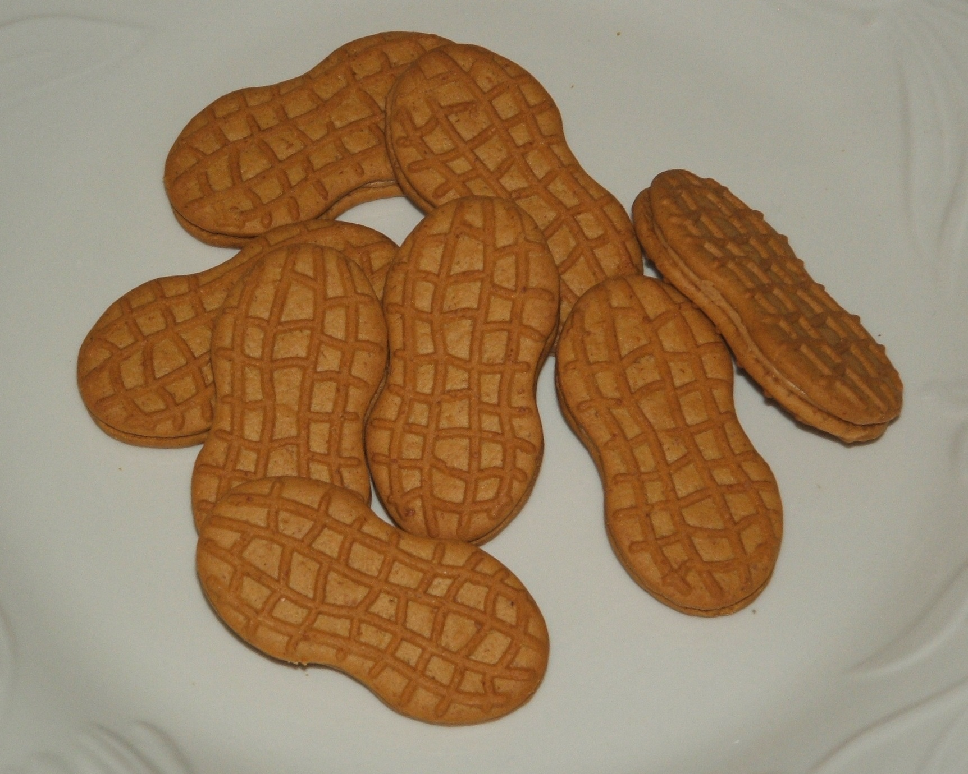
Making a good hamburger.
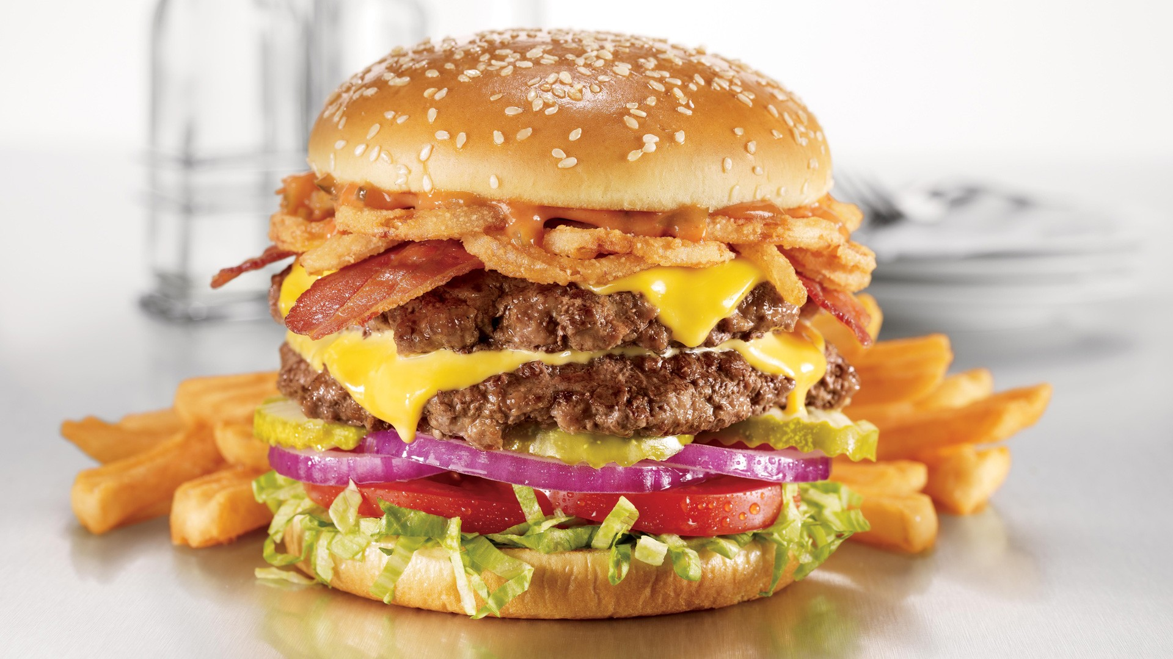
Picking berries
Harvesting wheat
Painting a scene on canvas
Painting a car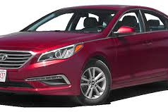
Driving a car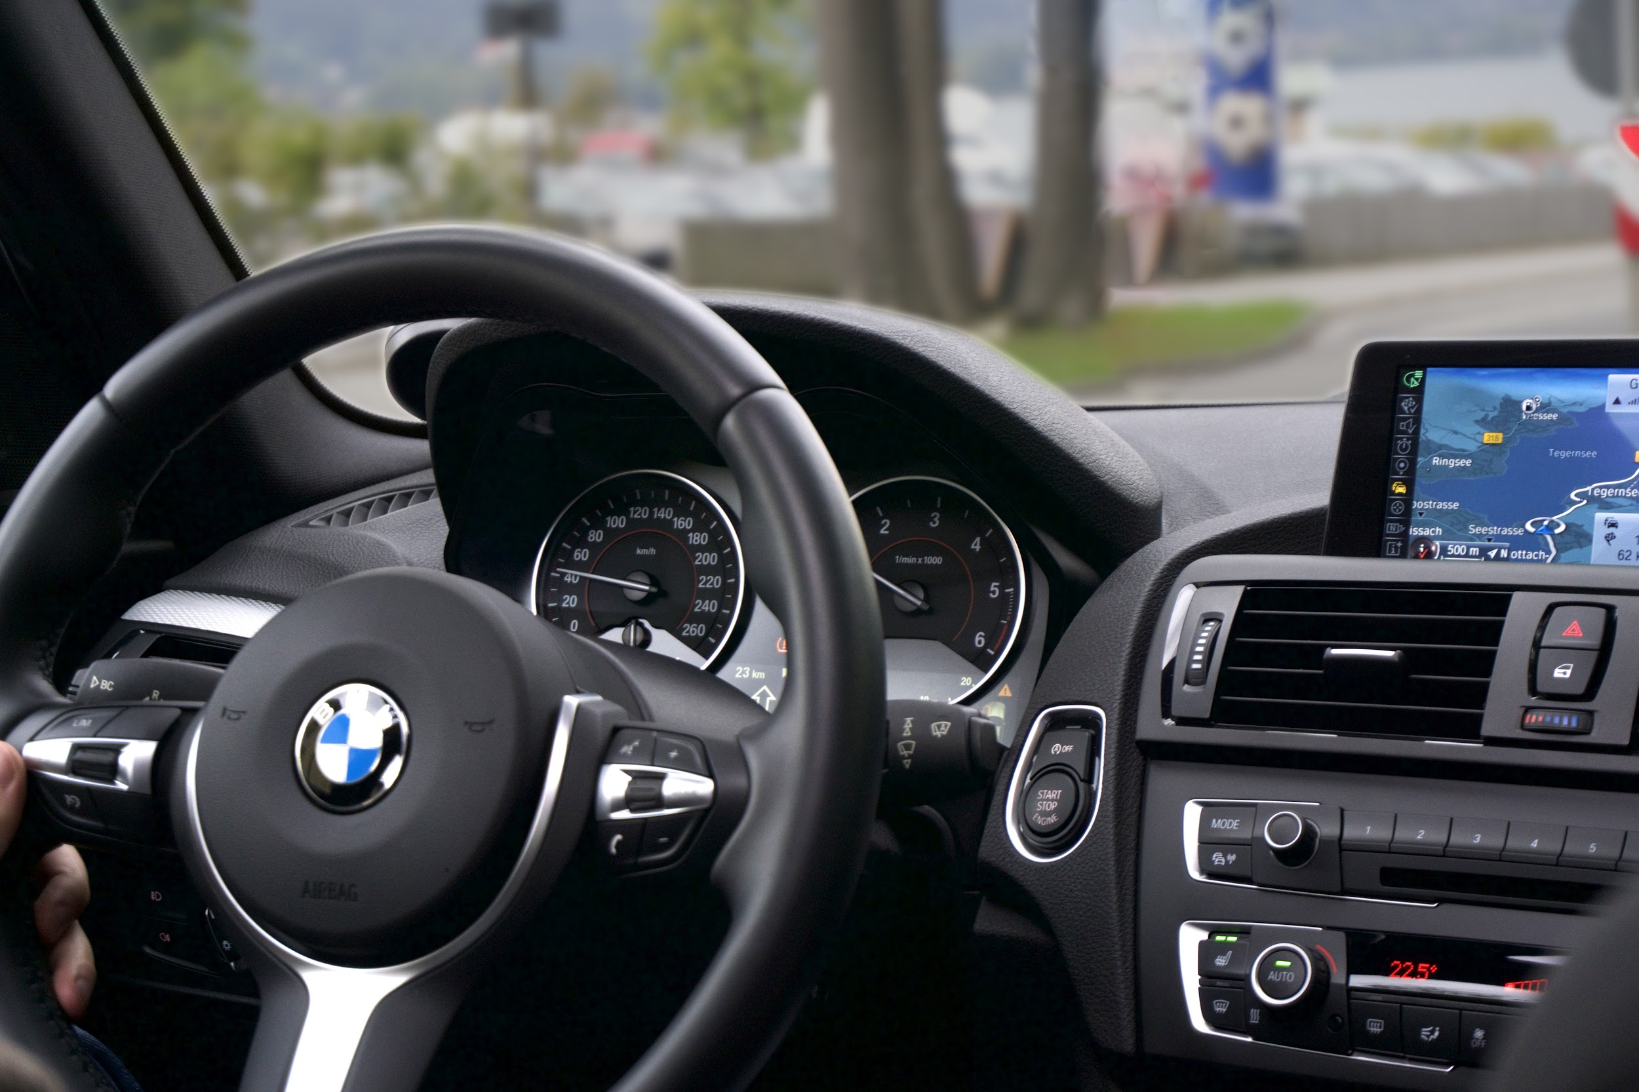
Exploring a volcano

Composing music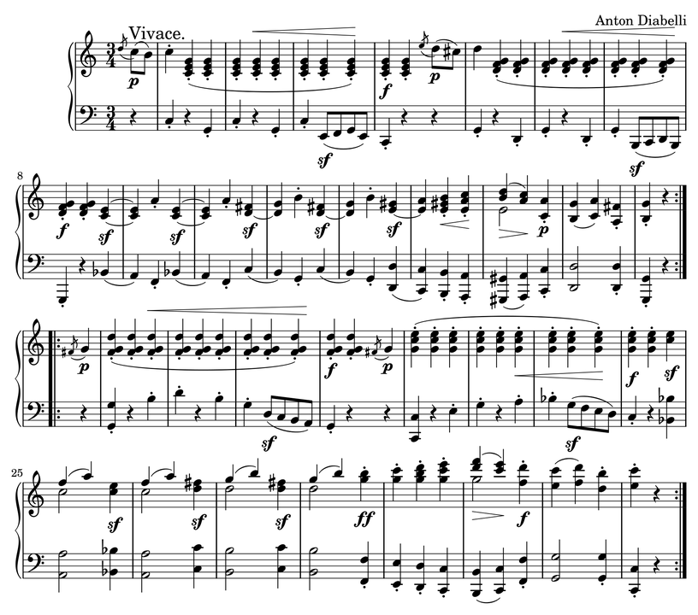

Would a robot or a human be better at filling out this worksheet?

Name two things you think a human would be better at.

Name two things you think a robot would be better at.

