 | LUNG WORKSHEET | Name:_______________________

- Label the following in picture below. What is the path the air takes?

Left lung
Right lung
Trachea
Diaphram
Nose
Throat

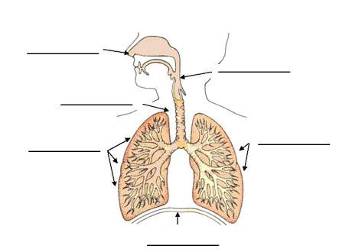

- Why do we need air? What important element do we use from air?

- Where does this important element go after it leaves the lungs?

Lung capacity activity

1) Fill in the chart below of your lung capacity measurements.

Trial | Capacity (in milliliters)
1
2
3

2) Plot your data on the bar graph below. You can a bar or a line graph.

3) What is your average lung capacity? Once you have calculated it, put it on the board for the competition.

