Magnetic Energy

Preface
Magnetism can be a difficult and abstract subject. High school students and college freshmen sometimes don’t get it (confusion over magnets are even the subject of some pretty notorious rap lyrics). So let’s separate students based on age group and see how far we can get through these activities.

Also, I’ve decided not to talk about electromagnets because their explanation is arguably very distinct from how ferromagnets work (I would argue ferromagnets are a result of quantum mechanics and electromagnets are a result of special relativity).

Materials:
Iron nails.
A menagerie of magnetic and non-magnetic objects for testing magnetism.
Iron filings
Ring magnets
Bar magnets
A shaft to hold ring magnets (maybe a pencil or skewer).

Concepts to get across:
What are magnets?

assignmentpoints.com

The north and south pole of a magnet.
What types of materials make up a magnet?
What are magnetic fields? What do they look like?
Earth’s magnetic field.
How do compasses work?

Intro video:
https://www.youtube.com/watch?v=yXCeuSiTOug

Activity 1: Discussion
Break into groups.
What are magnets?
Rocks/metals that create an invisible field (the magnetic field) that pushes and pulls other magnetic objects.
Have a north and south pole.
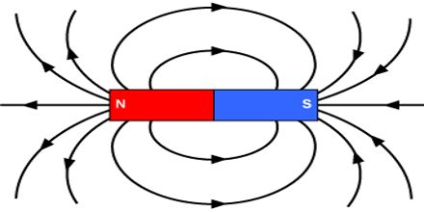

Activity 2: What is magnetic?
What are magnets made out of?
Iron, nickel, or cobalt. (It’s probably just ok to say iron).

For the tutor: Electrons have magnetic moments. Some atoms have unpaired electrons. Iron, nickel, and cobalt have a crystal structure where domains of unpaired electrons can line up, but these domains are randomly oriented. Under an external magnetic field, these domains will line up. This is what magnetises the metals.
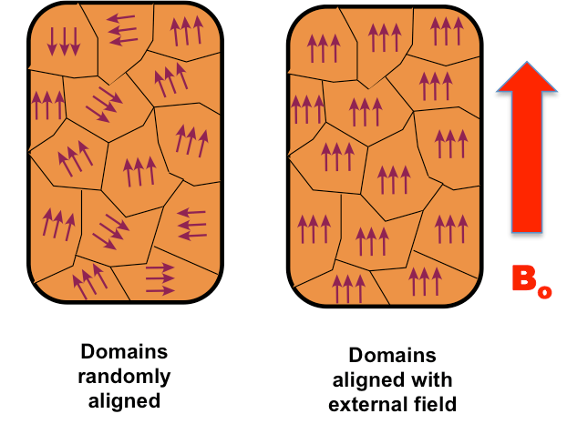

Also, see if this video helps: https://www.youtube.com/watch?v=hFAOXdXZ5TM

Have an array of random objects. Have students guess which ones are magnetic? Then verify.
Examples: Rubber, paper clip, nail, another magnet, aluminum spoon, nickel, penny.

Why is the nail magnetic, but the spoon isn’t? Because iron is magnetic, but aluminum isn’t.

For tutor: Another thing one might try to get across is that electricity and magnetism are different things. Try adding charge onto a rubber balloon via triboelectric effect and see that it’s still not magnetic. This might be a distraction though.

Activity 3:
North and south poles.
Opposites attract, and like repels. Demonstrate with the ring magnets on the stand.
Also, the stronger the magnetic field, the stronger the attraction or repulsion. Demonstrate by putting multiple magnets together.

You can also try stacking an array of repelling magnets.

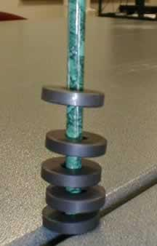
physics.stackexchange.com

For the tutor: The magnet is picked up or repelled at the point where the magnetic force is able to overcome the gravitational force.

Activity 4:
What do magnetic fields look like?
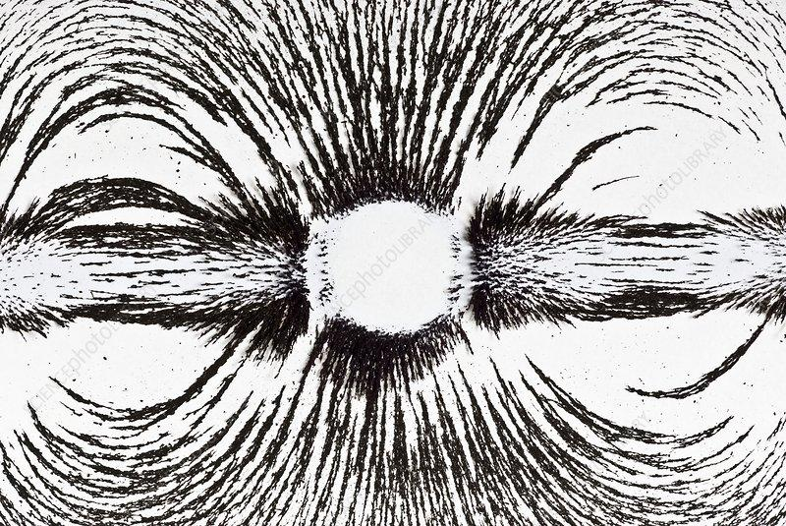
sciencephoto.com

Put a magnet underneath the paper. Sprinkle a small amount of iron fillings on top.
Have students recognize the magnetic field pattern.

This is a pretty neat video: https://www.youtube.com/watch?v=snNG481SYJw

Activity 5:
Earth has a magnetic field.
A compass is just a magnetized needle that’s allowed to rotate.
Let’s make our own compass.
Magnetize a nail by rubbing it in 1 direction 30 times.
Have a big water bath. Put a nail on top of a floating object.
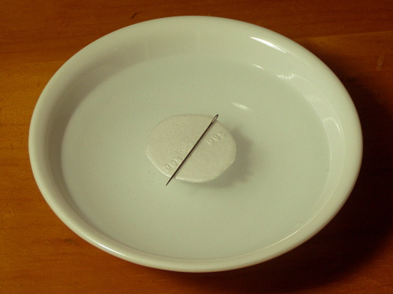
survivaltek.com

