The Mysteries of Milk

- What are the differences when you touch the food coloring with a soapy toothpick in the different types of milk and the water? Draw pictures of each reaction.

_____________________________________________________________________________

_____________________________________________________________________________

_____________________________________________________________________________

_____________________________________________________________________________

Whole Milk | Skim Milk | Water

2) What is different about using a q-tip as opposed to a toothpick?

_____________________________________________________________________________

_____________________________________________________________________________

_____________________________________________________________________________

_____________________________________________________________________________

3) What happens when you use pepper instead of food coloring?

_____________________________________________________________________________

_____________________________________________________________________________

_____________________________________________________________________________
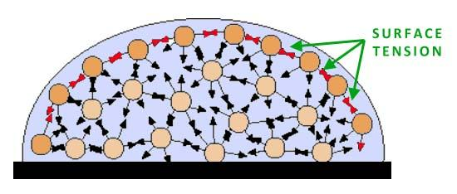

4) How many drops of plain water do you think you’ll get on the penny? _______

5) How many plain water drops did you get on the penny? _______

6) How many drops of soapy water do you think you’ll get on the penny? Why do you think
you’ll get more/less than plain water? _______

_____________________________________________________________________________

_____________________________________________________________________________

6) How many drops of soapy water did you actually get on the penny? _______

