Exploring magnetism
Objective:
Students will learn about magnetic materials and basic concept about magnetism, like north/south pole and magnetic field. They will also explore electromagnetic effect.

Introduction:
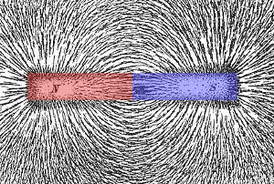
Magnetic materials play an important role in modern daily life, it can be as simply as a refrigerator magnet and can be as complex as the magnetism-based memoirist in computers. Knowing magnetism is essential in understanding the science in our life.
Permanent magnets, such as a refrigerator magnet, bar magnet and horseshoe magnet, are ferromagnetic material. Permanent magnets always have two sides with different polarity, we usually call them ’South Pole’ and ‘North Pole’. Poles with different polarity will attract each other, poles with same polarity will push each other away. The force between the two poles of magnet is usually described with an abstract physics concept - magnetic field. In this lesson, we will use magnetic powders to visualize this abstract concept.
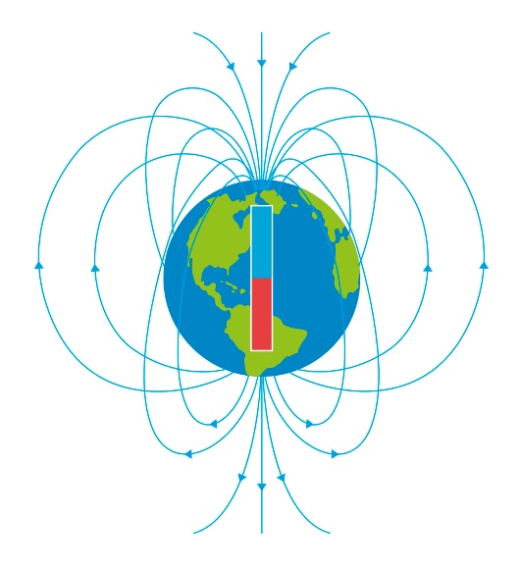
Earth itself is a huge magnet with magnetic south pole locate near geographical north pole, and magnetic north pole locate near geographical south pole. Compass, which is a small permanent magnet, is used in navigation to determine north and south. It is a very good tool to probe weak magnetic field. In this lesson, we will use compass to see the magnetic field around a bar magnet.
Electricity is closely related to magnetism. Electromagnets are very important in modern industries. The strength of an electromagnets can be controlled by electric current that flow through it. In this lesson, we will make electromagnets by winding coils on a small screws and then pass current.

Materials:
Learn about Permanent magnets
- Bar magnets
- Small boxes with magnetic powder
- Compass
Learn about electromagnets
- Batteries
- Copper Coils
- Screws
- Paper clips

Activities
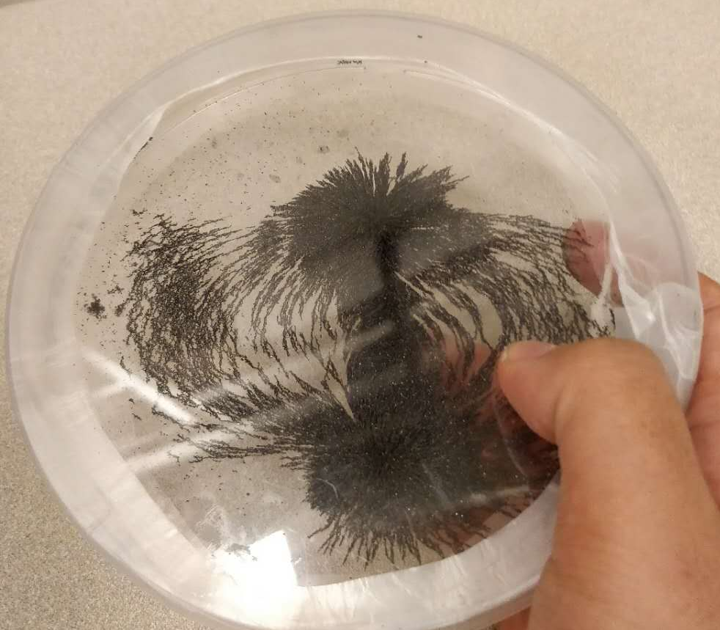
Learn about permanent magnets
- Introduce a bar magnet, ask students to explore how two bar magnet interact with each other, when put same poles together and when put different poles together.
- Ask students to explore how bar magnet interact with other materials, like wood, metal. Introduce the concept that some materials can be easily magnetized.
- Ask students to put bar magnet under magnetic powder, to visualize the magnetic field.
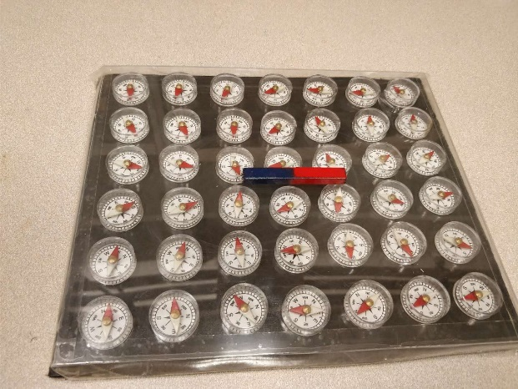
- Ask students to identify north and south with compass, then put bar magnet around to see the change. Explain the compass’s direction always points to the magnetic south pole.
Learn about electromagnets
- Help students build a electromagnet. First winding copper coil around the screw, then pass current use a battery, try to pick up paper clip with the magnetized screw.
- Ask students to explore what happens if you wind more coil onto the screw, explain the relation between the current density and magnetic strength
- Ask students to explore the poles of electromagnet with compass, explore what happens if reverse the current direction

