UW Science Explorers pre-lesson questions: Lungs

- Color in the lungs with one color and the diaphragm with another.
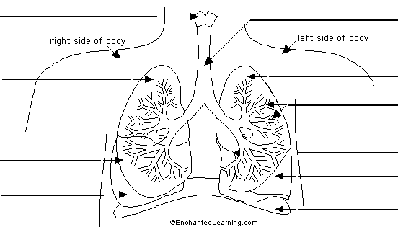

- What does the diaphragm do?

UW Science Explorers post-lesson questions: Lungs

- Label the lungs and the diaphragm in the picture below.
What else can you identify?
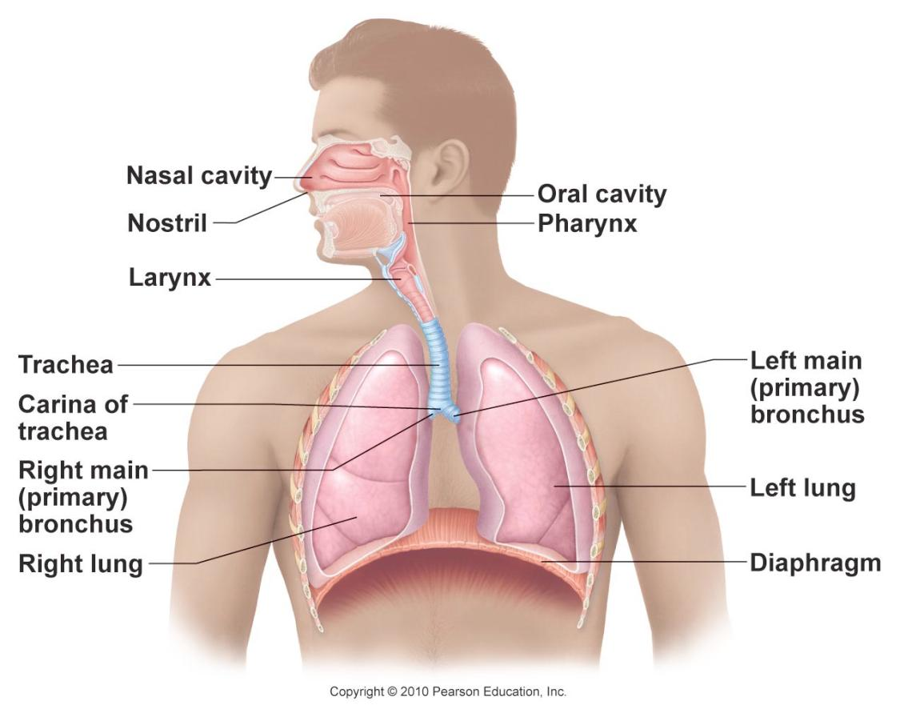

- What does the diaphragm do?

- Why is our left lung smaller than our right lung? (Think about other major organs!)

