Science Explorers Spring 2019
Week 2 - Crystal Structure

Objectives:
Students will learn what the distinguishing characteristics of the crystalline state of matter are by constructing models of typical crystal structures. They will also visualize self-assembly and crystal defects through the bubble raft demo.
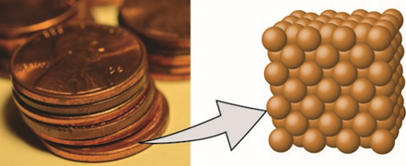
Introduction
Many types of solid materials are what are known as crystals, which are made up of a regular, repeating pattern of atoms or molecules when viewed on the smallest scales. Crystallography is the scientific study of crystals and their formation. Some common examples of crystals that we come into contact with in daily life are table salt, snowflakes, pencil lead (graphite), and metals, such as the zinc that pennies are made of or the gold and silver that is in jewelry. Gemstones like rubies, emeralds, and sapphires are also crystals. These examples demonstrate that crystals can come in many different forms and can exhibit a wide range of physical properties.
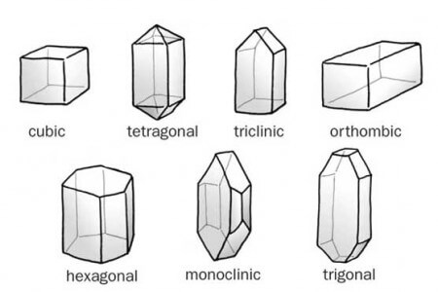
The regular repeating structure is the most important property of a crystal. The unit cell is the basic building block of a crystal. It is the smallest arrangement of atoms that shows the crystal structure. It turns out that only certain types of unit cells are possible. These differ from one another in important ways. The faces of these 3D objects are different shapes, the edges can be different lengths or the same length, and the angles between the edges can take on different values. The concept of symmetry is extremely important in understanding and classifying crystals. For instance, the cubic unit cell is very symmetric; it looks the same when viewed from many different angles. The triclinic unit cell, however, is not so symmetric. In this lesson the students will be able to work together to generate a crystal lattice by each constructing a certain 3D unit cell and linking them together.
Materials
Pre-made paper models and goniometers/rulers
- Cardstock
- Fasteners
- Protractors
- Scissors
- Tape
- Crystal system paper model

Building Crystal Models (per group)
- One of each of crystal system paper models, already assembled
- Cardstock Rulers
- Cardstock Goniometers
- Pencils or Pens
  - Boxes of DOTS candy
  - Toothpicks of various lengths
  - Worksheet
Bubble Raft Demo
- Aquarium pump
- Blunt syringe tips
- Valves
- Clear tray
- Dish soap
- Glycerin or corn syrup
- Plastic spatulas
Activity 1 – Building a crystal structure
- Students should first be split into small groups (4 or 5 students per group). Have an introductory discussion. Ask the students if they know what crystals are, what are some crystals that we come into contact with often (salt, sugar, metals, minerals), etc. Crystals form because it is the lowest energy configuration for the atoms when they are packed together. The goal is to lead them to the definition of a crystal, which is a solid which is made up of a regular, repeating pattern of atoms. You can emphasize that not all solids are crystals; for instance, glass is not a crystal. If you looked at glass on the atomic scale, you would see a random, chaotic arrangement of atoms or molecules. It is not easy to see the regular arrangement of atoms in a crystal when you look at a material because the scale is so small (you can try and convey how small an Angstrom is). Describe that scientists often use artificial models to mimic the behavior of a real system. What we want to do in this activity is make one such model of a crystal structure that we can see with our eyes without powerful microscopes and hold in our hands
- Describe to the students that many crystals form using the same basic building blocks which come in different shapes and sizes. Many of the properties of the crystal are determined by which building block makes the crystal. Have the students observe the paper models for the different crystal systems. Ask them how they differ from one another. They can use the worksheet along with the goniometers and rulers to identify some of the important features distinguishing the different unit cells. Examples are the number of faces, the shapes of the faces, the lengths of the edges, whether all of the edges are the same length, and the angles that the edges make. They can use rulers to measure the lengths of edges and use a goniometer to measure the angles (See instructions below for making a goniometer).

- Making a goniometer (these should be premade for the kids)
A goniometer is a tool for measuring angles. Scientists who study macroscopic crystals like gemstones and minerals use these to identify different materials.
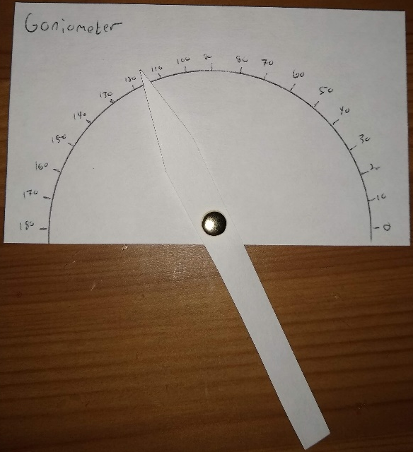
- Firmly hold a protractor on a piece of card and trace carefully around the protractor onto the card
- With the protractor still in place, mark off 10 degree divisions around the edge. Remove the protractor then mark the angles at the divisions
- Cut a thin strip from a different card that is roughly the same length as the base of the semicircle. Cut one end square and cut the other end into a point
- Mark the correct position for the hole on the protractor card. It needs to be in the center of the straight edge
- Make a hole in the pointer so the point will be inside the edge of the semicircle once attached. Fix them together. Flatten out the fastener on the back
- The goniometer is finished! Rest the straight edge on one face of an object. Move the side of your pointer onto the next face with the point towards the angle number. Read off the angle

- Have the students decide together which building block they want to use to form a crystal lattice (warning: monoclinic and triclinic are fairly challenging)
- Once they have decided, each student should then use the DOTS candy and toothpicks to replicate the paper building block. To do those, the students must measure the angles that the edges of the building block make with each other and depending on which crystal system they chose, they may need toothpicks of different lengths.
- Once each student has finished making their individual building blocks, describe that the full crystal lattice is made by assembling the building blocks together. Have the students think about how they can do that. It may require adding more toothpicks or removing some toothpicks.
- Once the students have been able to correctly combine their building blocks into a lattice, they can grow the lattice by adding more DOTS and more toothpicks in the correct spots/constructing more unit cells and attaching them appropiately. This is actually quite similar to how real crystals grow; a small seed crystal nucleates, and then atoms or molecules attach one by one. They can continue until they have used all of their DOTS; the lattices can become quite large and impressive. Here is an example of the tetrahdron building block and lattice:
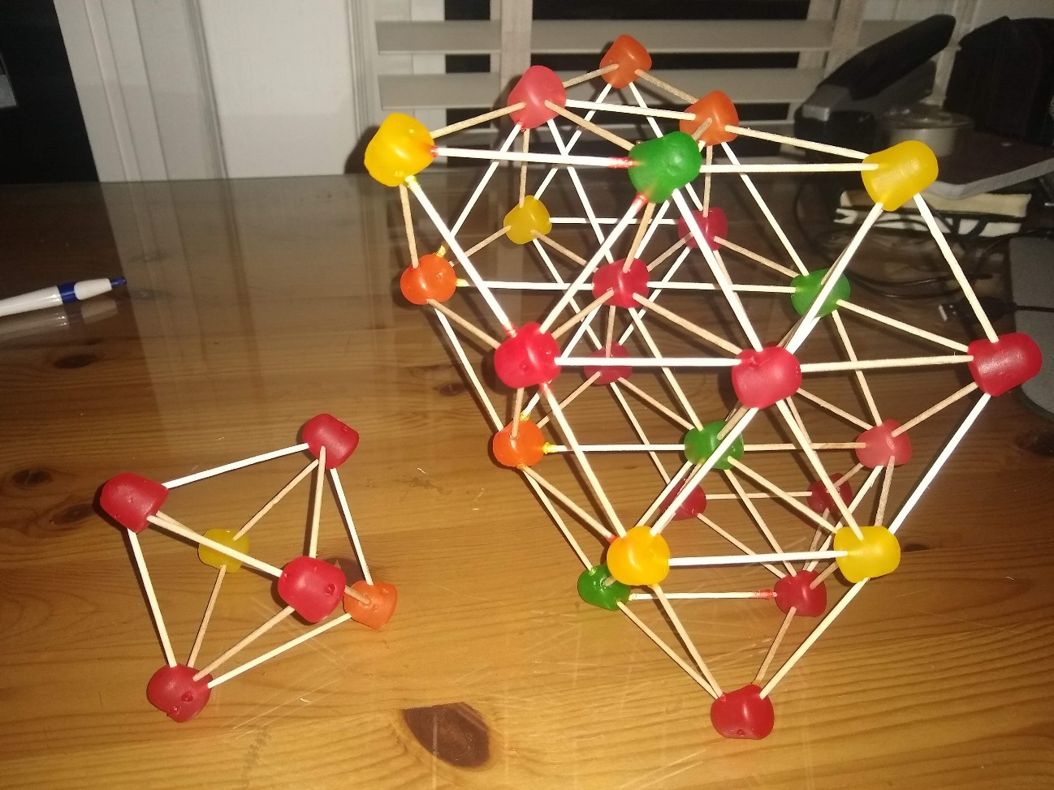
- Finally, once all of the groups have finished, the kids can go to other groups and see if they can identify which unit cell that group chose by looking at the full crystal lattice. They might need to use their rulers and goniometers to decide.

Activity 2 – Bubble Raft (this activity might not work well for a lot of students at once; the best way might be to have one person run this the whole time and have the small groups come over one at a time while the previous activity is going on.)
- Bubbles will self-assemble in a way very similar to the way that atoms do when they form a crystal. Studying the way that the bubbles behave when forming a lattice demonstrates many of the features of actual crystal growth.
- Connect a blunt syringe to a hose to the aquarium pump and fix it to the side of plastic tray so that it sits near the bottom.
- Mix up a bubble solution with 2 cups hot water, ¼ cup dish soap and 2 tablespoons of glycerin.
- Fill the tray with soap solution to ½ inch from the top.
- Turn on the pump and regulate the pressure until you have steady stream of uniform small bubbles. The lower the pressure, the slower the production of bubbles, but the better quality of the resulting structure.
- The bubbles will naturally self-assemble into a regular lattice. Using the plastic spatulas students can manipulate these “bubble crystals”.
- Using the syringes, students can introduce large bubbles into the lattice which act as “defects”.
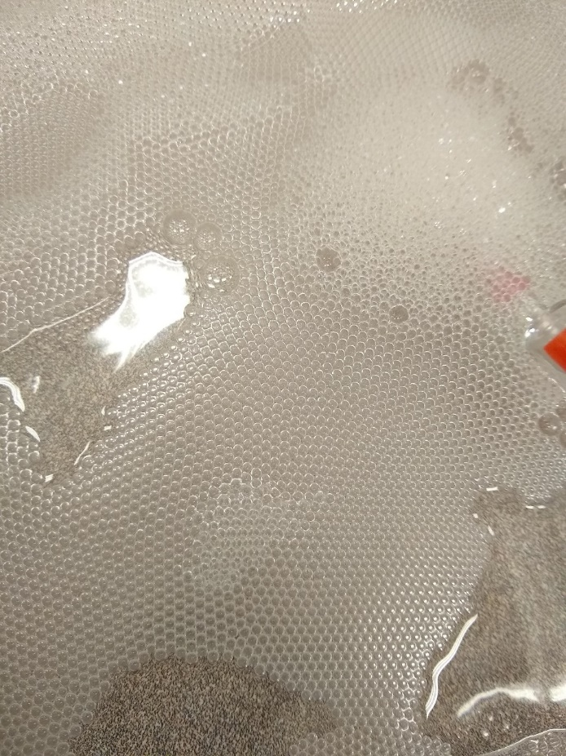
Things to discuss/ask the students
- What happens when the pressure is too high or there are bubbles of different sizes?
- What is keeping the bubbles together?
- What happens if we introduce a single large bubble “defect”?
- Can you see or make grain/domain boundaries where two different lattices of different orientations join?

