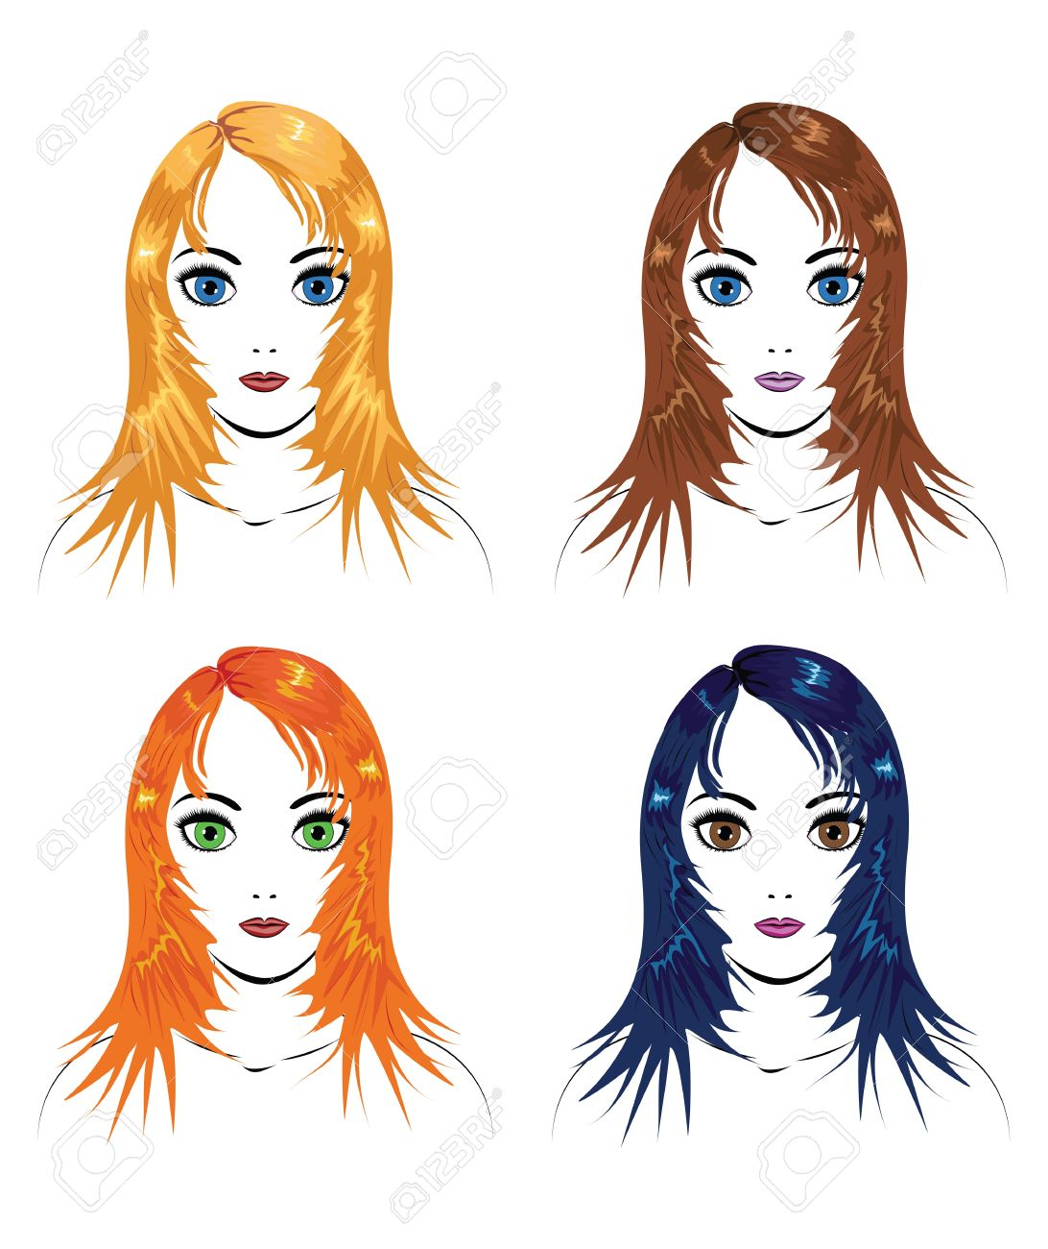
1.Hair Color

Blonde Brown
Bead #1 Bead #2

Red Black
Bead #1 Bead #2

2.Handedness
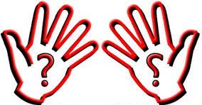

Left Right
Bead #1 Bead #2
3.Hairline

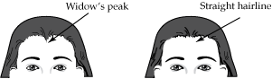
Bead #1 Bead #2

4.Tongue Rolling
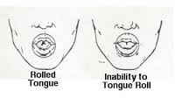
Bead #1 Bead #2

5.Eye Color

Brown Gray
Bead #1 Bead #2
Green Blue

Bead #3 Bead #4

6.Dimples
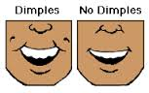
Bead #1 Bead #2
7.Ear Lobes
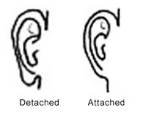
Bead #1 Bead #2
8.Hair Texture
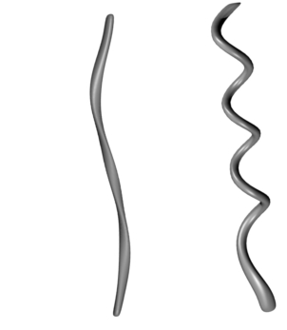
Straight Curly
Bead #1 Bead #2

