Name: ____________________________ Team’s Boat Name: ______________________
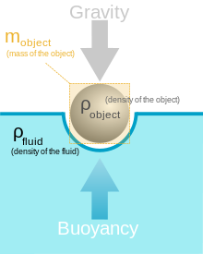
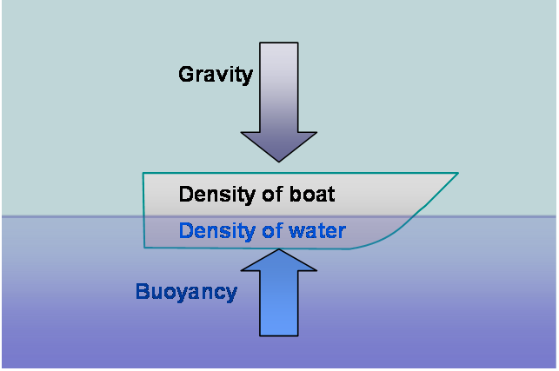
Density of water = 1 gram per milliliter = 1 g/mL
$$mass÷volume = density$$
Design Matrix:
Order these from most important to least important (top to bottom).
Cost/Resources, Buoyancy, Time in Water, Appearance, and Complexity/Time to produce

Categories: | Scores (1-5): | Drawing:

Testing Your Design: Record Your Results
# of Pennies | Max Weight Held  =  2.5g * Column 1 | Resources | Point of Failure | Time of Failure | What to fix

