Objectives:
- Understand that vascular plants utilize the physical process of capillary action to passively move water from their roots upward
- Understand that capillary action has a noticeable effect only for small tubes
- Bonus: Understand that a model system of capillary tubes can be used to understand a general feature of vascular plant biology
Materials:
- Microscope (X10 magnification)
- Microscope slides
- Celery
- Knife or razor for preparing cross section
- Water
- Cups that can hold celery stalks upright
- Food coloring (multiple colors)
- Capillary tubes of various sizes
- Funnels or containers with pouring spouts
- Calipers
- Graph paper

Background: Ask your students the following questions -
- Humans and animals have blood that is mostly made of water. You need blood to reach all parts of your body. How does it get there?
- Do plants have blood? What do you think they have instead? (best answer: chlorophyll good answer for our purpose: water, because we all know plants need water)
- Where does the water come from?
- How does the water get from the roots to the other parts of the plant?

Understanding xylem (plus phloem!):
- Before the lesson, prepare “stained” celery cross sections:
  - Get three cups and fill them with about 200 mL of water
  - Mix at least 20 drops of food coloring into each cup, preferably a distinct color for each
  - Into each cup place at least one celery stalk with the wider taper in the water. For best results, cut the bottom of the stalk with a clean knife to allow for better water uptake
  - Let sit for several hours so that the colored water is taken up by the xylem
  - Remove the stalks from the water and use a sharp knife or razor to cut thin cross sections for use with the microscope
  - Refrigerate until use
- Grab a few samples of celery cross section, preferably of different colors
- Have the student inspect the cross sections and draw the cross section on their worksheet
- Discuss with students the necessity of handling the microscope safely
- Turn on the microscope (I found that the top light works well for this purpose; I was unable to get thin enough cross sections to use the bottom light)
- Place a celery cross section onto a microscope slide (no coverslip should be necessary)
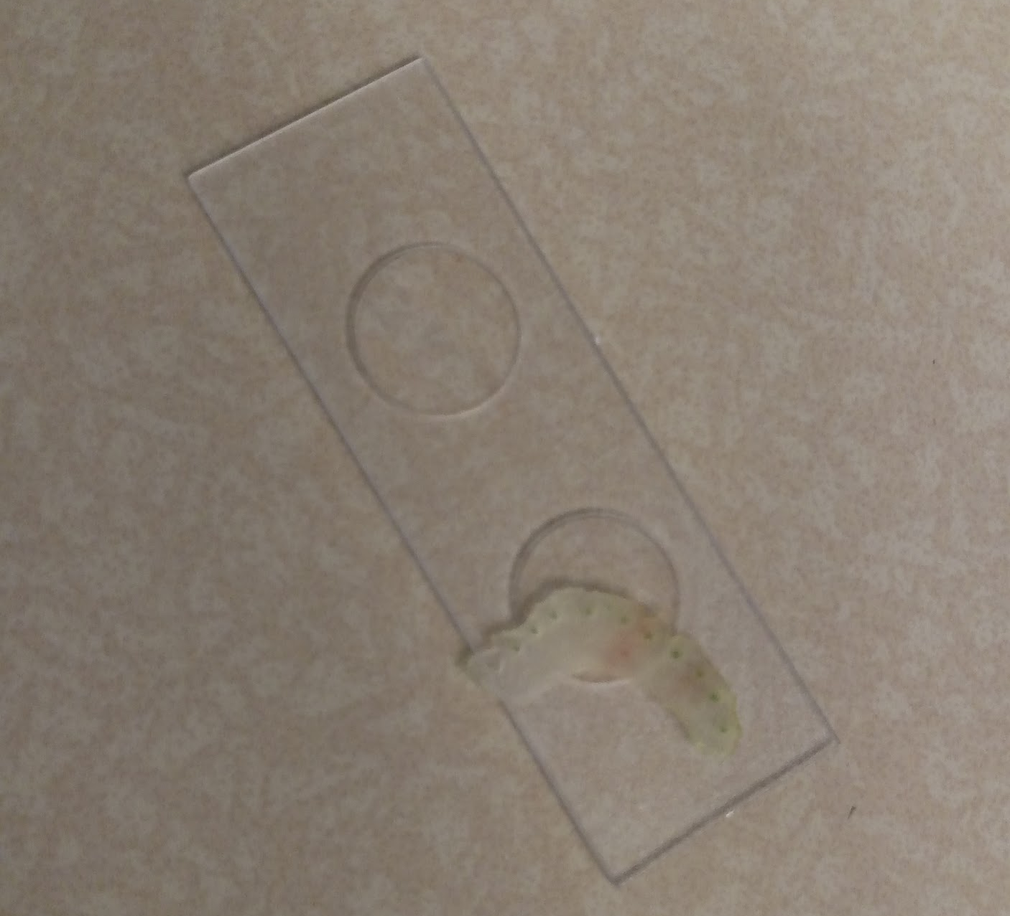
- Place the slide on the microscope table (no need to use the clips) and set the magnification to 4X
- Bring the image into focus
- Maneuver the slide to inspect one of the “holes” in the cross section. They should see something like this. The part which has taken up color is the xylem. The other section is the phloem.
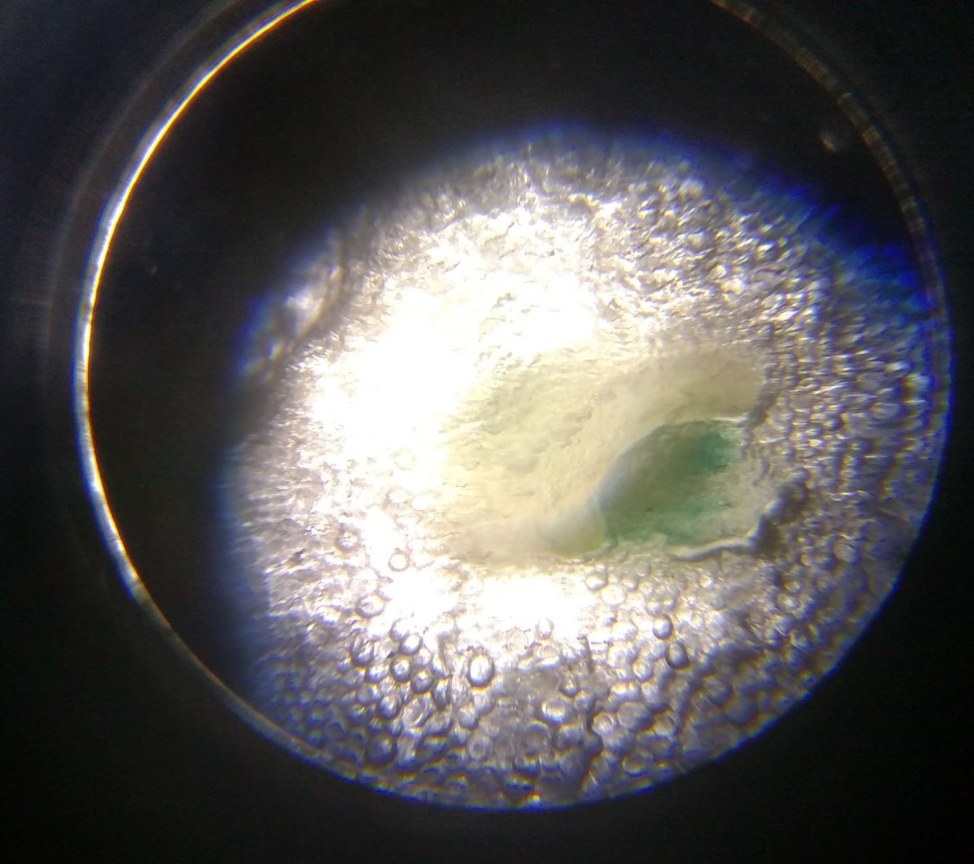
- Ask students for their observation.
- Look again with 10X magnification and ask for further observation.
- Have the students draw a the respiratory bundle on their worksheet
- Optional: discuss the difference between xylem and phloem and label them on their drawing
- Follow up question: Would you call the xylem large or small? Why do you think it is that size?

Capillary action:

- Show students the capillary tube set (maybe ask them what they think it’s purpose is?)
- Ask students what will happen if we pour water into the tube set.
- Specifically, ask the students where the level of the water will be in each tube
- Have the students draw the predicted water level on their worksheet
- Prepare a solution of colored water with which to fill the capillary tube set reservoir about halfway; the water needs to be dyed just enough to easily read the level of the water in the tubes
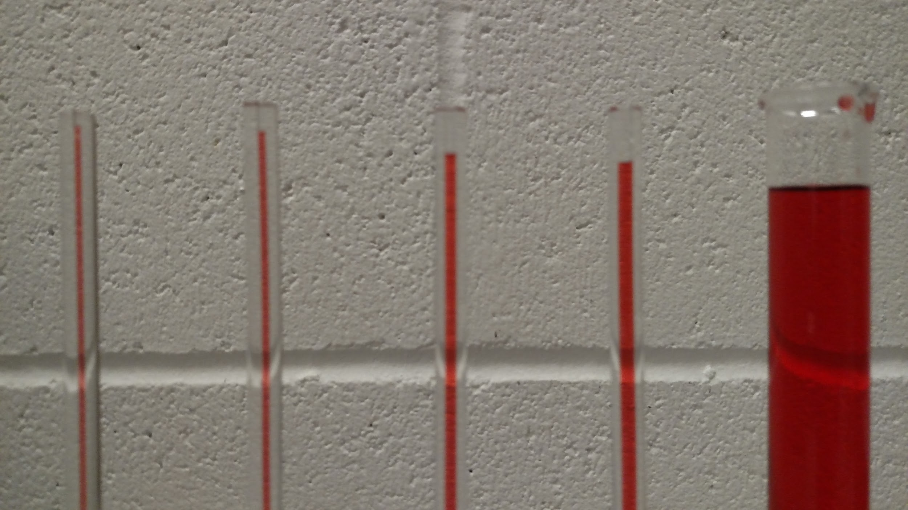
- Ask the students to observe the level of the water.
- Have the students record the level of the water on their worksheet and describe whether their prediction was correct.
- Discuss capillary action: Water is made up of things called molecules. These molecules are separate from each other and generally can move around relative to one another. However, one water molecule will have a slight attraction to another in a similar way that static charge on your hair will stick to a balloon. Water molecules also feel a slight attraction to the walls of the tubes. These two forces of attraction will pull up water through small tubes, even against the pull of gravity. Many liquids have this property but because of the way water molecules are built the effect is particularly strong.
- Practice some graphing!
  - Ask the students: if you were doing research on water transport in plants, how would you know why the size of the plants “water carrying tubes” are as large or small as they are? How far does a plant need water to passively move up? Does it depend on the type of plant?
  - Ask also: how can we use the model system of different sized tubes to try to answer the above questions? If I said that plants have a capillary tube that was exactly half the size of the smallest tube in the set, how far would the water rise?
  - What are the things we can measure about the system? (diameter of the tube and the height the water rises to)
  - Use the callipers to measure the diameter of the narrowest tube and the height to which the water rises in the tube
  - Grab a piece of pre-labeled graph paper and ask the students to read the labels on the bottom (x-axis) and then the top (y-axis).
  - Can we make an X in one of these boxes that would represent the measurements we made?
  - Where should we put the X for the hypothetical twice as narrow capillary?? We don’t know! Maybe we should see where the other tubes fall on this chart and see if there is a trend
  - Repeat the measurement of diameter and water level with the remaining capillary tubes and mark them on the chart
  - Draw a trend “line” through the data
  - Can we guess where this line would extend to? What does that say about the hypothetical tube?

Wrap Up: We will “watch” capillary action using celery stalks.
- Measure out about 200 mL of water into a cup
- Find a celery stalk that has a large number of leaves
- Cut the bottom end of the stock at an angle to expose a large cross section of fresh xylem
- Ask students: what will happen if I place the celery in the water? (answer: water will move up the xylem) How will we know if it’s moving up? (answer: let’s add color)
- Add at least 20 drops of food coloring to the water and stir.
- You can prepare cups with different colors as well.
- Place the celery in the water and wait for several days.
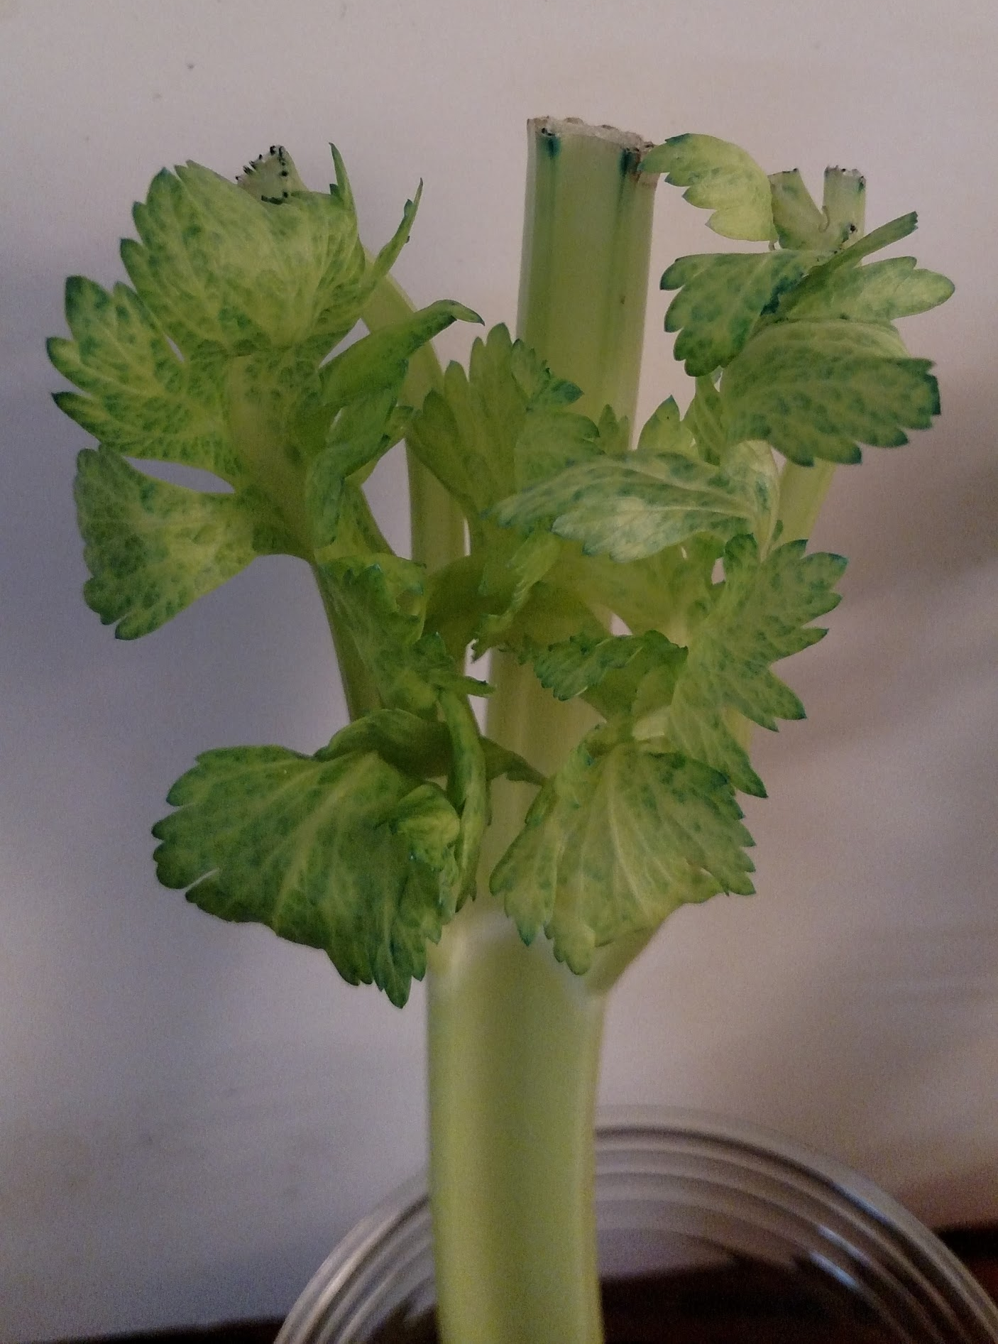
- After a day there will be visible spots of color in the leaves. After several days the color will become more pronounced.
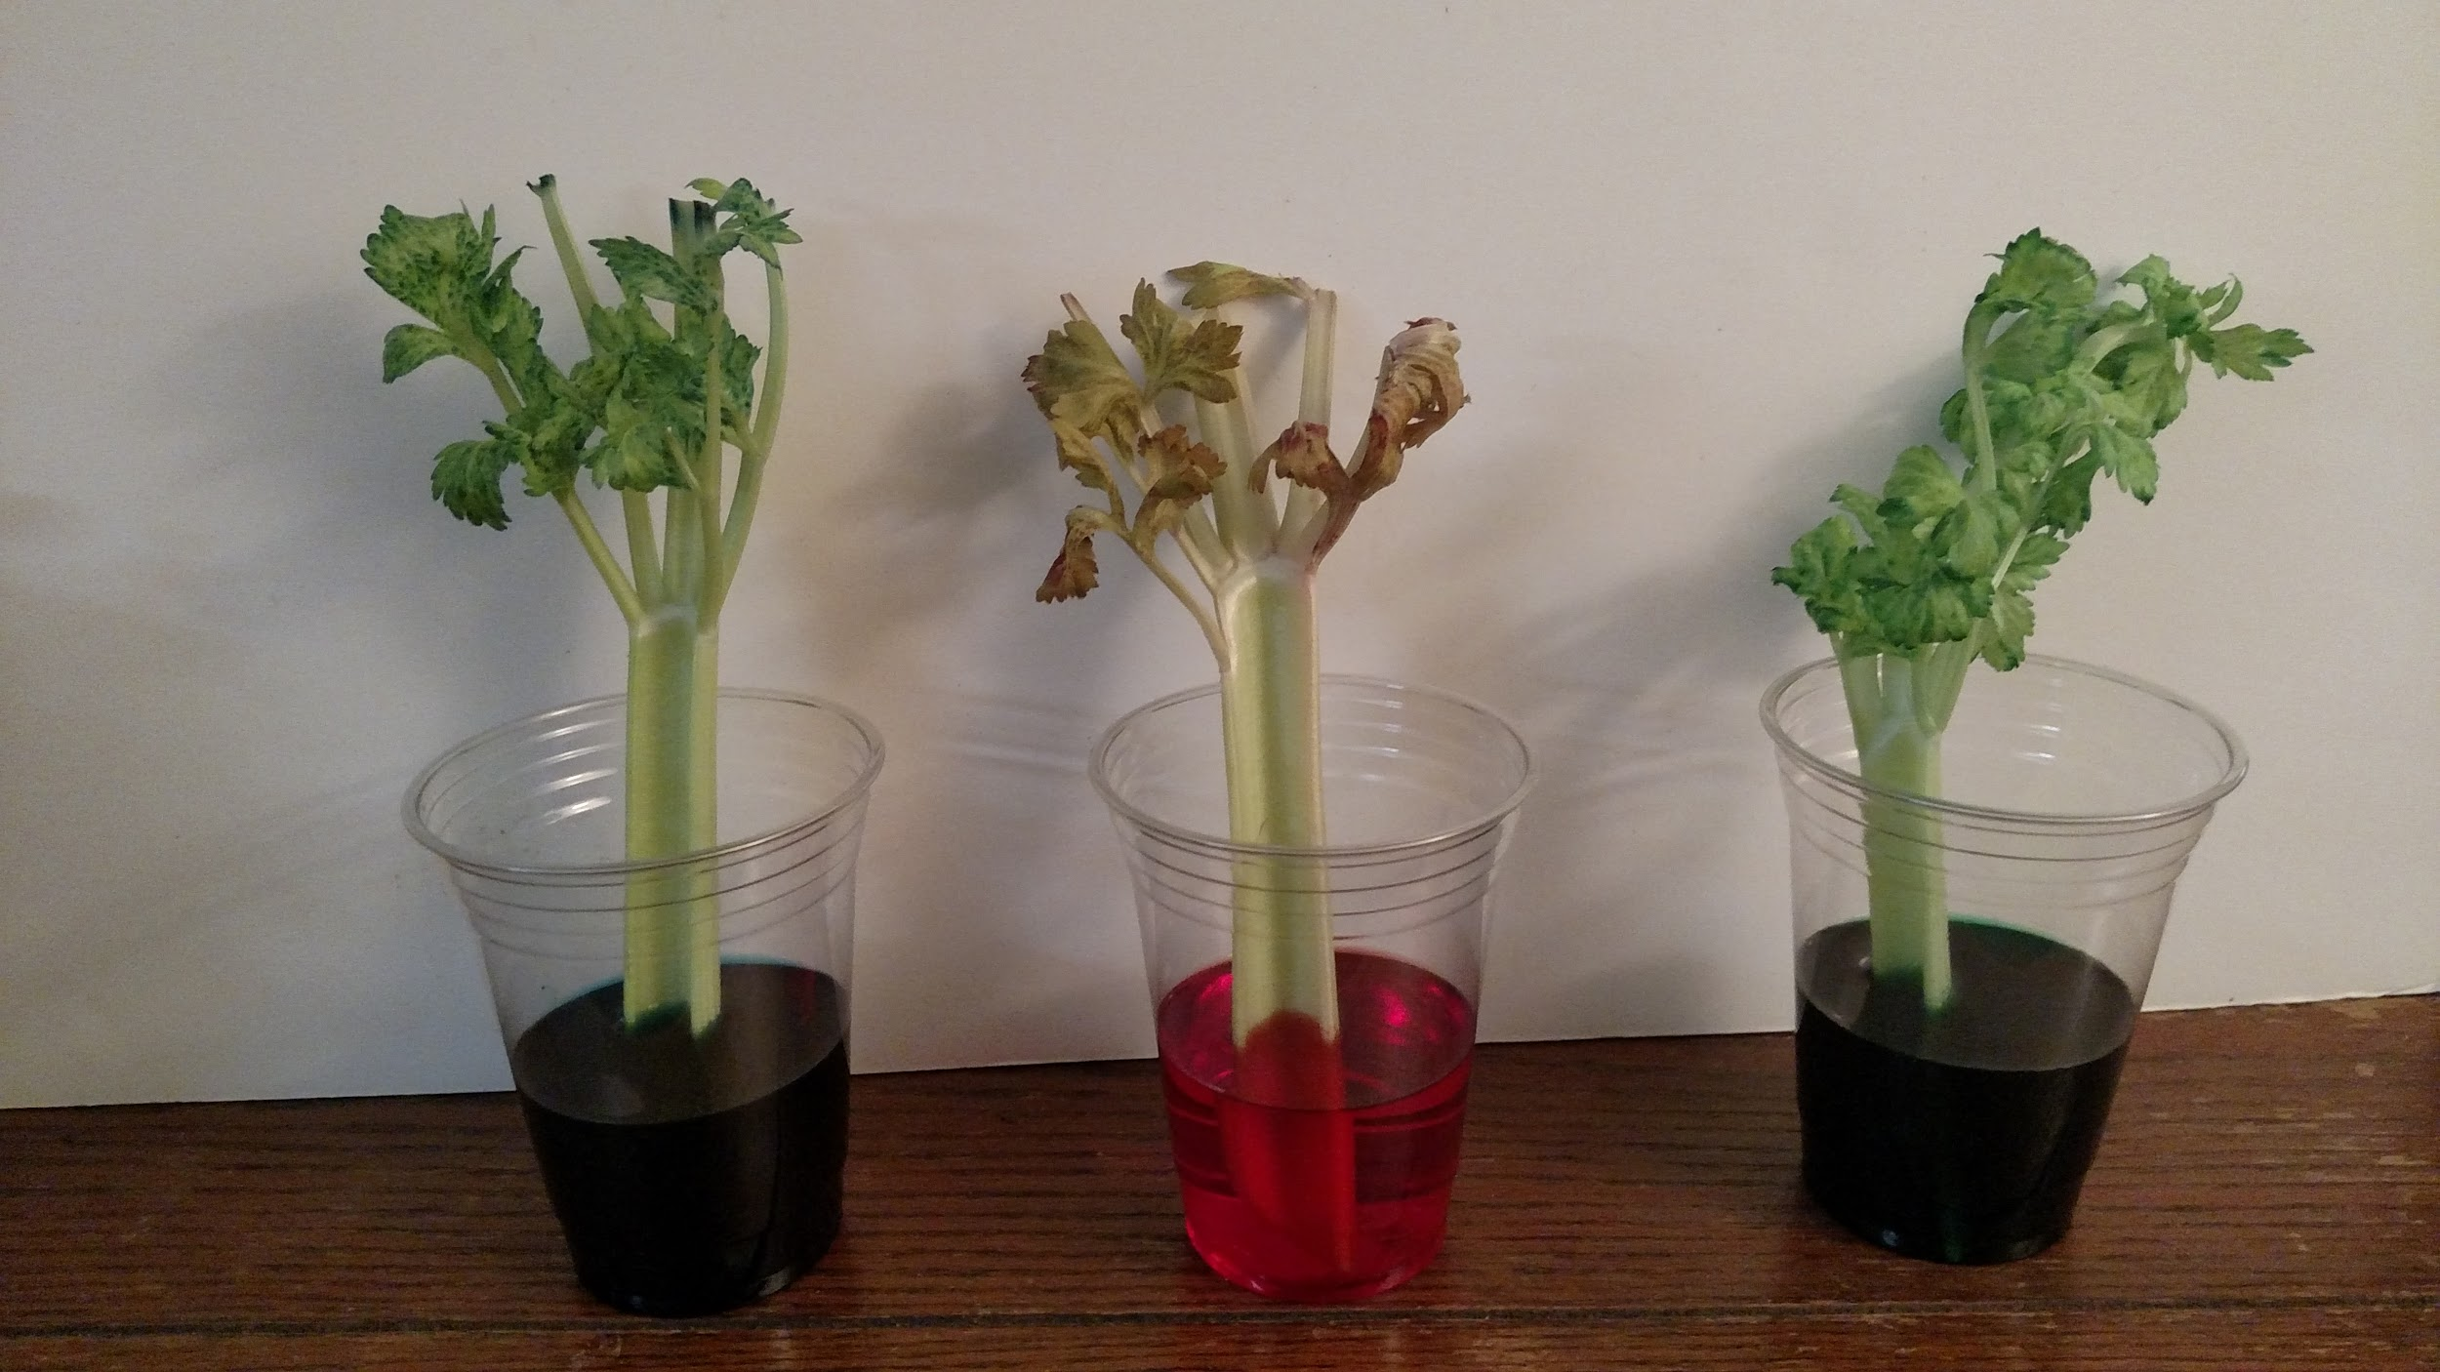
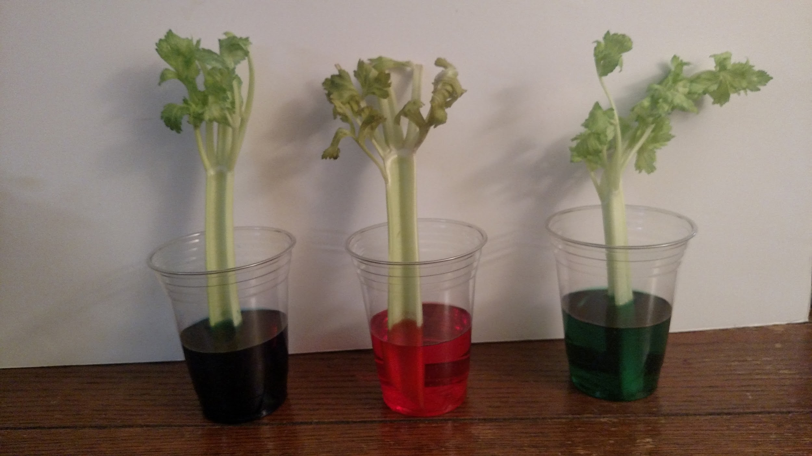
- At the end of the week observe where most of the color has accumulated. You may want to snap the stalk in half to view a cross section. How did the color get there? Why do you think the color accumulated where it did?
after 1 day
after 4 days

