Microscope Observations of Celery
Instructions: Draw the slice of celery as you see it with your eyes under “NO MAGNIFICATION.” After looking with the microscope at X10 Magnification, draw what you see under “X10 MAGNIFICATION.”

NO MAGNIFICATION

X10 MAGNIFICATION

Water Level in Capillaries (small straws)
Instructions: Think about how high the water will rise in each tube when it is poured in. Using the picture below, color in the water level you have guessed in “PREDICTED WATER LEVEL.” After your experiment draw the actual water level you see under “OBSERVED WATER LEVEL.”
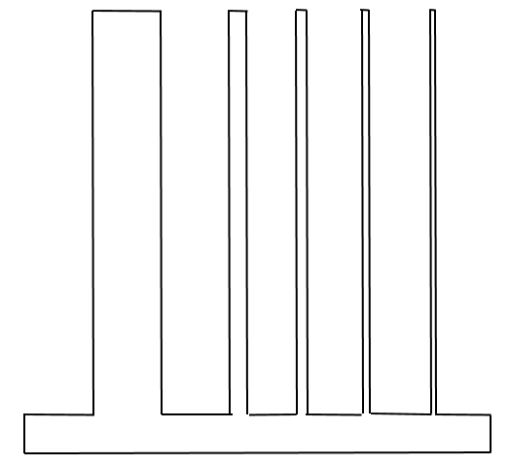
PREDICTED WATER LEVEL OBSERVED WATER LEVEL

Question: Did the water rise to the level you had guessed? If not, explain how your observation was different from your guess.

