Purpose: The purpose of this lesson is to demonstrate the acidification of water. We will simulate the emission of CO₂ from burning fossil fuels by reacting vinegar and baking soda. The CO₂ released by this reaction will dissolve into plain water. Then, we will test the pH of this carbonic acid solution as well as plain water for comparison.

Introduction:
Watch this 3 minute video from the Alliance for Climate Education: https://www.youtube.com/watch?v=ogZkV-Yj7Hc

Materials:
- Two plastic bottles with screw on caps, holes drilled into the caps
- About 1’ of vinyl tubing
- Clamp for hose
- Vinegar
- Baking soda
- Toilet paper
- pH test liquid, reference card, test tubes
- Bucket for preventing spills
Instructions:
- Small group discussion:
  - Have the students read the vocabulary words aloud and answer any questions they have about them. (optional: look at the acidity of various foods on the pH scale with provided handout)
  - Explain the procedure to your students.
  - Ask the students what each of the two bottles in our simulation represents.
  - Have the students label each bottle appropriately
  - Help students answer the two prediction questions on their worksheet.
- Assemble your reaction chamber: Force one end of the vinyl tubing through the hole on each cap (this might be easier with the cap still attached to the bottle). Pull the tubing down about 1” from the hole in one cap and several inches down from the other.
- Fill one bottle about ⅓ full of plain water.
- Fill the other about ⅓ full of vinegar.
- Place the long end of the tube into the water and screw on the cap. Make sure the end of the tube is submerged in the water.
- Place the short end of the tube into the vinegar bottle and screw on the cap. Make sure the end of the tube sits well above the level of the vinegar.
- Make a baking soda slow release packet: Measure approximately 2 tablespoons of baking soda onto a sheet of toilet paper. Fold or twist the paper to secure the baking soda.
- Add the baking soda packet to the vinegar: It’s best to prevent the reaction from happening until you can screw on the lid. I recommend tilting the vinegar bottle slightly and sliding the baking soda packet into the bottle, supported by the sidewall of the cavity. With the bottle still tilted, close the lid.
- Shake the vinegar bottle to release the baking soda and watch the reaction.
- Wait about 5 minutes for the production of carbon dioxide. Shake the vinegar bottle periodically.
- Prepare to open the bottles: This will release a lot of pressure! Clamp the tubing in in the middle and slowly unscrew the lid to the carbonic acid solution. Place the free end of the tube into the bucket in case of accidental discharge. Release the pressure in the vinegar bottle by slowly unscrewing the lid.
- Measure the pH of the carbonic acid solution and of plain water: Label one test tube with “water” and one “carbonic acid.” Pour 5 mL into each tube according to its label. Add three drops of pH test liquid. Shake. Refer to the color card to approximate the pH.
- Help students correct any errors on their worksheet.
- Clean up. Pour the extra carbonic acid and water down the sink. The vinegar solution can also go down the sink but you might want to filter the piece of toilet paper through a paper towel.
- OPTIONAL: Simulate the dissolution of sea animal shells using chalk! Chalk is made of calcium carbonate, the same compound with which ocean organisms build shells. Empty both your bottles and place a small piece of chalk in the bottom of each. Then, pour in a little water into one and a little acid into another (either vinegar or carbonic acid - but vinegar will be more dramatic). Have students predict and observe the result.
Wrapup:
Ask students what the vinegar/baking soda and the water were used to simulate in our experiment. To see actual human scientists studying ocean acidification, watch this video from the EPA: https://www.youtube.com/watch?v=Z5qorsKSEqY

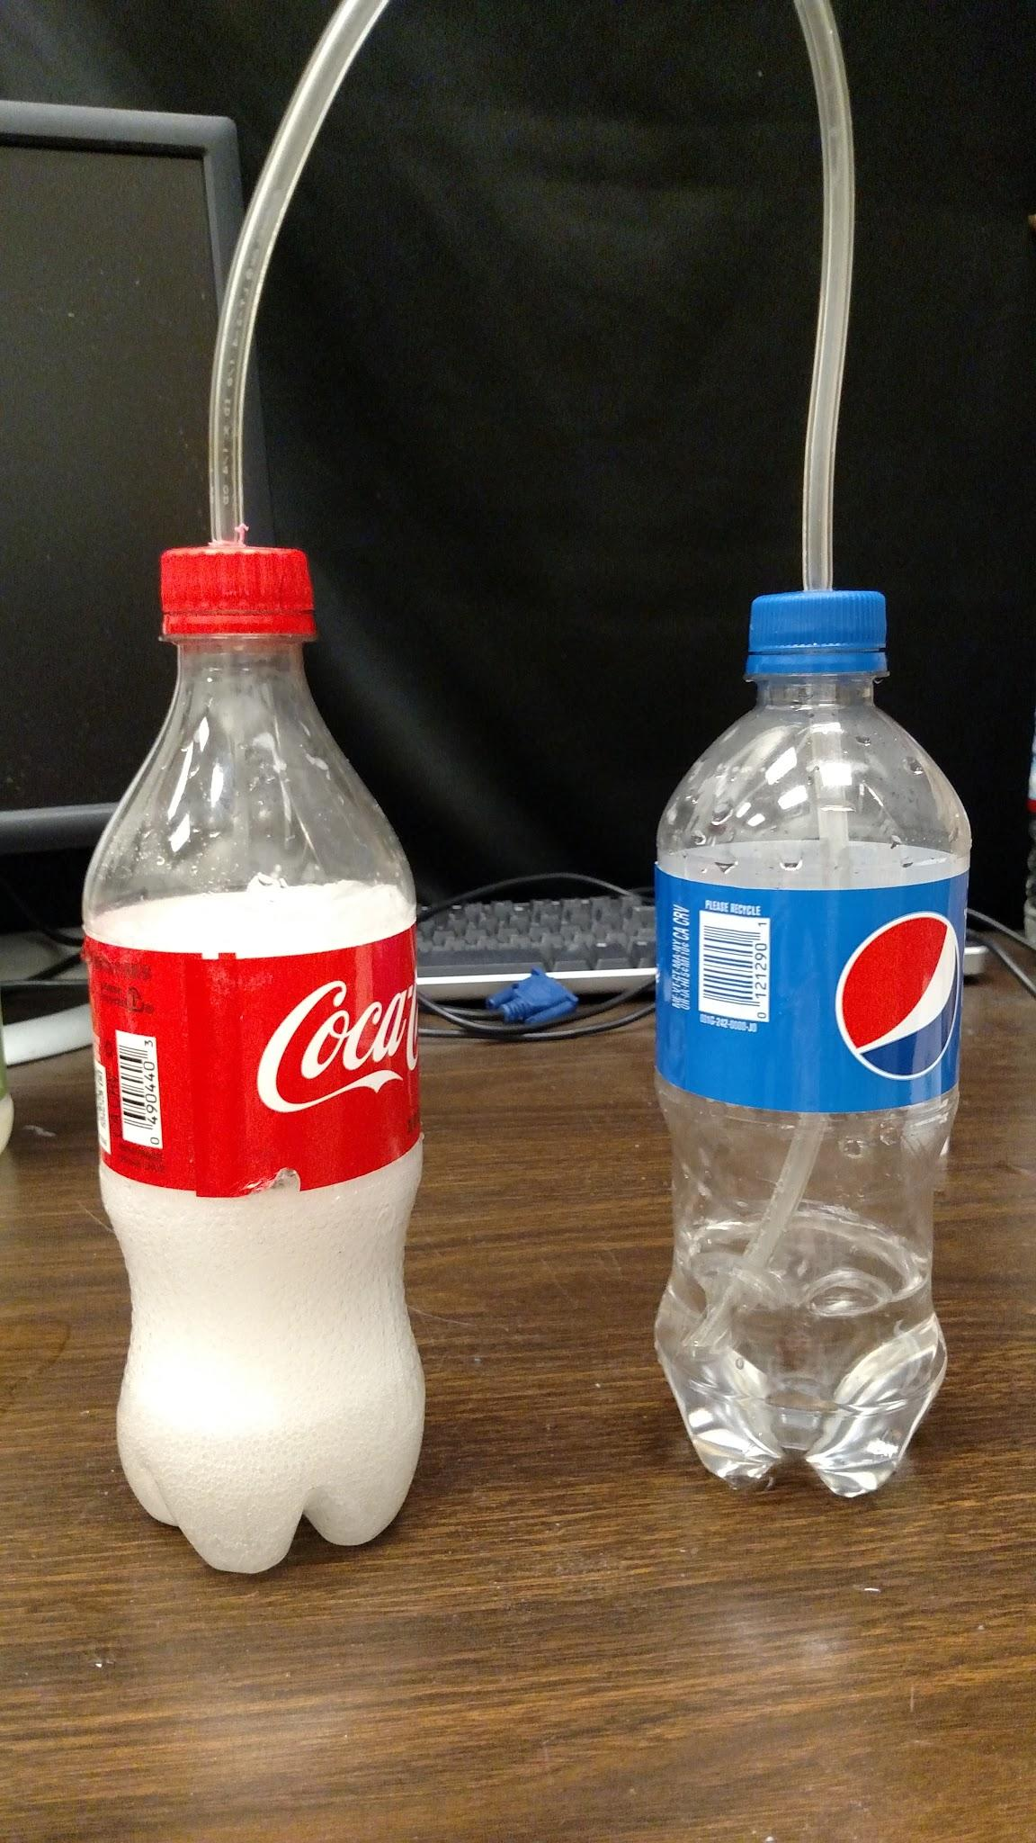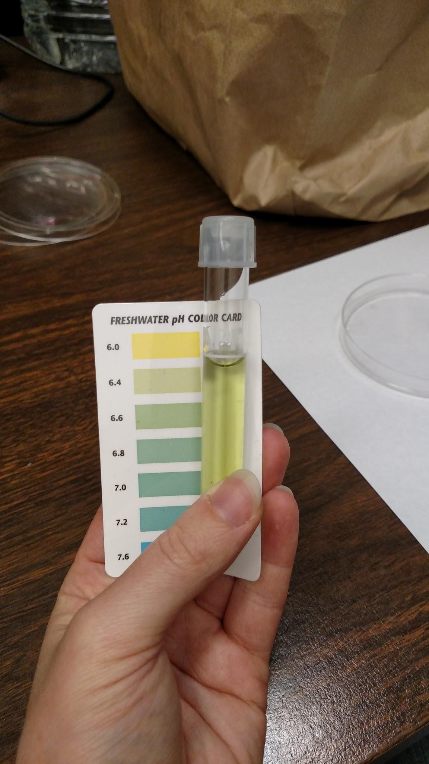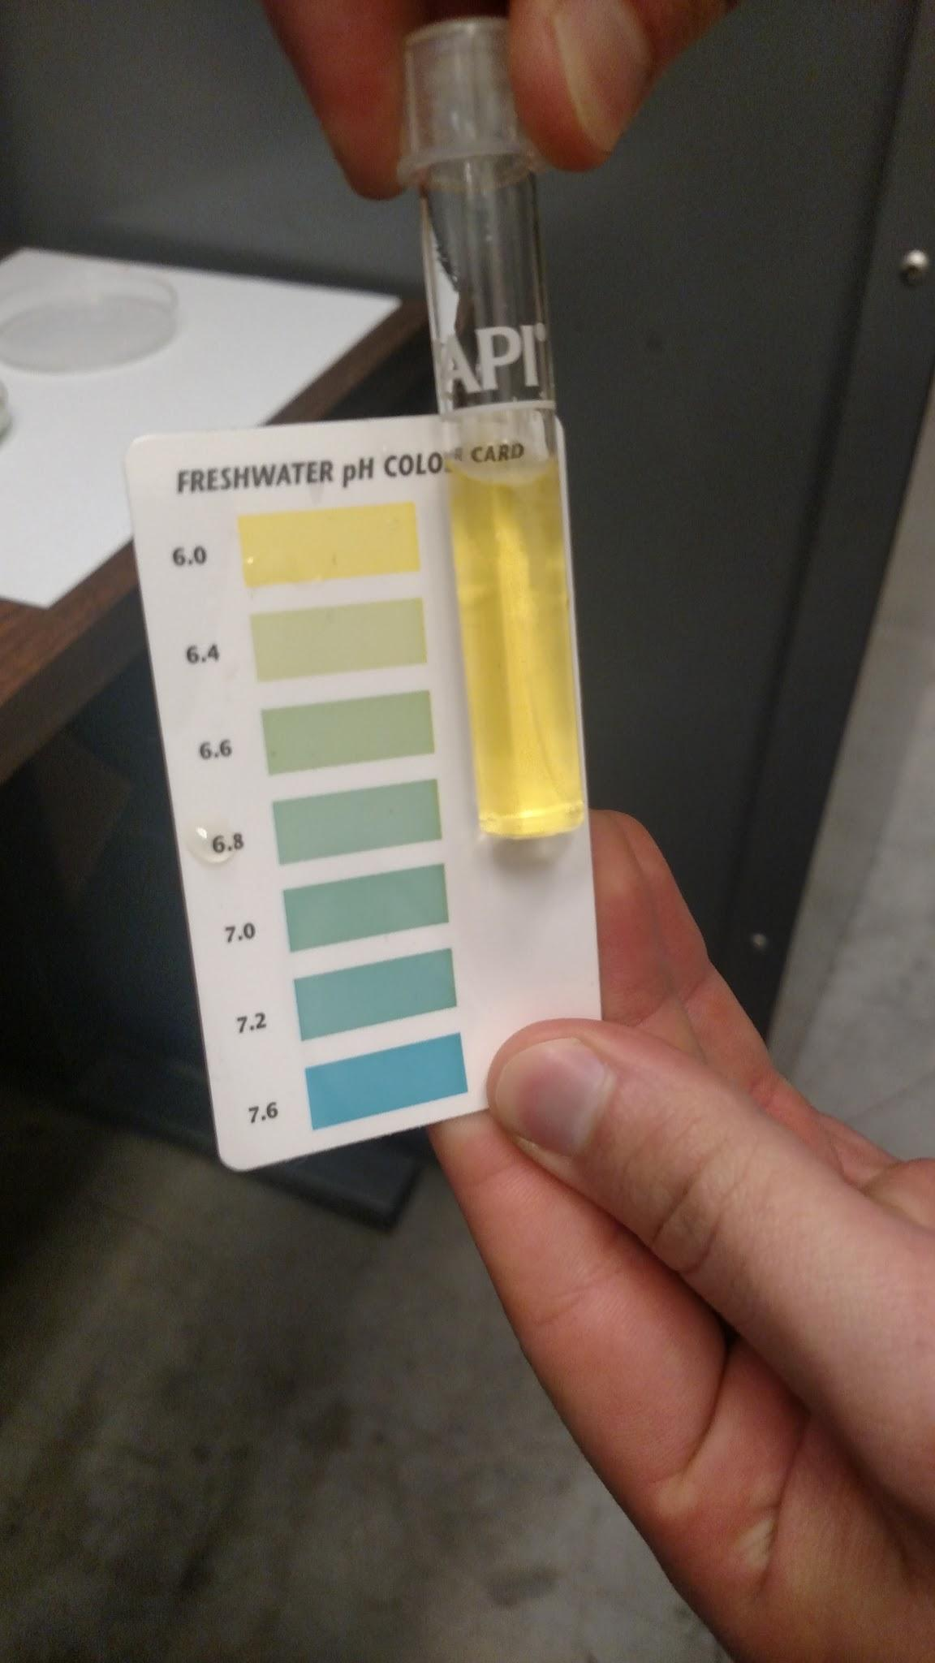
LEFT: Acidification process. CENTER: pH test of water. RIGHT: pH test of carbonic acid.

