Moving plants!

Diagram for plant cells

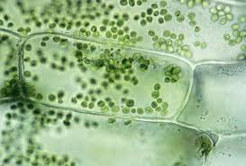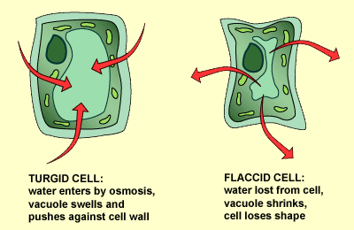
Normal cell Osmosis
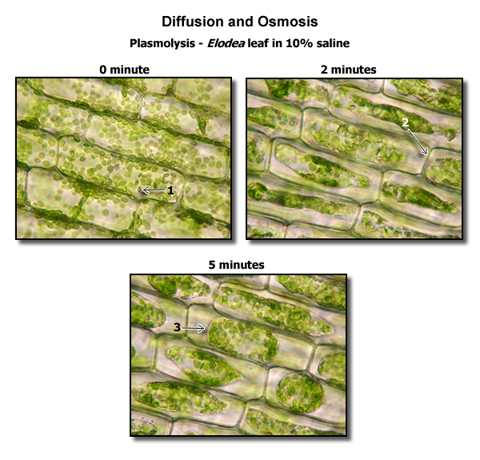
Introduction: Video about moving plants (coming soon)

Objectives:
- Understand how plants use osmosis for movement.
- Understand the concept of turgor
- See osmosis and turgor working in real time in live plants

Materials:
- Slices of potato
- Salt
- Water
- Distilled water
- 3 containers per group
- 1 ruler per team
- 1 Balloon per team
- 1 leaf per team
- Mimosa pudica
- Carnivorous plant

Background:

Turgor pressure is the force within the cell that pushes the plasma membrane against the cell wall. It is also called hydrostatic pressure, and more intricately defined as the pressure measured by a fluid, measured at a certain point within itself when at equilibrium

Osmosis is the spontaneous net movement of solvent molecules through a semi-permeable membrane into a region of higher solute concentration, in the direction that tends to equalize the solute concentrations on the two sides.

Plants: Mimosa pudica and Carnivorous plants
Is also called sensitive plant, sleepy plant, action plant, Dormilones, touch-me-not, shameplant, or shy plant) The leaves fold inward and droop when touched or shaken, defending themselves from harm, and re-open a few minutes later. The species is native to South America and Central America, but now it can also be found in Asia.

Mimosa pudica is well known for its rapid plant movement. Like a number of other plant species, it undergoes changes in leaf orientation termed "sleep" or nyctinastic movement. The foliage closes during darkness and reopens in light. The leaflets also close when stimulated in other ways, such as touching, warming, blowing, or shaking. The signal passes from cell to cell from the leaf to the base of the petiole the rachis.

The signal causes molecules of potassium ions to flow from cell to cell, then the water to flow out from those cells by osmosis, making them lose turgor, which is the force that is applied onto the cell wall by water within the cell. Differences in turgidity in different regions of the leaf and stem results in the closing of the leaflets and the collapse of the leaf petiole
This movement of folding inwards is energetically costly for the plant and also interferes with the process of photosynthesis. The stimulus can also be transmitted to neighboring leaves. It is not known exactly why Mimosa pudica evolved this trait, but many scientists think that the plant uses its ability to shrink as a defense from herbivores. Animals may be afraid of a fast moving plant and would rather eat a less active one. Another possible explanation is that the sudden movement dislodges harmful insects.

Methods
Turgor
- Explain turgor
- Show how turgor works by Inflating the balloon fully
- Ask them why the balloon is shaped like it is
- Release air out of the balloon until it becomes floppy
- Ask the students why the balloon does not hold the shape any more
- Explain that for plants the balloon is the equivalent to the cell wall and the air is equivalent to the water that they take from their roots.

Osmosis
- Explain osmosis
- Fill two containers with tap water and one with distilled water
- Add two tablespoons of salt to one container of tap water and stir until is dissolved
- Measure the potatoes length and record it.
- Place some potato slices in each container
- Allow them to sit for 20 minutes
- Measure the potatoes length again and record it.
- DId the size changed? Why?

Wrap Up: See movement in live plants

- Introduce the plants to the kids
- LIght a match and make it close to the Mimosa leaf, ask the kids what they think will happen
- Explain how osmosis and turgor are related to the plant movements
- Feed a bug to the carnivorous plant
- Ask the kids what they think will happen
- Reinforce how osmosis and turgor are related to the plant movements

Conclusion: Video about osmosis https://www.youtube.com/watch?v=IaZ8MtF3C6M

