Hypothesis: an educated guess about the outcome of the experiment.

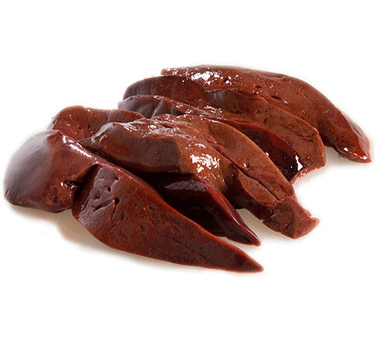
Our experiment: testing how well the enzyme catalase works in liver with the following conditions:

- Control ( no treatment to the liver)
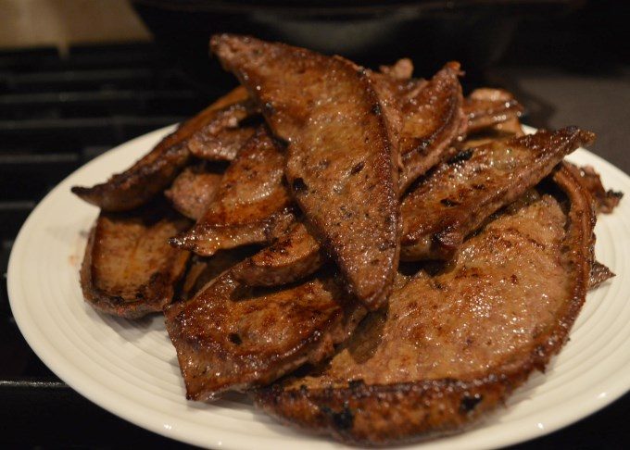

- Heat (cooked) liver

- Acid-soaked liver
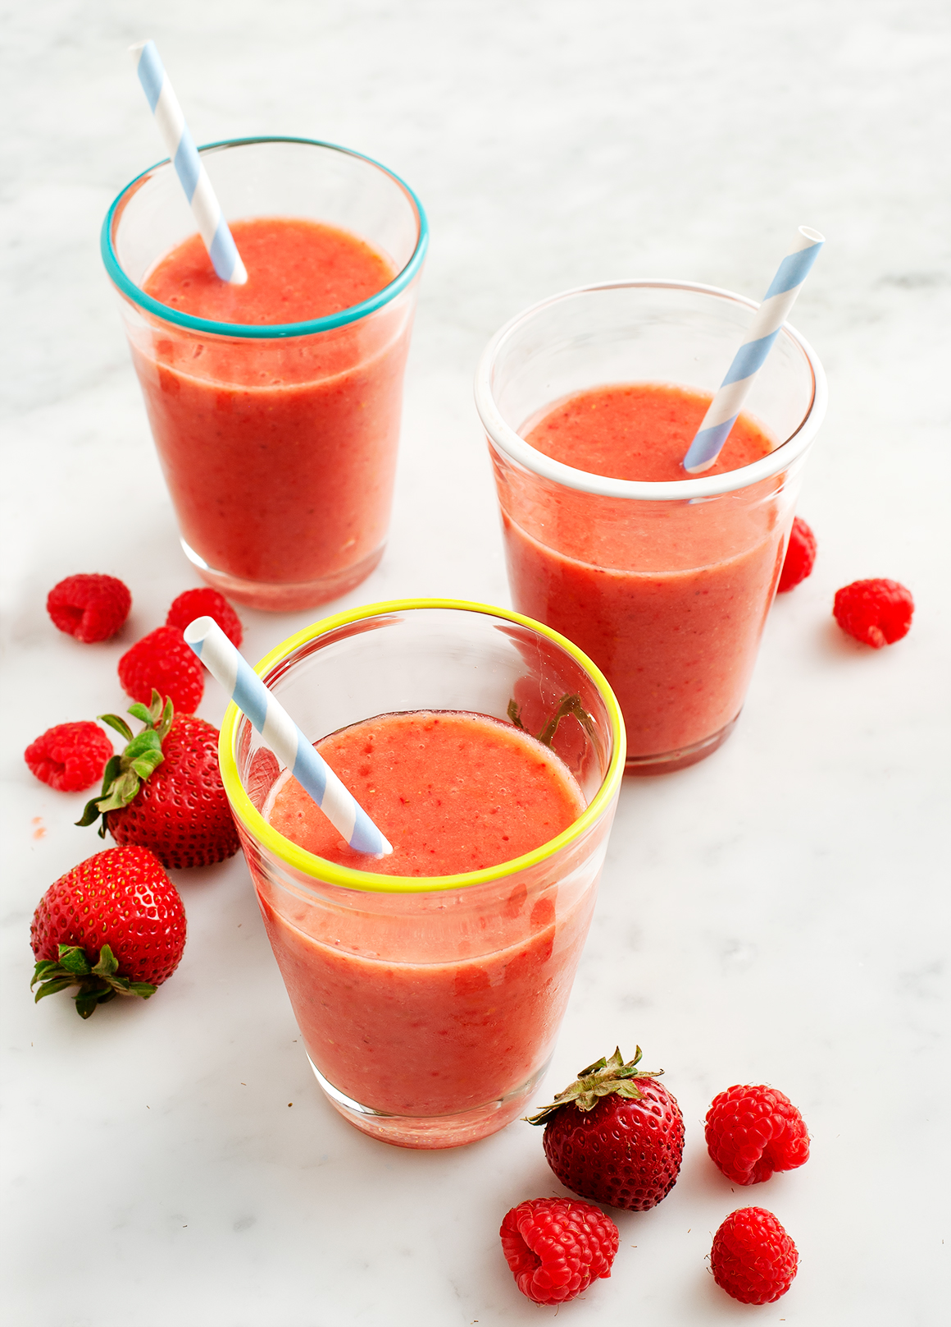
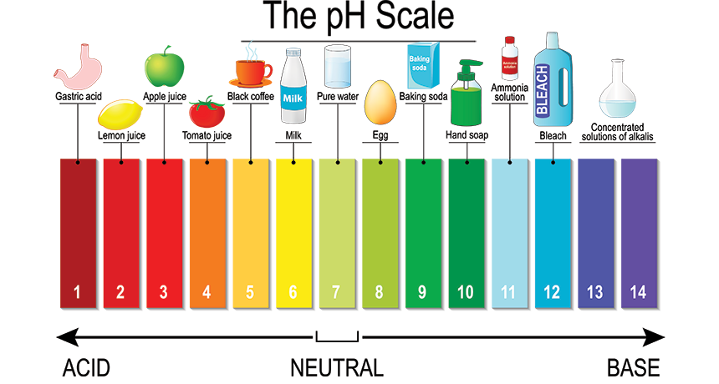

- Blended (liver smoothie)

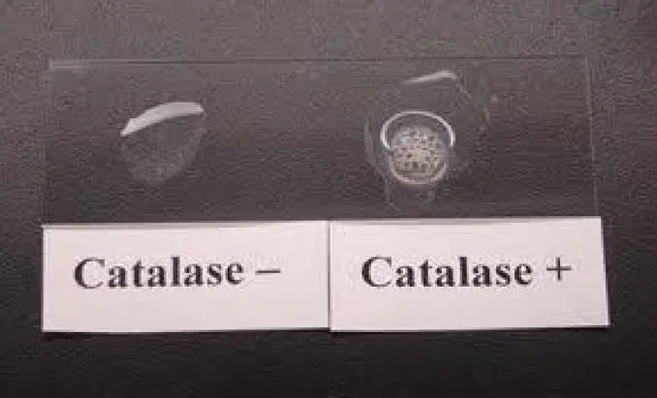

How will we test this?

When we add hydrogen peroxide
to liver that contains active
catalase, it will form oxygen (a gas)
and water (a liquid) and bubble.
We can see and monitor these
bubbles to test how well the enzyme is working!
We will record how long the liver bubbles after hydrogen peroxide is added to the liver chunks. We will time how long bubbles persist and have a rating, on a scale from 0 (no bubbles) to 5 ( SO MANY BUBBLES) recorded for each condition to test how heat, acid, and blending affect catalase activity in a liver sample.

Hypotheses:Circle one of the underlined words in each sentence to fill in your own initial hypotheses.

- The control (untreated) liver sample will / will not bubble

- The heated liver sample (cooked liver) will bubble more / less than the control (untreated) liver sample.
Why? ______________________________________
______________________________________

- The acid-soaked liver sample will bubble more / less than the control (untreated) liver sample.
Why? ______________________________________
______________________________________

- The liver smoothie (blended liver) will bubble more / less than the control (untreated) liver sample.
Why? ______________________________________
______________________________________
Treatments | Bubbling Time (seconds) | Bubble Rating
Untreated
Heated
Acidic
Liver smoothie
No hydrogen peroxide added* | 0 seconds | 0
- By not adding any hydrogen peroxide to a liver slice, we have made what is called a “negative control.” This will be our true 0 because no bubbles can form without adding the hydrogen peroxide to the sample.

